CSCI 3100 SOFTWARE ENGINEERING – GROUP 15 

|  |  |
| --- | --- |
| Wong Sin Yi(1155110677) | Computer Science, The Chinese University of Hong Kong |
| Cheung Kam Ho(1155092634) | Computer Science, The Chinese University of Hong Kong |
| Cheung Chi Hang Calvin(1155110302) | Computer Science, The Chinese University of Hong Kong |
| Cheung Tsz Ho(1155102444) | Computer Science, The Chinese University of Hong Kong |
| Yuen Ching Yin(1155110657) | Computer Science, The Chinese University of Hong Kong |

**CONTENTS**

**1. Introduction** **4**

1.1. Project Overview 4

1.2. Objective 4

1.3. Highlights 4

1.3.1. Sharing and Trading System 4

1.3.2. Material Preview 4

1.3.3. Forum 4

1.3.4. Search Engine 5

1.4. Project Statistics 5

**2. System Architecture Design by DFD** **7**

2.1. Architecture Design 7

2.1.1. Architecture Diagram 7

2.1.2. System Components 7

2.2. Data Flow Diagram (DFD) 8

2.2.1. Database 8

2.2.2 Data Flow Diagram 9

**3. Detailed Description of Component by UML** **10**

3.1. Component-1: Personal Account System 10

3.1.1. Structural Diagram 10

3.1.2. UMLs 10

3.1.2.1. Use Case Diagram 10

3.1.2.2. Sequence Diagram for Guest 11

3.1.2.3. Activity Diagram for Guest 11

3.1.2.4. Sequence Diagram for User (log in and change personal info) 12

3.1.2.5. Activity Diagram for User (log in and change personal info) 13

3.1.3. Functionality 13

3.1.4. Procedures and Functions 13

3.2. Component-2: Academic Resource System 15

3.2.1. Structural Diagram 15

3.2.2. UMLs 16

3.2.2.1. Use Case Diagram 16

3.2.2.2. Sequence Diagram for Uploading Resources 16

3.2.2.3. Sequence Diagram for Searching and Download Resources 17

3.2.3. Functionality 18

3.2.4. Procedures and Functions 18

3.3. Component-3: Question Discussion Forum 19

3.3.1. Structural Diagram 19

3.3.2. UMLs 20

3.3.2.1. Use Case Diagram 20

3.3.2.2. Sequence Diagram for Creating a Question and an answer 21

3.3.3. Functionality 21

3.3.4. Procedures and Functions 22

3.4. Component-4: Mailbox 23

3.4.1. Structural Diagram 23

3.4.2. UMLs 23

3.4.2.1. Use Case Diagram 23

3.4.2.2. Sequence Diagram for Sending message 24

3.4.2.3. Sequence Diagram for System message 25

3.4.3. Functionality 25

3.4.4. Procedures and Functions 25

3.5. Overall Class Diagram 26

**4. User Interface Design** **27**

4.1. Description of the User Interface 27

4.1.1. Interaction style 27

4.1.2. Golden rules of UI Design 27

4.2 Screen Images 29

4.2.1. Homepage 29

4.2.2. Menu Bar (Without Login) 30

4.2.3. Menu Bar (Login) 30

4.2.4. About Us 30

4.3. Object and Action 32

4.3.1. Homepage of ARM 32

4.3.2. Registration 33

4.3.3. Login 33

4.3.4. Profile 34

4.3.5. Forum 35

4.3.6. Mail Box 36

4.3.7. Materials Searching 37

4.3.8. View and Download the materials 38

4.3.9. Upload the file. 39

**5. Test** **39**

5.1. Overview and plan 39

5.2. Register/login + personalInfo 39

5.2.1. purpose 39

5.2.2. Inputs 39

5.2.2.1. Login Page: 39

5.2.2.2. Registratation Page: 40

5.2.3. Expected Outputs & Pass/Fail Criteria 40

5.2.3.1 Login page: 40

5.2.3.2 Restratation page: 41

5.3. Material List and search 43

5.3.1. purpose 43

5.3.2. Upload Material 44

5.3.2.1. Inputs 44

5.3.2.2. Expected Outputs & Pass/Fail Criteria 45

5.3.3. Purchase material 49

5.3.3.1. Inputs 49

5.3.3.2 Expected Outputs & Pass/Fail Criteria 49

Case 1 (Pass) 50

5.3.4. Search Material 51

5.3.4.1. Inputs 51

5.3.4.2. Expected Outputs & Pass/Fail Criteria 53

5.4. Question Discussion Forum 57

5.4.1. purpose 57

5.4.2. Question Category 57

5.4.2.1. Inputs 57

5.4.2.2. Expected Outputs & Pass/Fail Criteria 57

5.4.3 View Question 58

5.4.3.1. Inputs 58

5.4.4.2. Expected Outputs & Pass/Fail Criteria 58

5.4.4 Ask Question 61

5.4.4.1. Inputs 61

5.4.4.2. Expected Outputs & Pass/Fail Criteria 61

5.5 Mailbox 63

5.5.1. purpose 63

5.5.2. Inputs 63

5.5.3. Expected Outputs & Pass/Fail Criteria 63

**6. Lesson Learned** **65**

**7. Conclusion** **65**

# 1. Introduction

## 1.1. Project Overview

We are going to develop an open online learning system including a library, forum, and mailbox technique. It is a platform for users to find learning materials, share school exercise or exam paper source to others so as to build a friendly relationship with others.

## 1.2. Objective

University provides a good learning environment that students can receive enough academical supports. Students can get study materials freely and easily from their friends and the university library. However, in secondary education, we notice many students apply for tutorial beyond their school because the tutor centres provide extra materials for them. Because of that, the tuition fee is unaffordable by most of the students. These facts imply that the commodification of education is very serious in society.

To change this trend, we encourage open online learning platform to secondary students that the resources can be shared among the peers.

## 1.3. Highlights

### 1.3.1. Sharing and Trading System

Providing a platform for secondary students to share their materials is the main service of ARM. For the trading system, the fully functional system that allows using tokens to buy the resource. The uploader can get token and Buyer can get the permission to download the resource in full view. Users can rate and comment on the material that can recommend to another user, also the system can rearrange all the materials based on the rating of all the resource.

### 1.3.2. Material Preview

To guarantee the buyer not to be deceived, ARM provides the preview version of the resource. The preview automatically generated after the users upload the file to the platforms. The preview version only contains first few pages of the .pdf files, and contain a watermark for preventing others invalid commercial purpose and copyright infringement. It also protects the benefits of the publisher if files are priced.

### 1.3.3. Forum

We encourage every student can be questioner and respondent for providing a good communication environment with every user. Users can create a forum topic to ask questions or bring out some ideas, also they can leave comments to answer and help each other. For user-friendliness, We categorize questions into different subjects and order the topics by rating and activeness (the number of views).

### 1.3.4. Search Engine

We have to make sure that the user can find what they want because it is a platform for sharing and getting the academic recourse. We provide a search feature that allows users to find the related material based on their typing words. To make the search feature more functional, We allow users to add the label tags during uploading the materials. When users type the keywords of tags, it will list all the material that contains the label.

If users have no idea of the keywords that they want to search, we also provide category searching. Users can choose the subject that they want, then it lists all the related materials ordered by ratings.

## 1.4. Project Statistics

Our team have finished 31 php pages within 10 weeks. The table below shows the line of code and the McCabe’s number of these pages. The statistics came from our self-calculation.

|  |  |  |  |  |  |
| --- | --- | --- | --- | --- | --- |
| Name | LOC | McCabe’s number | Name | LOC | McCabe’s number |
| 404.php | 55 | 1 | menu.php | 49 | 2 |
| about.php | 71 | 1 | previewGenerator.php | 58 | 3 |
| answer.php | 60 | 5 | question_category.php | 206 | 11 |
| ask_question.php | 106 | 3 | question.php | 120 | 4 |
| close_question.php | 31 | 2 | reference.php | 73 | 1 |
| comment.php | 55 | 5 | register.php | 267 | 8 |
| connect.php | 21 | 1 | result.php | 171 | 14 |
| contact.php | 90 | 1 | search_header.php | 84 | 4 |
| create_queston.php | 53 | 5 | search.php | 101 | 2 |
| create_rating.php | 36 | 3 | update_profile.php | 198 | 14 |
| footer.php | 60 | 1 | upload_file.php | 205 | 6 |
| help.php | 73 | 1 | view_my_profile.php | 179 | 8 |
| index.php | 236 | 7 | view_profile.php | 164 | 7 |
| login.php | 112 | 2 | view_question.php | 258 | 16 |
| logout.php | 16 | 1 | view.php | 280 | 13 |
| mail.php | 222 | 12 |  |  |  |

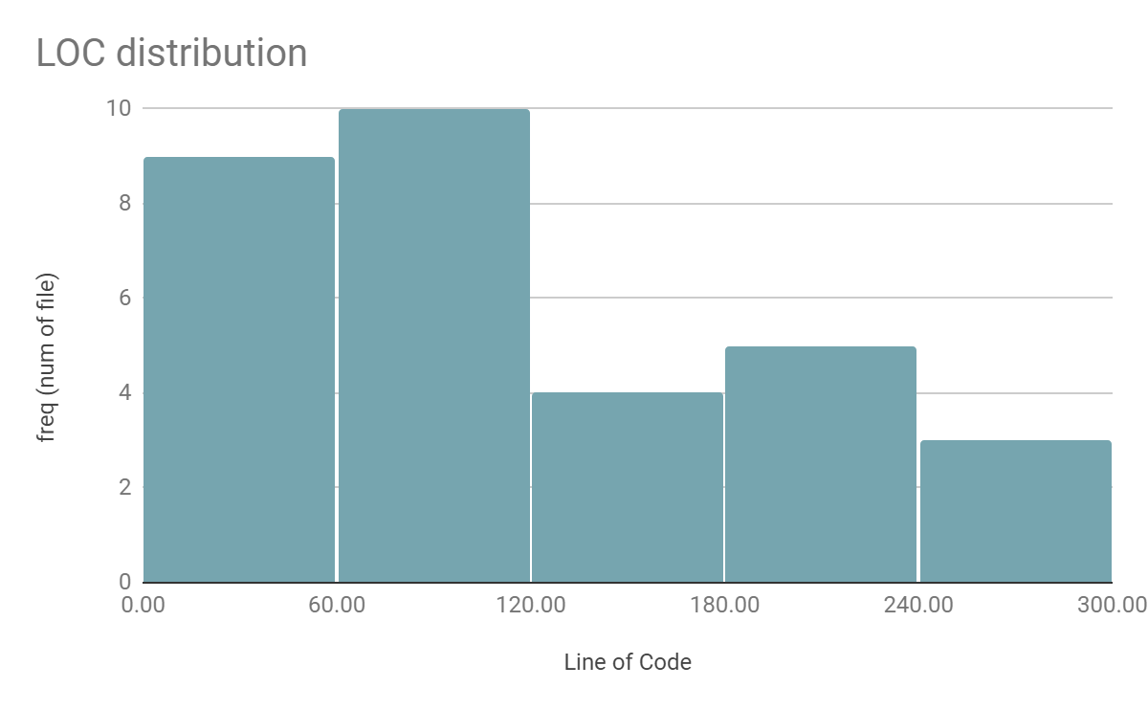

There are 3710 lines of code across the whole system, excluding external libraries. Majority of php files have less than 120 lines of code. On average, each file has 119.6 lines of code. As we have 5 team members, the LOC per person is 742 LOC/person.

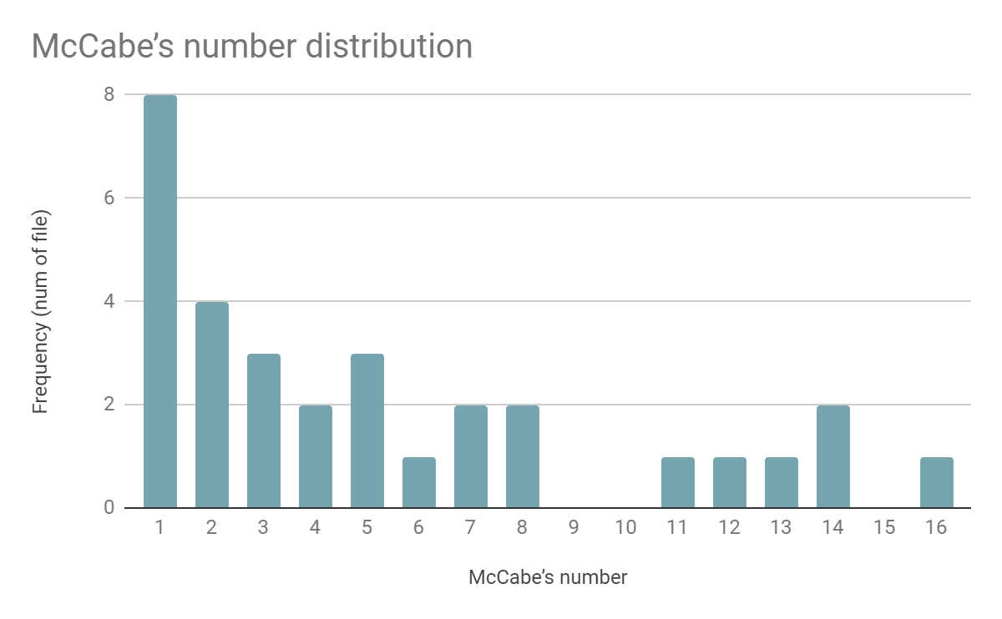

As the figure shown, the majority of php files’ Mccabe's number are less than 8. This shows that the system are in appropriate complexity.

# 

# 2. System Architecture Design by DFD

## 2.1. Architecture Design

### 2.1.1. Architecture Diagram

### 

### 2.1.2. System Components

|  |  |
| --- | --- |
| Personal Account System | Users Information are stored into the user database and record the token of the account. The system allows users to edit their email address, Based on user sharing and downloaded priced materials, the balance of token will change. |
| Academic Resource System | The system that manages the database of resource files. By the user searching result, the system will show the list of related materials. |
| Question Discussion Forum | List of question threads collected from Q&A database, allows users to ask and answer. |
| Mailbox | The system allows users to send mails to others and receive the system messages. |

## 

## 2.2. Data Flow Diagram (DFD)

### 2.2.1. Database

The database of ARM is shown below.

1. User Database includes the user account, account password, user token points
2. Resource database includes the resource content( name, category, uploader, material type, the rating, comment of the source, free or purchase)
3. Download history database includes the download resource record
4. Question and Answer database includes the question ( categories, reply, the rating for the reply)
5. Mail database includes the mail history with the user exchanging messages and system messages.

### 

### 2.2.2 Data Flow Diagram

Data Flow Diagram of our main functions is shown below.

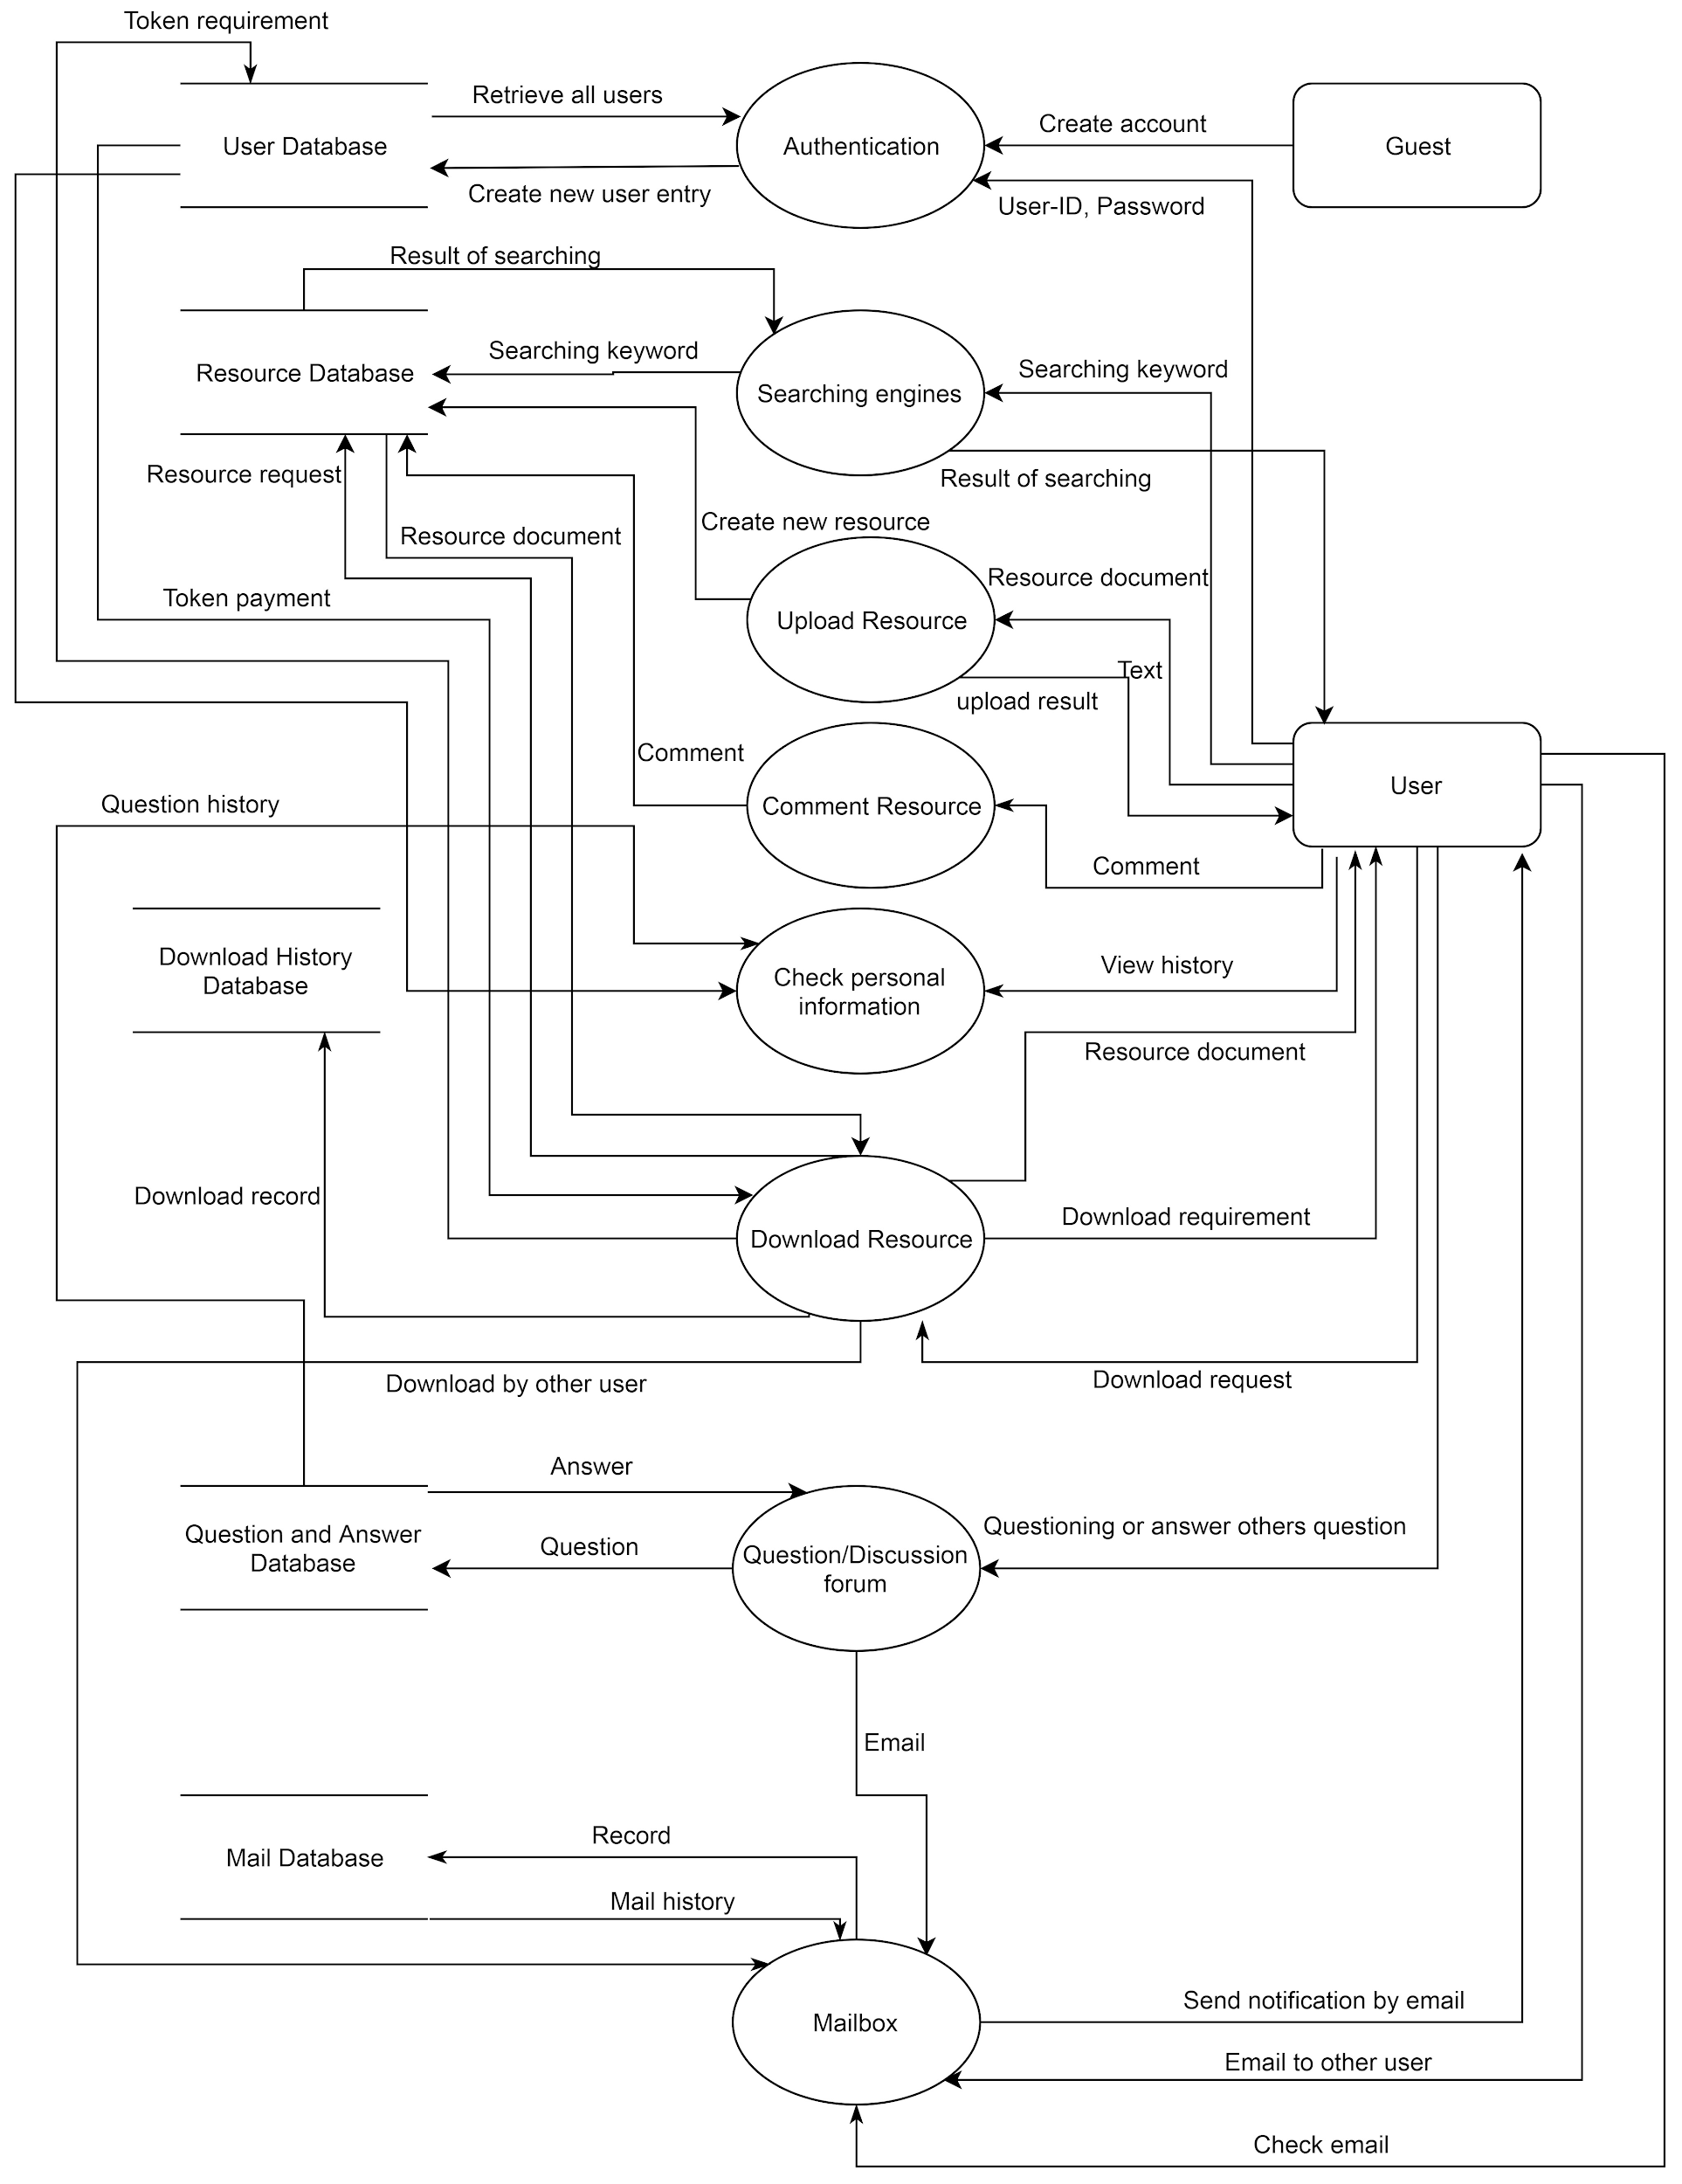

# 

# 3. Detailed Description of Component by UML

## 3.1. Component-1: Personal Account System

Personal Account System is a database system to provide the identity for students in server and interact with others.

### 3.1.1. Structural Diagram

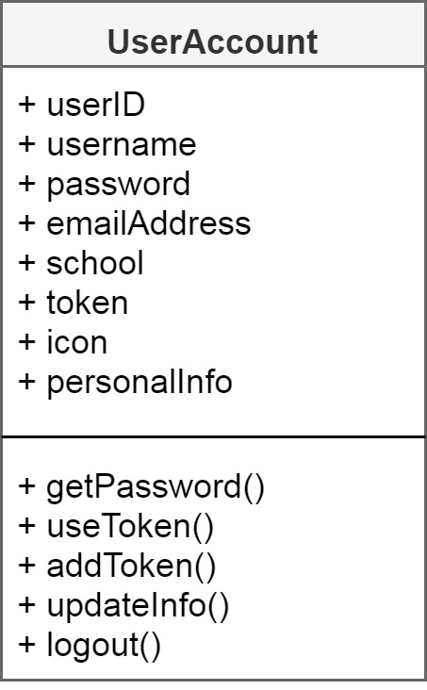

### 3.1.2. UMLs

#### 3.1.2.1. Use Case Diagram

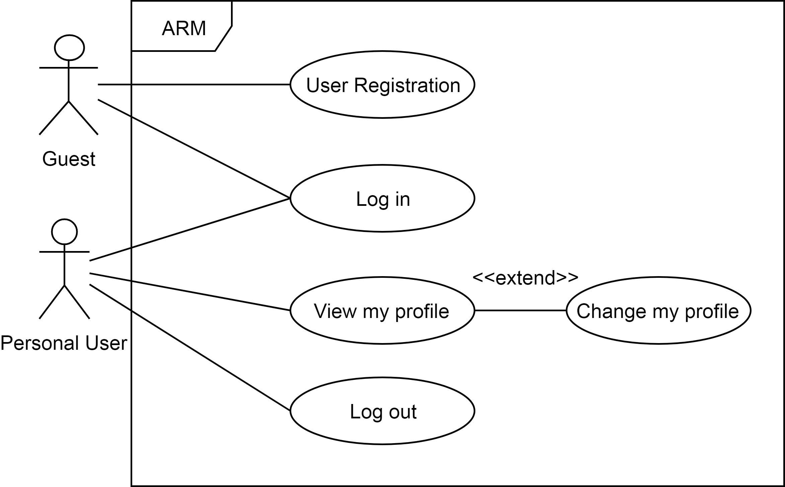

For a new coming guest, Personal Account System allows he/she can either go to log in or register.

For a user, Personal Account System allows he/she to log in and view their profile. And it provided a page for user to change their personal information, such as email address, icon or personal introduction.

#### 3.1.2.2. Sequence Diagram for Guest

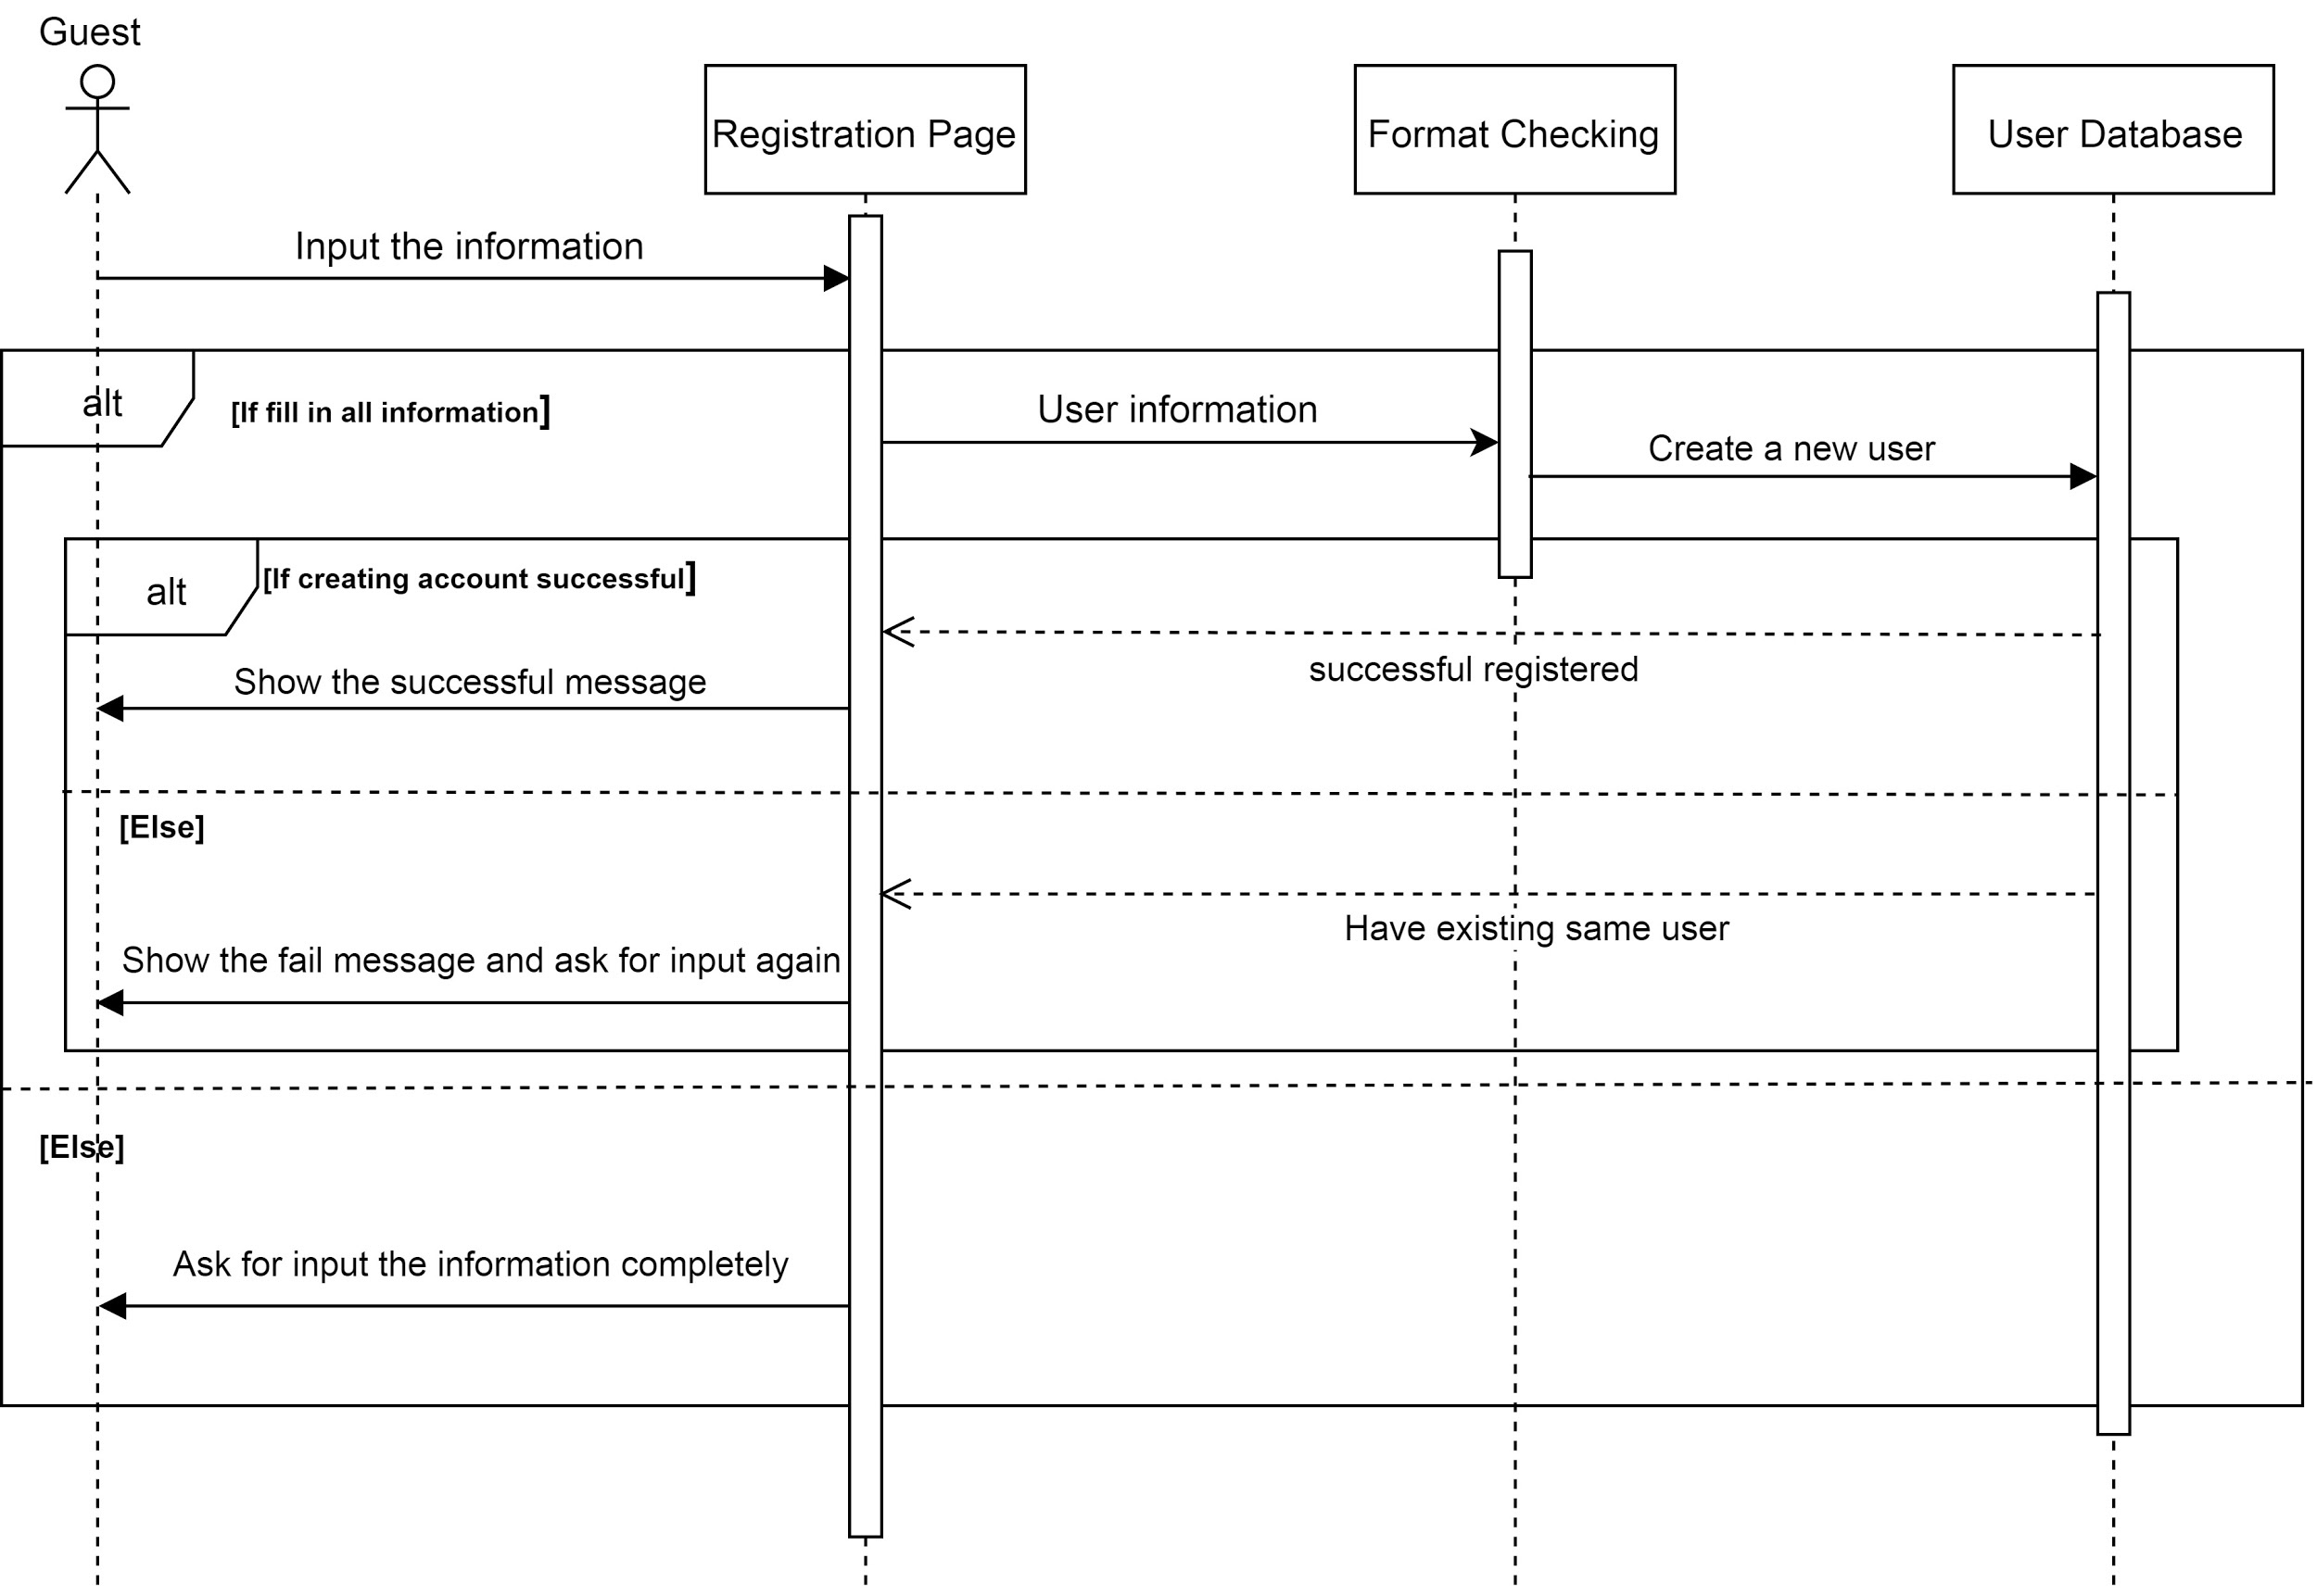

#### 3.1.2.3. Activity Diagram for Guest

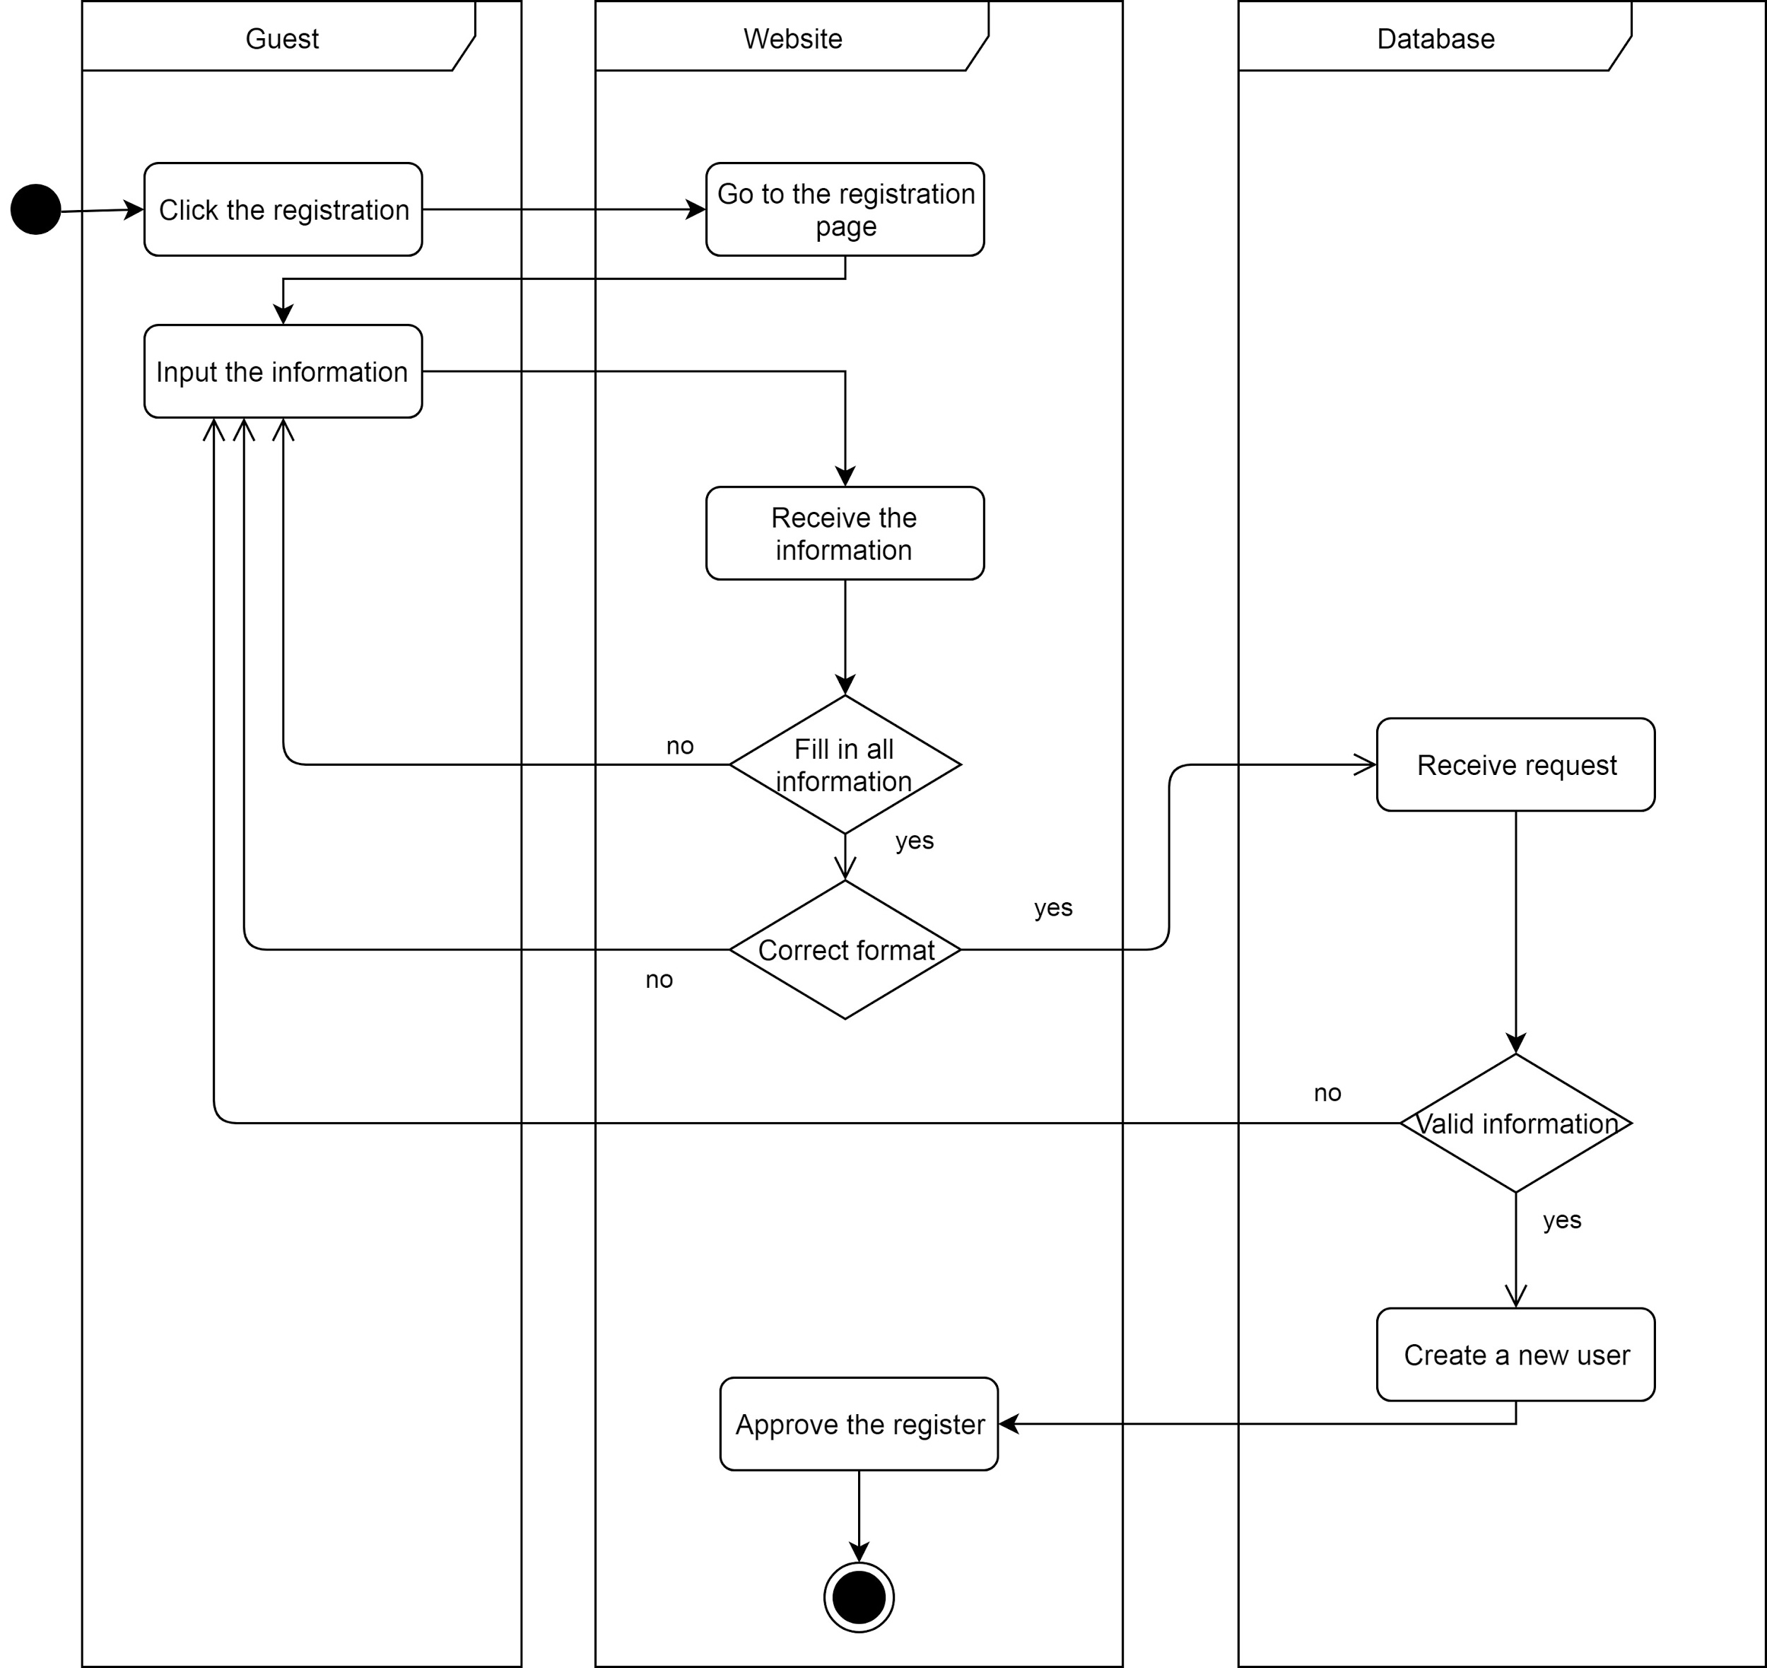

#### 3.1.2.4. Sequence Diagram for User (log in and change personal info)

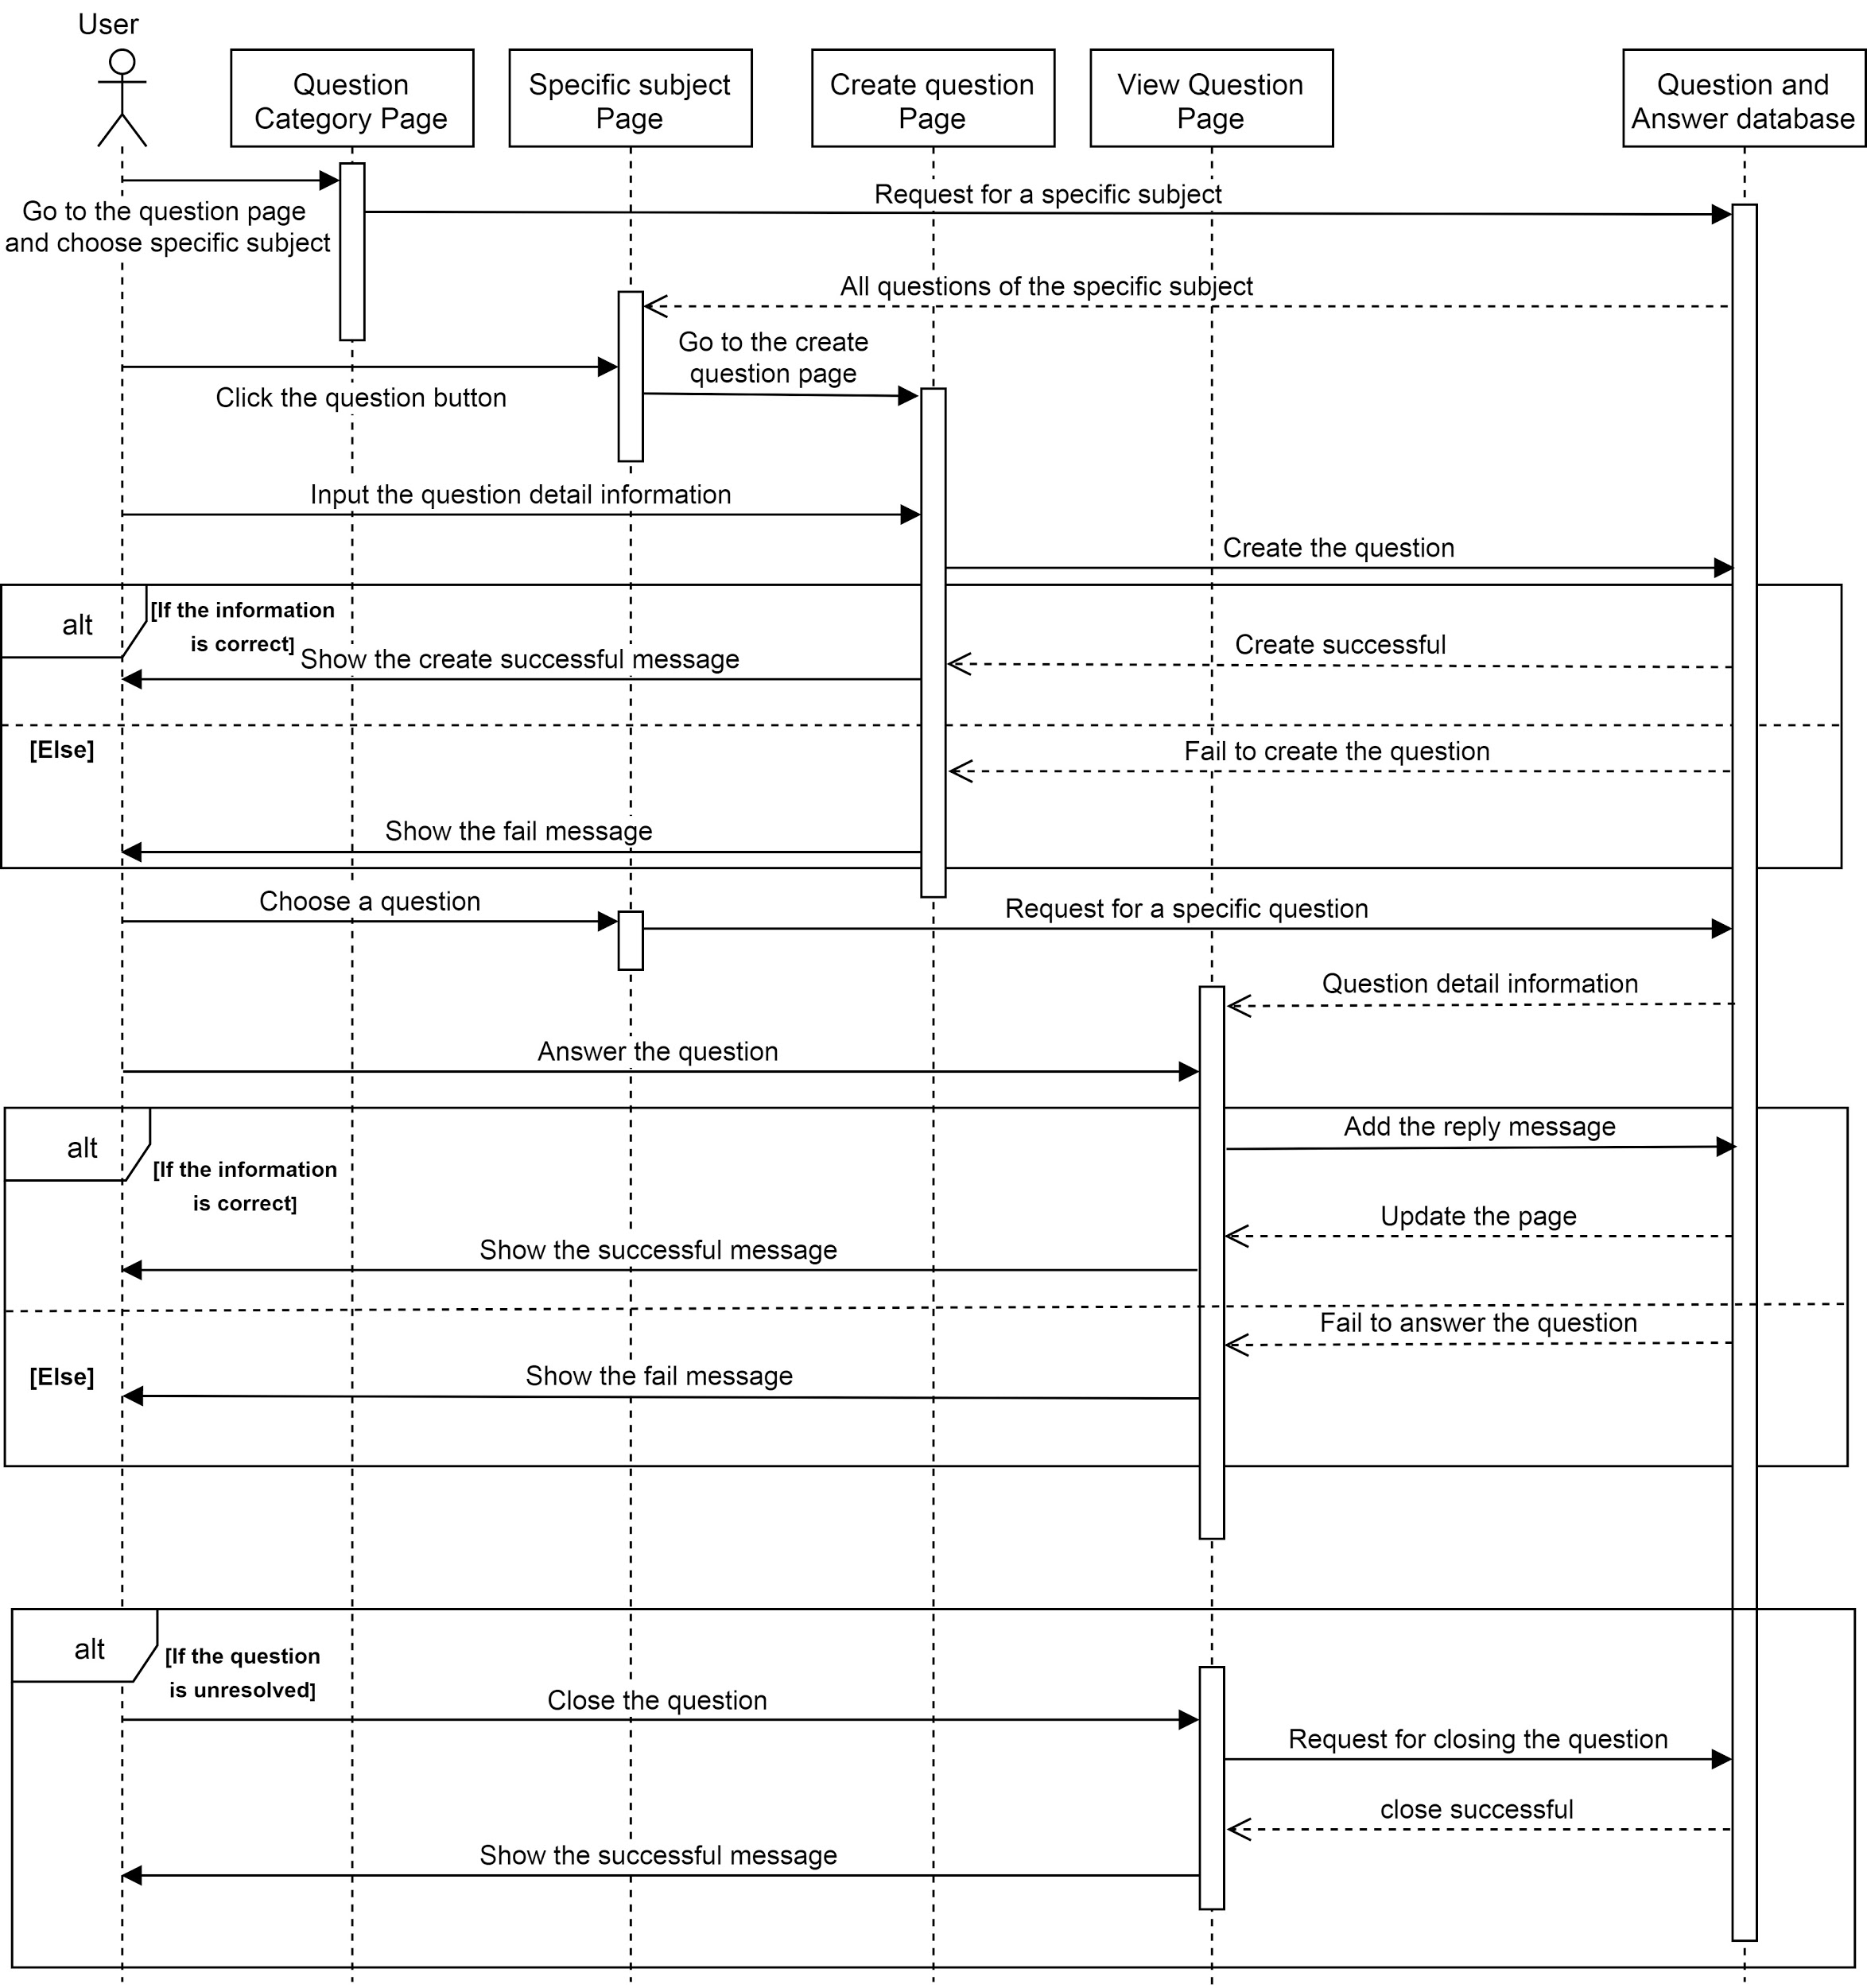

#### 3.1.2.5. Activity Diagram for User (log in and change personal info)

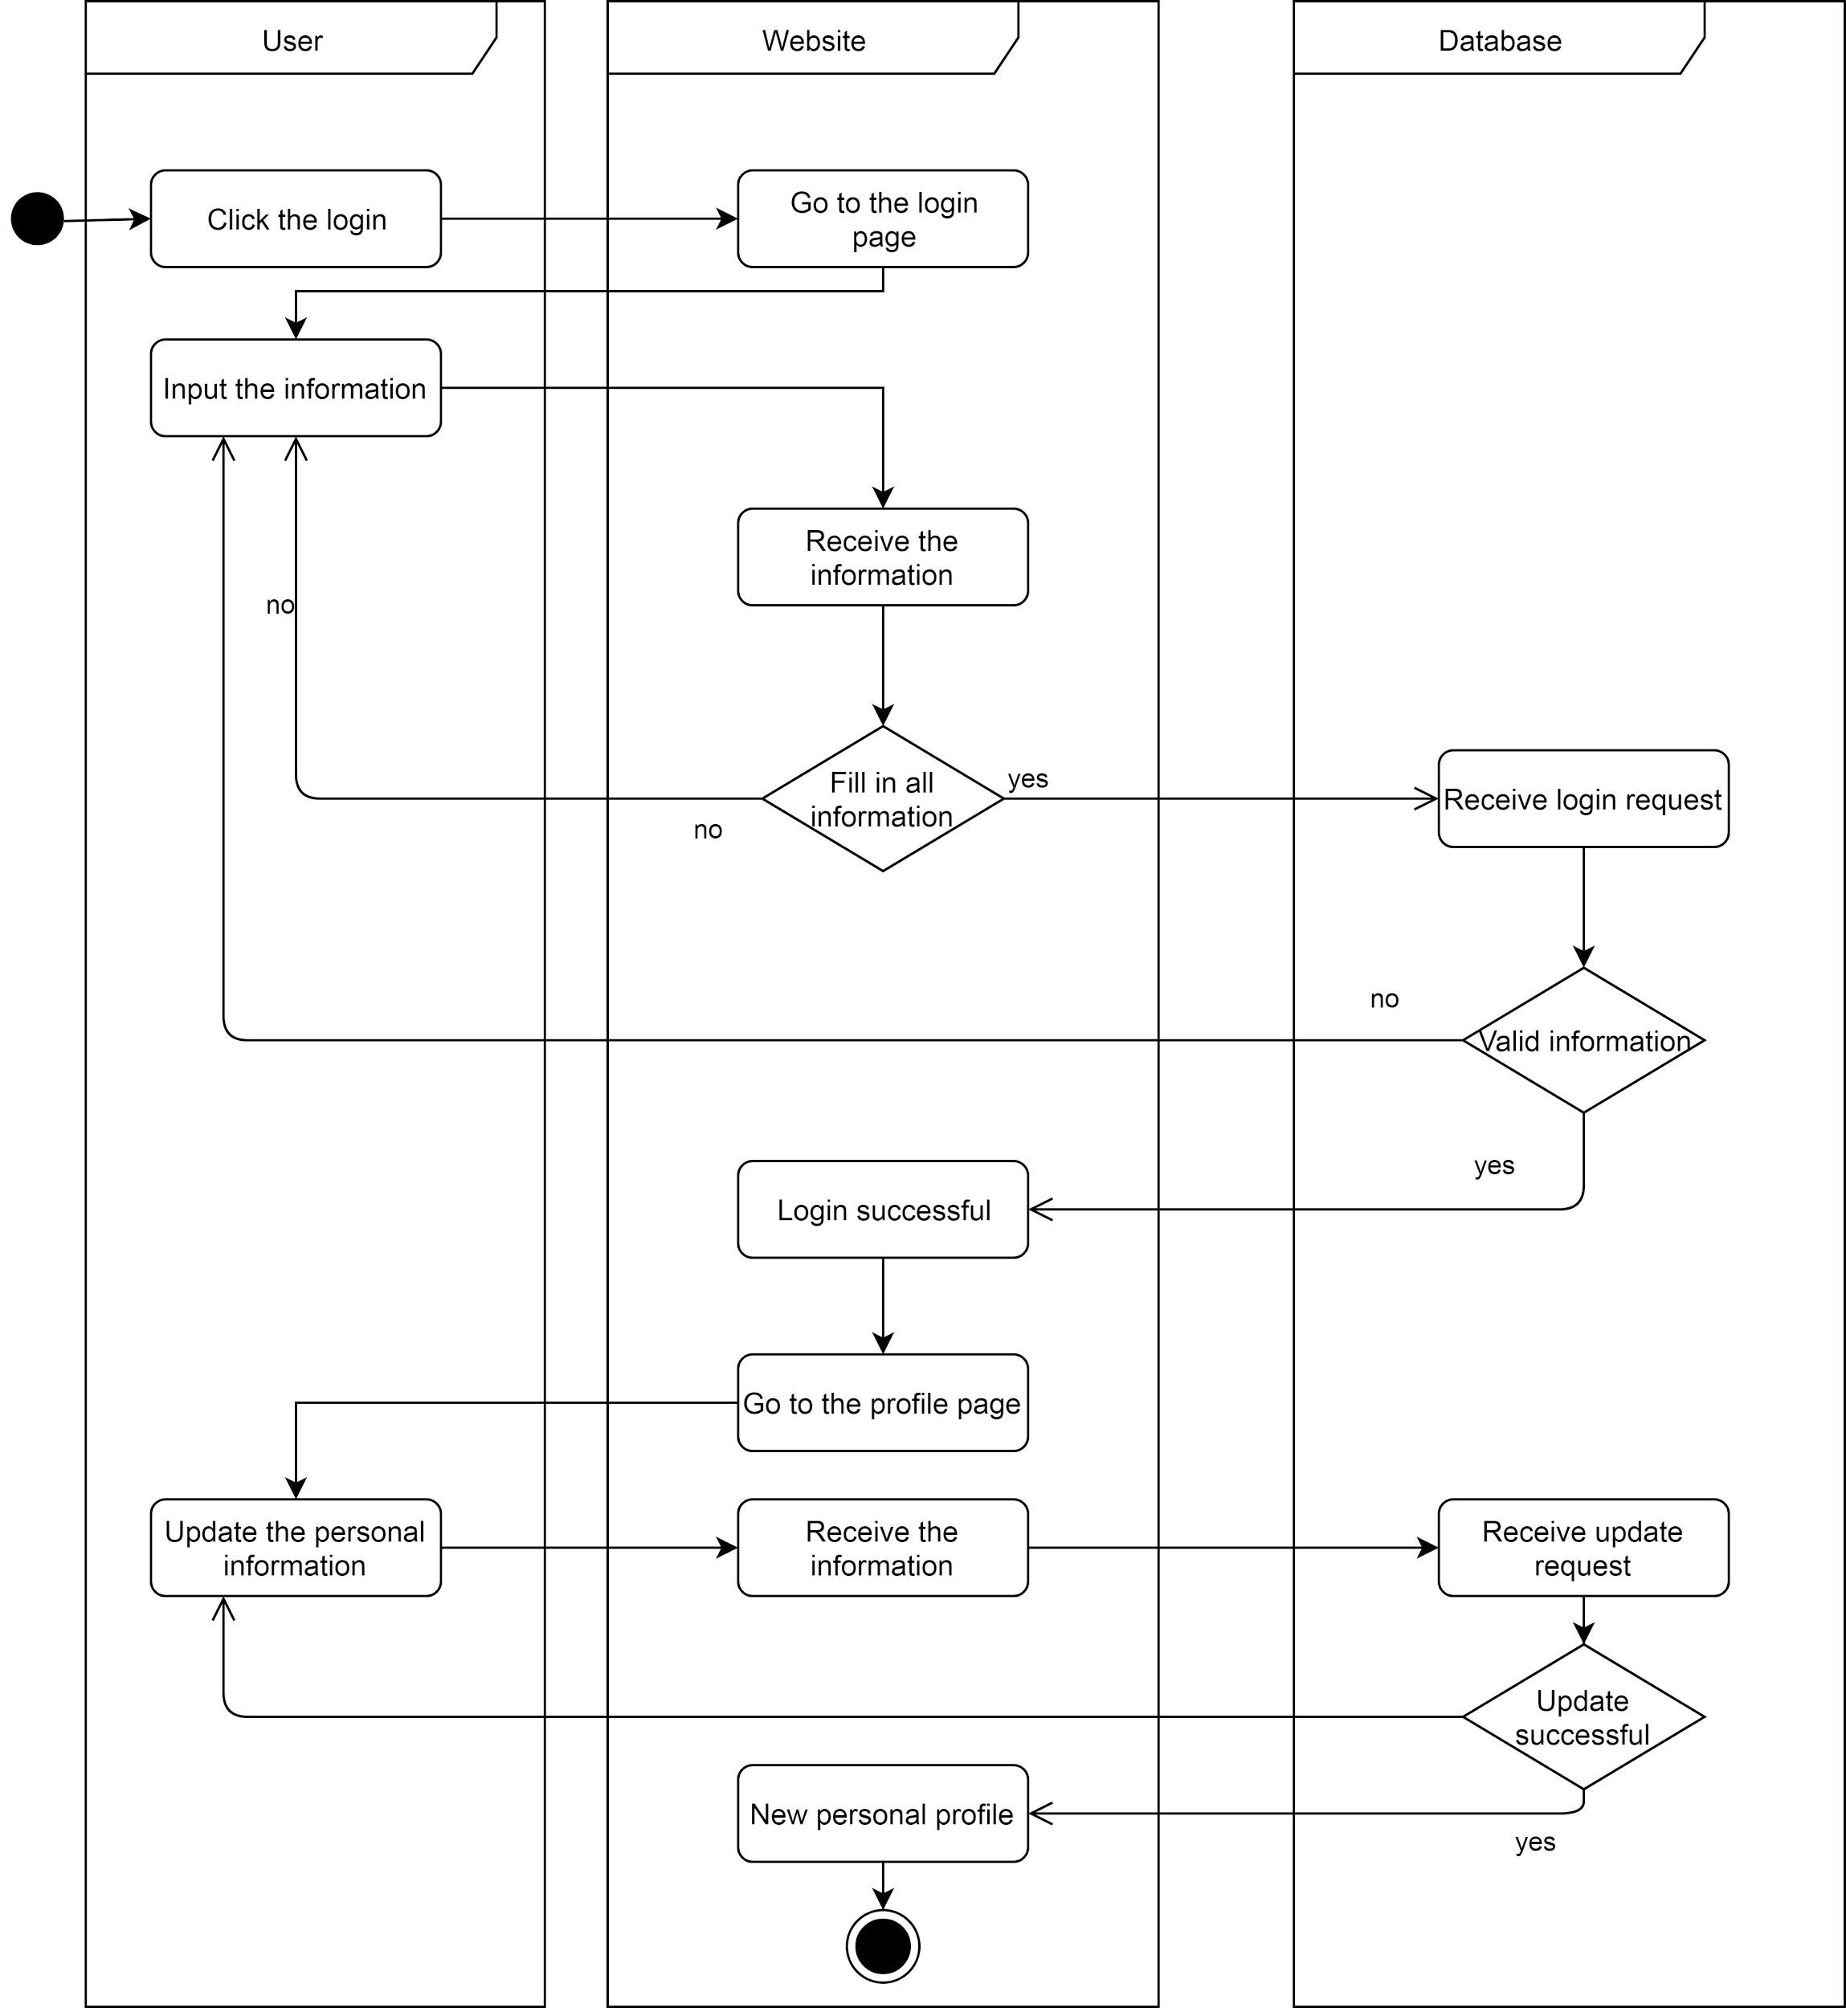

### 3.1.3. Functionality

This component provided user authentication. It prevented guest without authentication to use some functions which need user identity. For example, uploading materials, updating personal information or commenting materials. It also provides an easier way for the system to record all payment history, uploaded history or personal information. And user can retrieve those information.

### 3.1.4. Procedures and Functions

This component provides front-webpages, which are guest registration, user login page, user information page.

The guest registration and user login page provided basic input checking (format, completion, and length) before passing data request to the server side. After passing the input checking, the webpages will send requests to the database, checking the availability, whether the guest input available username and checking the information correctness, whether the user login with correct pair of username and password.

And the user information page allows users to check their personal information when they need. In this page, users can find their profile with icon, username, email address, the number of tokens, and their question asking history. This page will send a request to the server side, getting those information. Moreover, this page allows users to change their profile, and it will do the data checking for user input. Then it will send the request to the server side, changing the personal information.

For the backend application part, there are lots of functions with SQL statement to retrieve data or update data from the database. And it will return the result to the front-end web pages after retrieving or updating data, whether it is successful to get or change data.

In conclusion, this system contains the following functions:

* **Account registration**, which is for the user registers account. This function will check whether the information user input is valid. If all information is in valid format, and keyfield is without duplication, create a new account related to the user information and report successful message, otherwise, request the user to input correct format information.
* **Account Login**, which gets a pack of user input which is ID and password, and checks the correctness from the account database. Log in to the server with user identity if the input is valid, otherwise request the user to input again.
* **Change personal information**, which is for user updates personal information, like email address.
* **Logout**, which stops the access permission with a logged in account.

## 

## 3.2. Component-2: Academic Resource System

This is the system provides user to upload new academic paper into the resource database and download an existing file from the server.

### 3.2.1. Structural Diagram

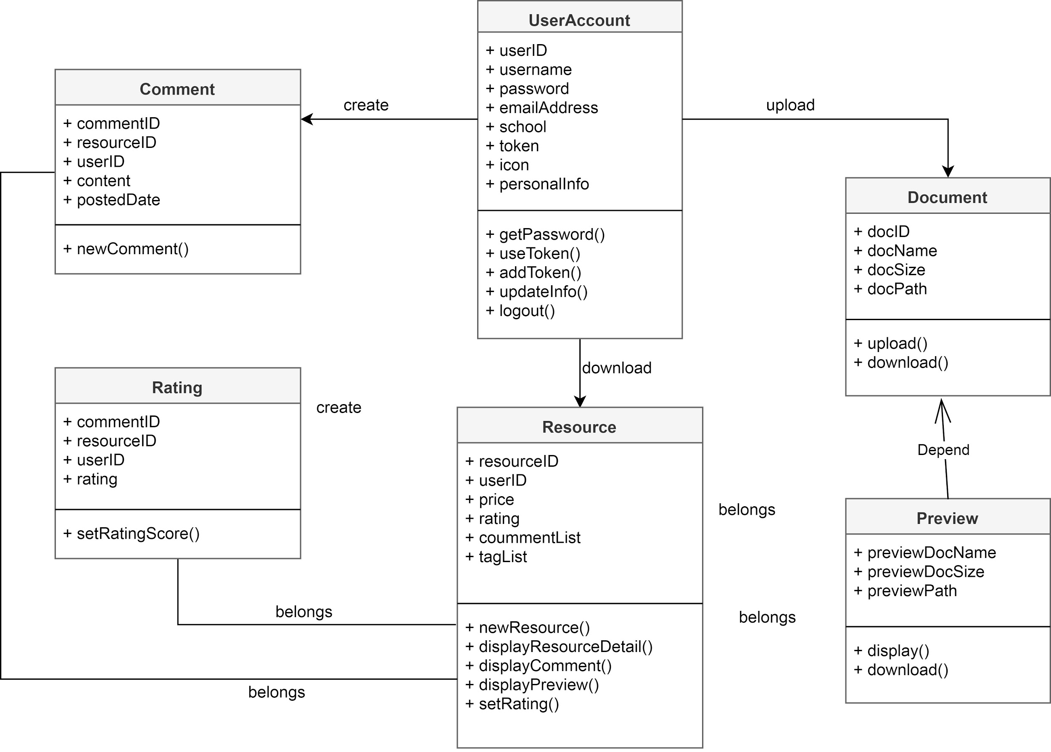

### 3.2.2. UMLs

#### 3.2.2.1. Use Case Diagram

#### 

In this system, functions are limited to a guest, but guests can preview the file, download preview file or search file with tags.

And every user can upload resources, search other resources by related tags, or download different resources. Before downloading, there will be a preview of the file. Users might need to pay for some of the files by token, which they can earn by uploading files. Also, users can leave a comment or give a rating for each file.

#### 3.2.2.2. Sequence Diagram for Uploading Resources

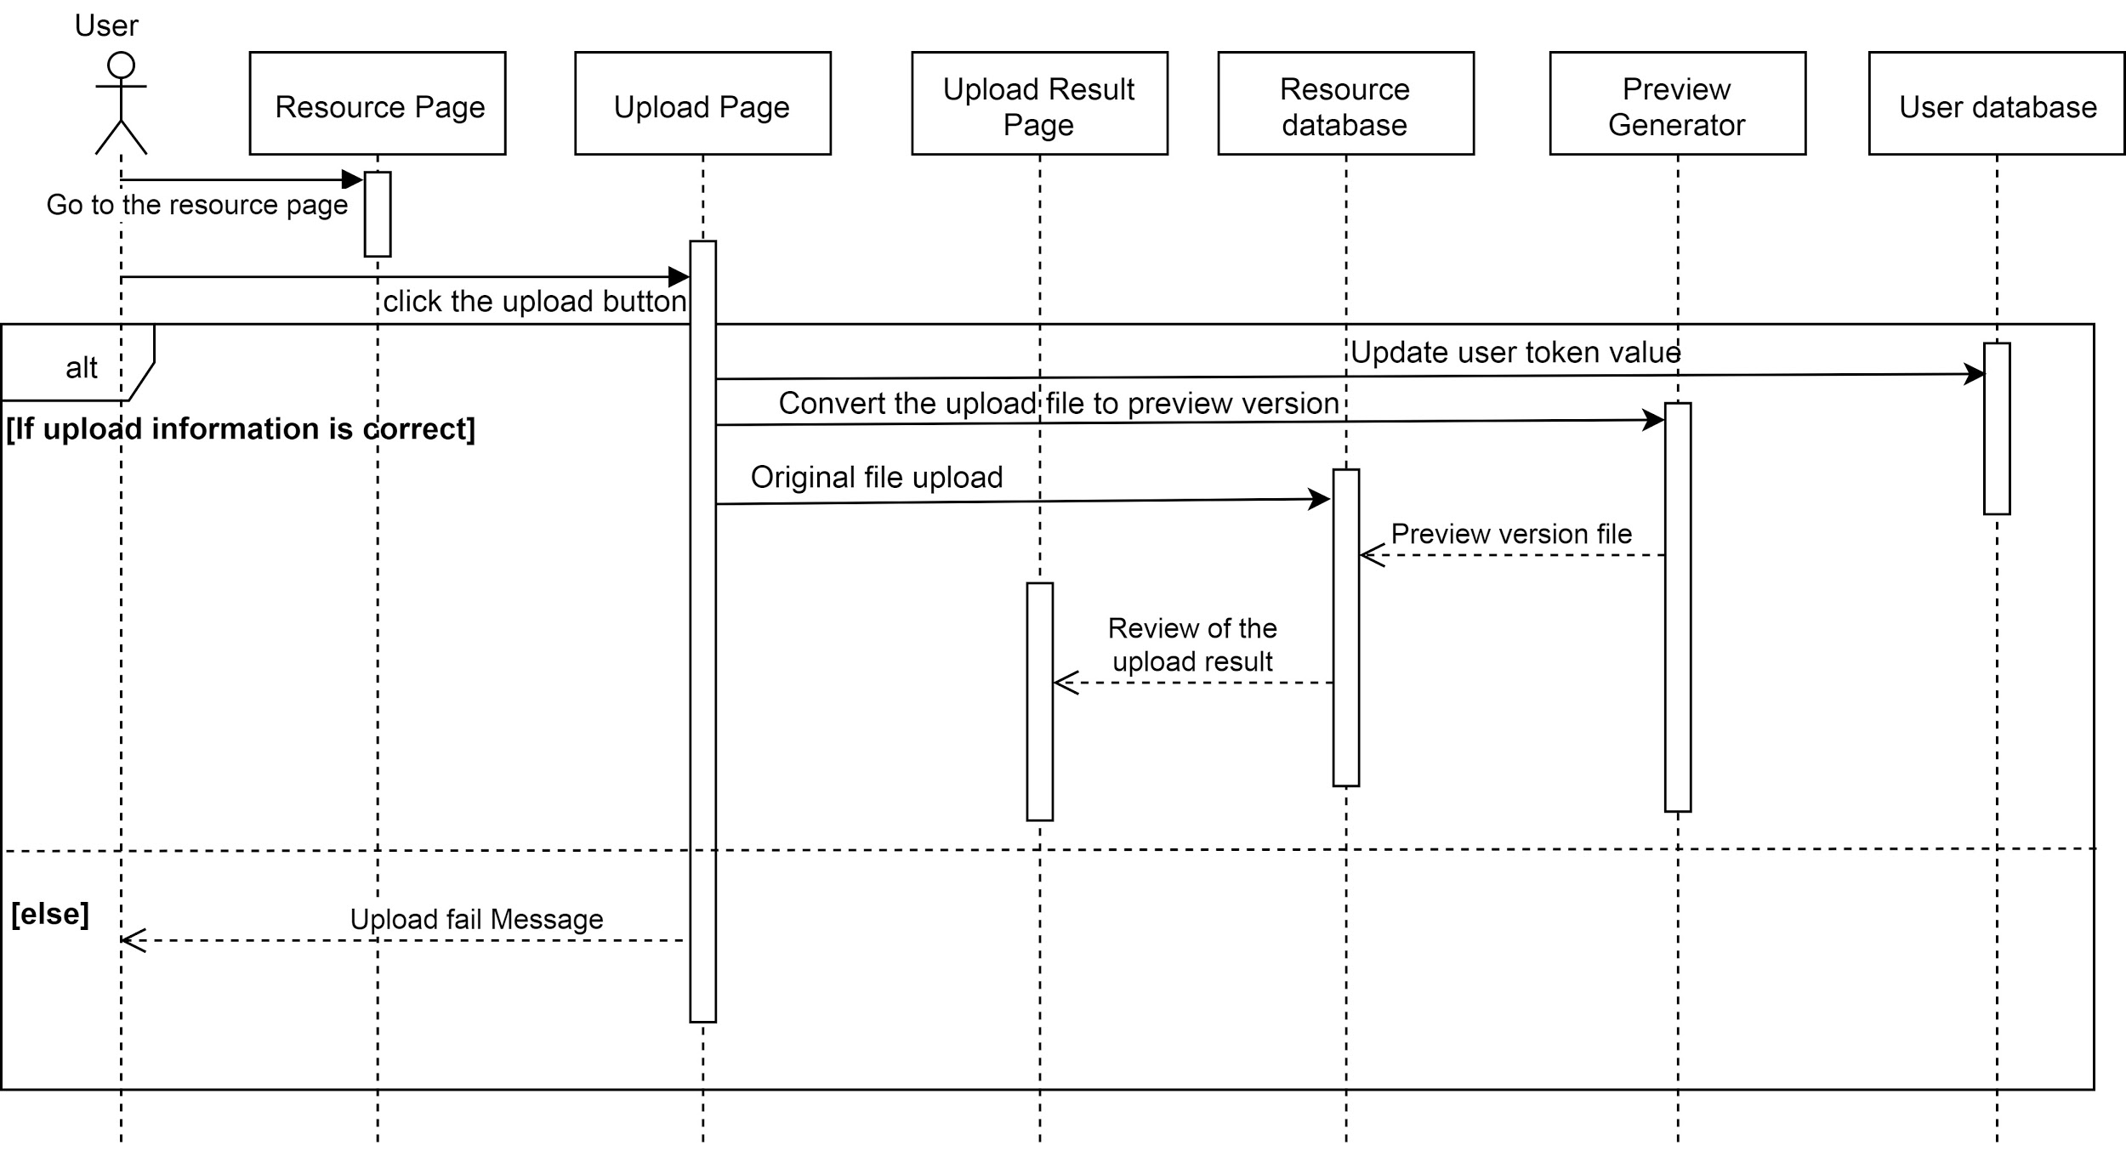

#### 3.2.2.3. Sequence Diagram for Searching and Download Resources

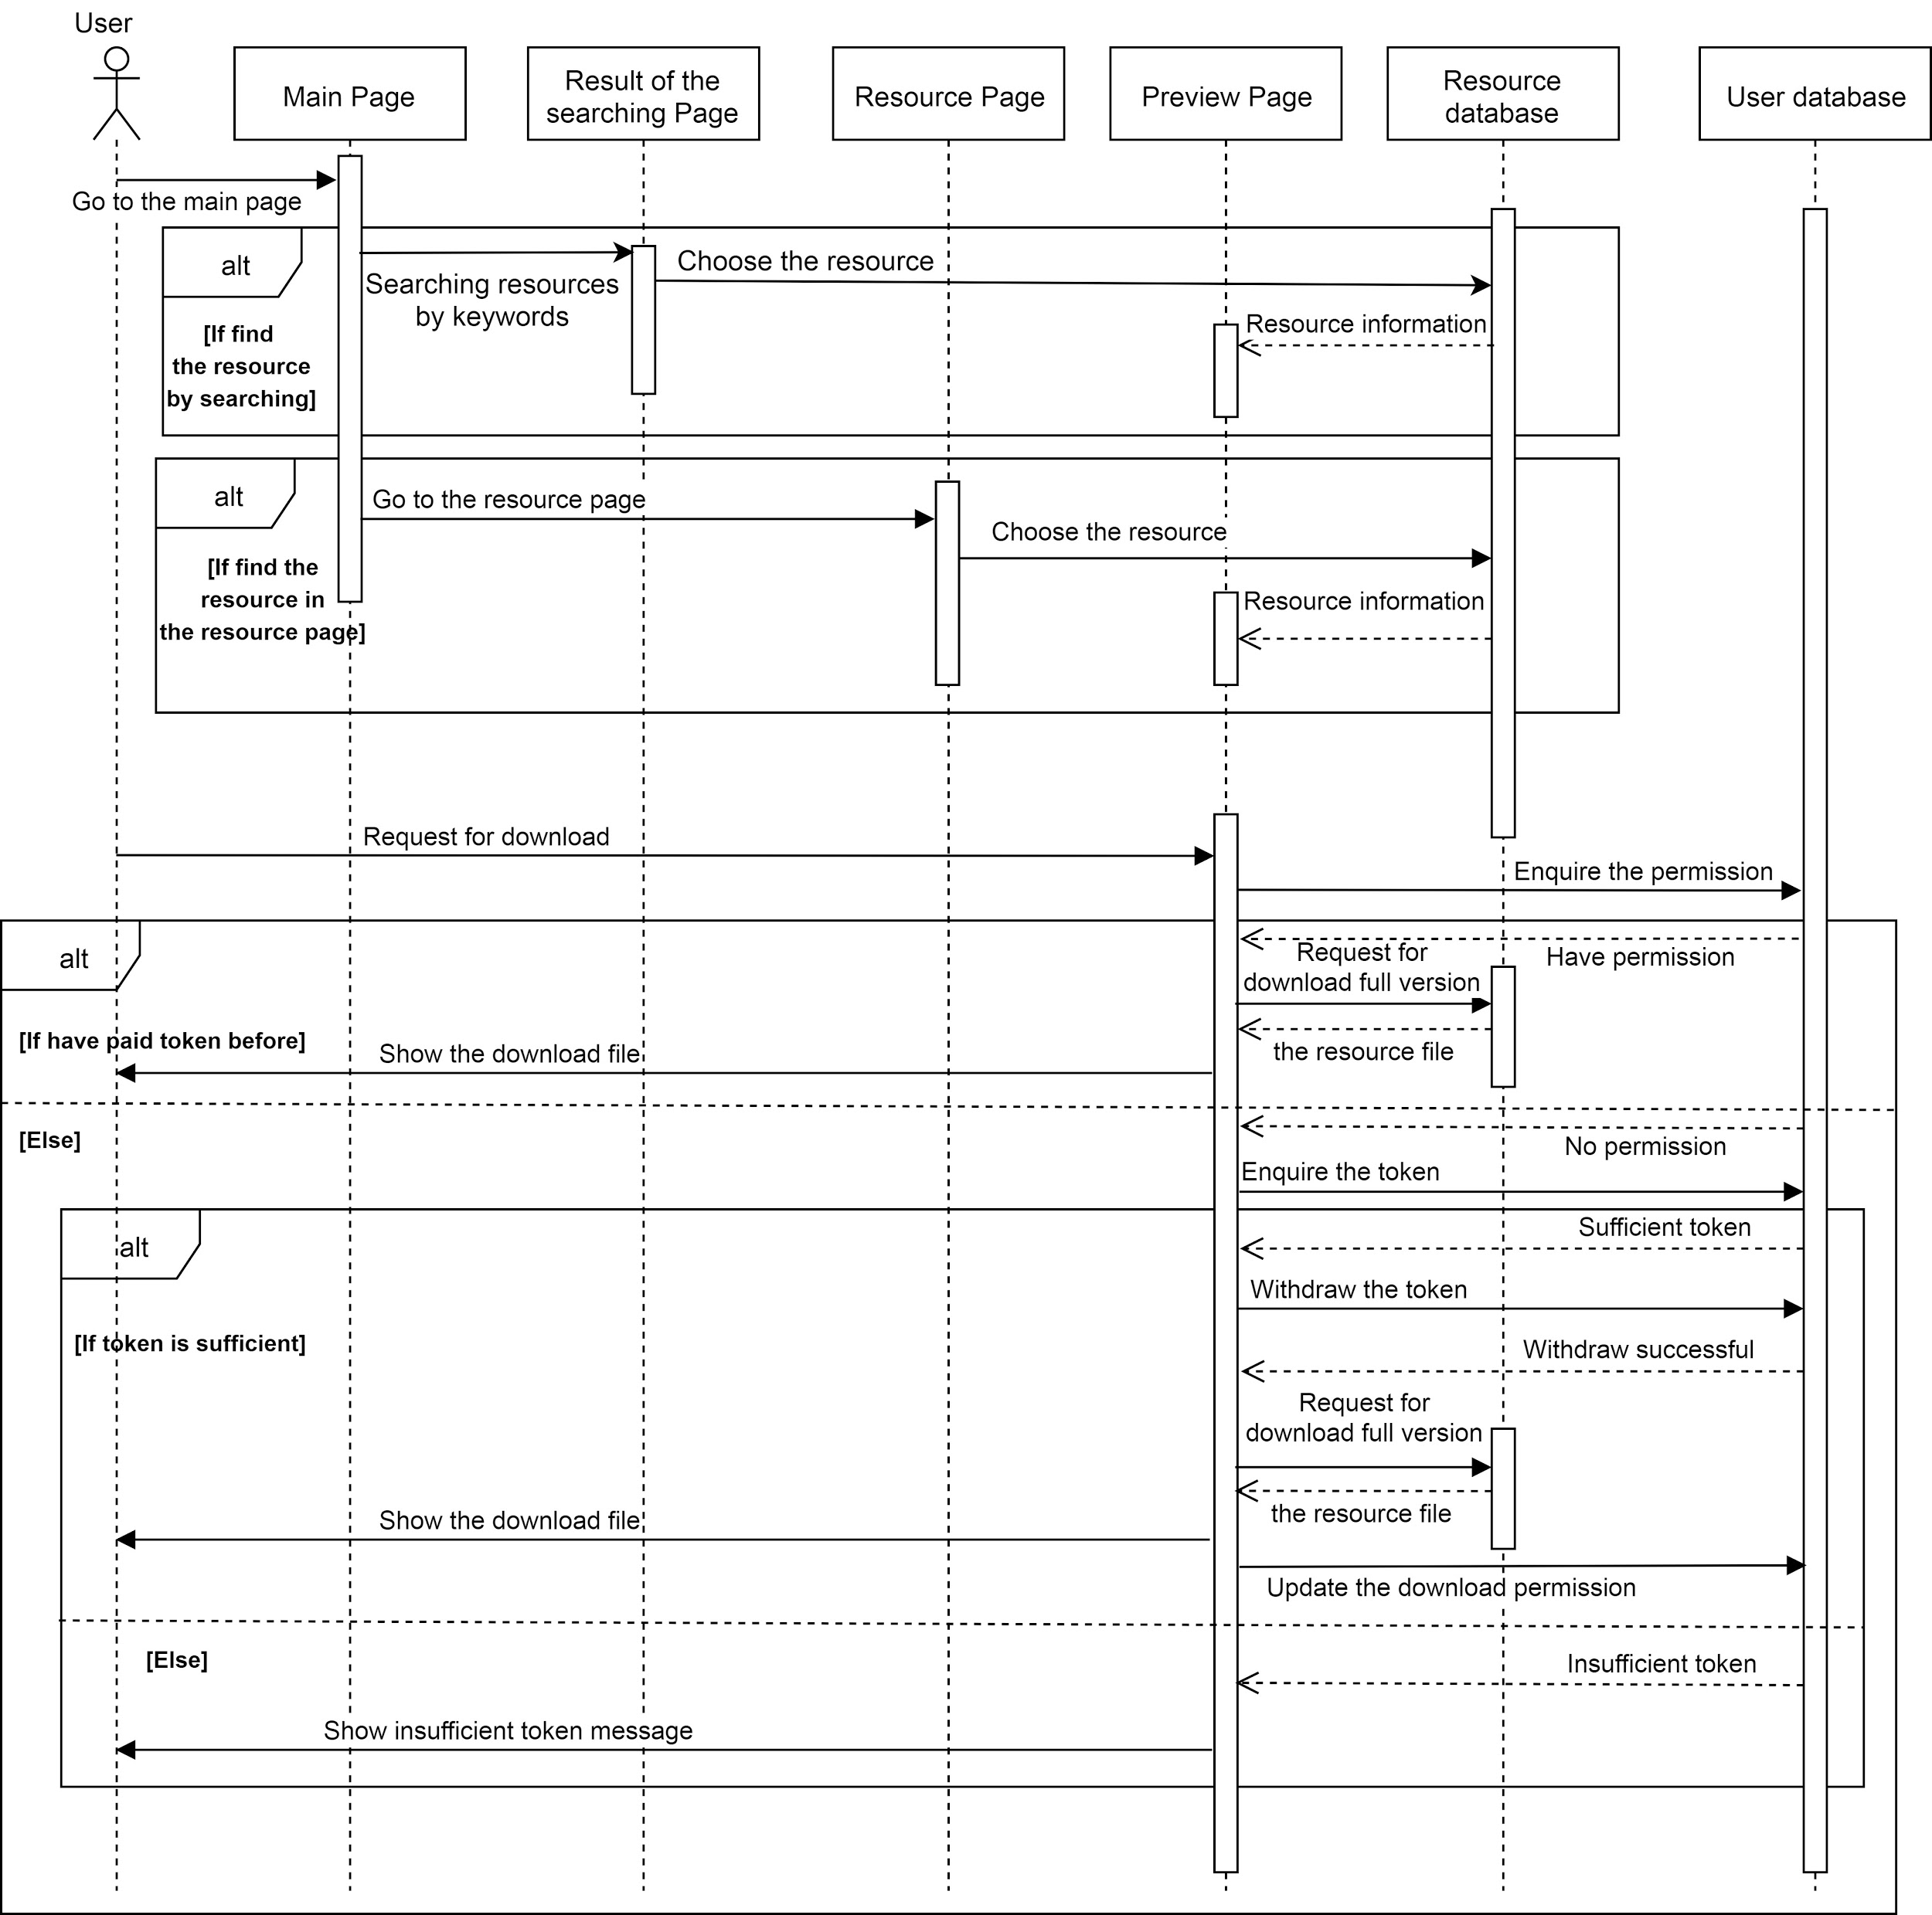

### 

### 3.2.3. Functionality

The resource system is our main provided system, which allows users to upload, download and search resource.

When a user uploads a resource, the user is required to write the resource name, type, token needed and the related tags. There will generate a preview version of the resource, which contains limited pages of the original resource with “This is a preview version.” watermark. And the uploader will get 5 tokens for uploading reward. Another user needs to make a payment with enough token if they want to download the original resource with full pages and no watermark.

For each resource, there is a comment section, which allows users to leave a comment under the resource. Also, It allows users to give a rating for the resource. Moreover, it provides a search engine for searching for resources with different tags and material types. And the searching result will be shown to the user. Different material types will be shown in a different color. It makes users easy to identify the type of resource.

### 3.2.4. Procedures and Functions

From the perspective of evaluating the front end procedures, We provide a preview version of the pdf file with the user to help them evaluate the file whether the material is worth it to download.

When downloading the file, the user can download the preview version and also the full version. If users download the full version of the material and it is priced, we have to check whether the user have enough token to buy the resource.

For commenting and rating, after users rate and comment on the material, the rating and other comments are visible to every user.

When uploading the file, the user needs to fill all the information of the source to insert a new file into the database.

With the back end procedure, every function needs to access the content of related databases. For example, after downloading the priced file, the system will insert a new record into the database. Therefore all function require a SQL statement to access the record to perform the tasks.

Behind the webpage, when users upload the file, it will automatically generate a preview version. There is a treatment of previewing the files such as watermarking and page cropping.

In conclusion, this system contains the following functions:

* **Upload File**, which receives the file input from the user and checks if the type of the file in a proper format. Reject all the improper file and display an error message to the user. For proper format, request the user to categorize the file and upload it with the marking of the user ID and other information into the database.
* **Search File by tags**, which is a search function receive file tags input and search all matching file.
* **Preview File**, which displays a part of the file for the user for a preview on the web page before they pay and download the full version of the file.
* **Download File**, which extracts the selected file from the server and downloads to the machine of the user.
* **Comment**, which provides user input comment on the file. The comment would be saved and categorized to the file.
* **Rating**, which provides user gives a rating to the file.

## 3.3. Component-3: Question Discussion Forum

This is a forum like a system for the user to discuss an academic topic, homework, and any and questions. The user could ask a new question, reply to the existing question and grade an answer.

### 3.3.1. Structural Diagram

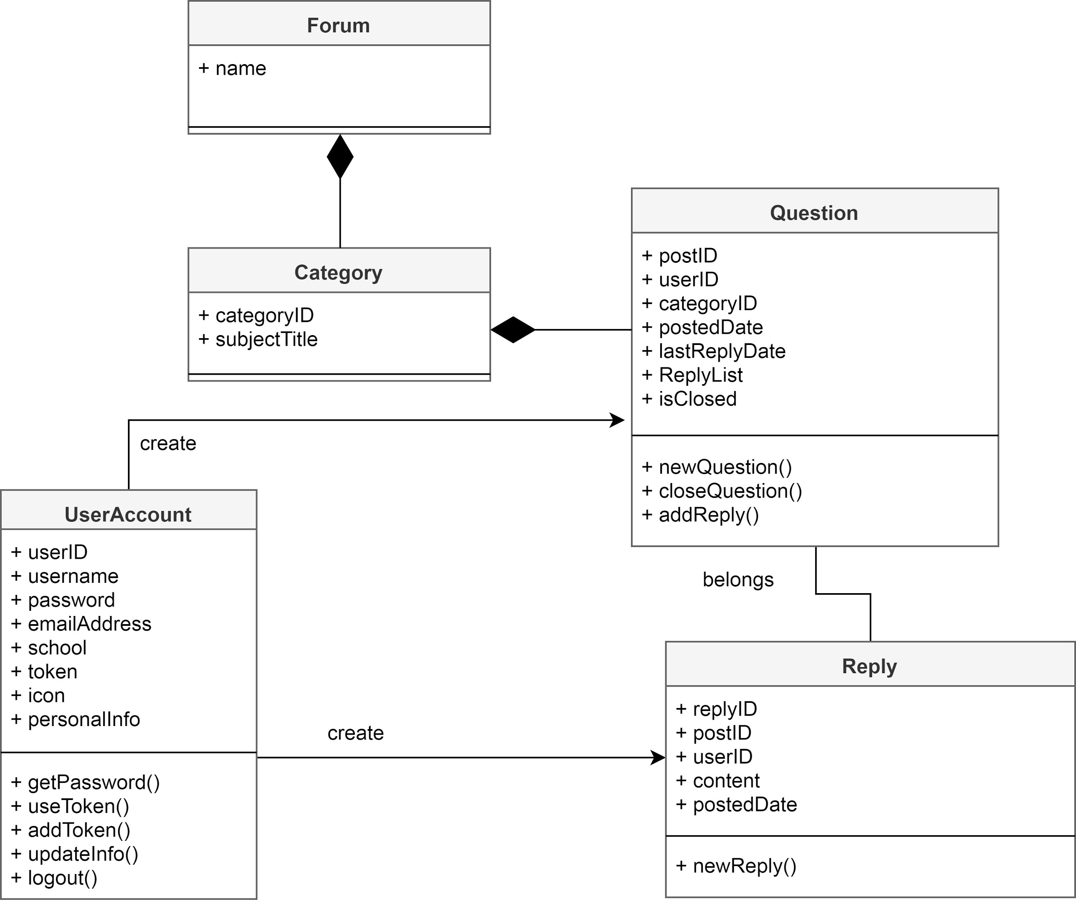

### 3.3.2. UMLs

#### 3.3.2.1. Use Case Diagram

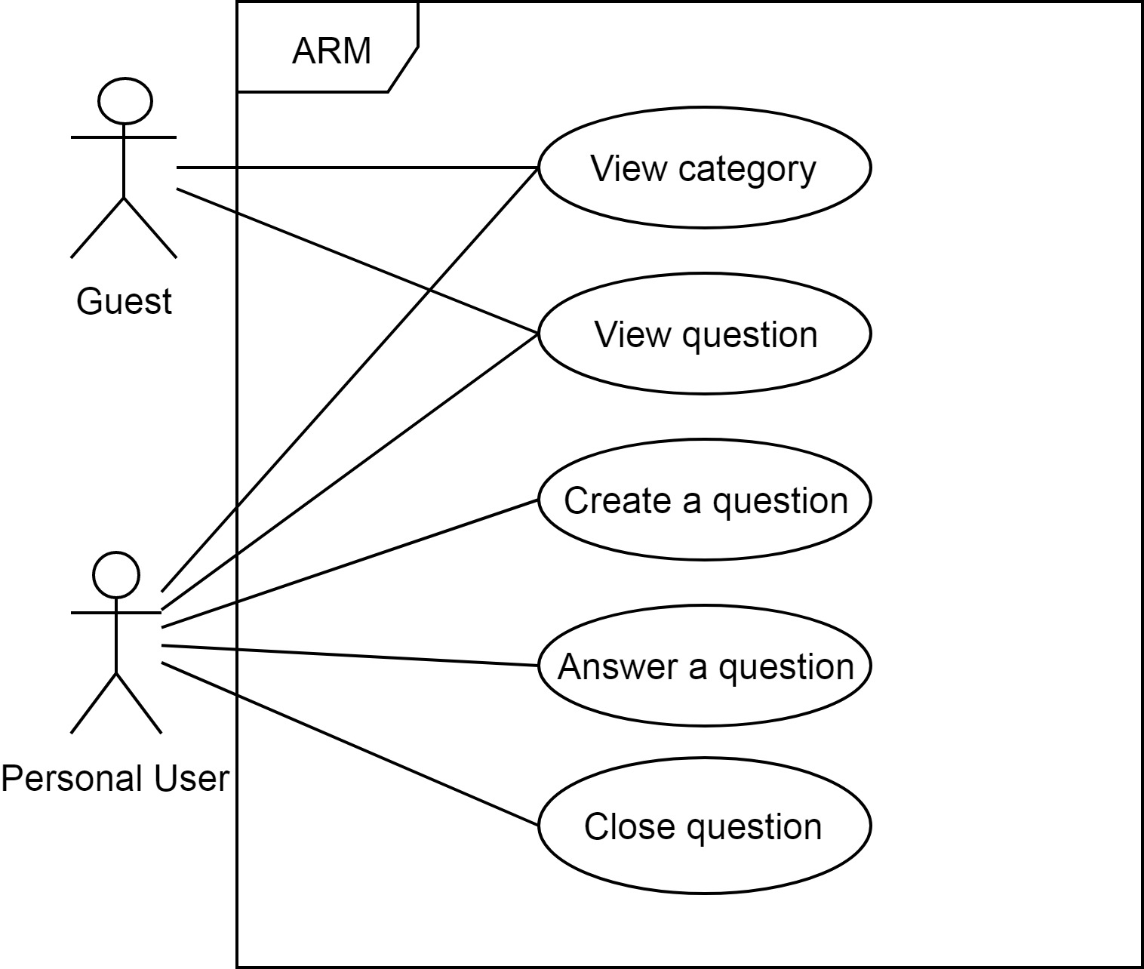

In this system, functions are limited to a guest, but guests can view a category or view a question. A user can view too, and a user is allowed to create a question or answer a question or close the question if the user is the question creator.

#### 3.3.2.2. Sequence Diagram for Creating a Question and an answer



### 3.3.3. Functionality

The forum component provides a platform for the user to asking questions or answering questions from other users. It contains view category, view question, creates a question, answers a question, and close question those functions. Everyone (guest and user) can view category, view question. And a user can create a question in the related subject category, and wait for other users answering. Only users are allowed to ask a question or answer a question. If the question creator is satisfied with the answer from other users, he/she can decide to close the topic, which means the question will be closed and everyone can’t answer or comment it.

Also, there are some marking for each question. For example, whether it is solved, or whether it is a hot question with a very high view number.

### 3.3.4. Procedures and Functions

For the front-end part, the system provided view forum, view category, view question and create a question these 4 pages. And the system will display limited functions to guests during an entry.

In view forum, category and question, guests and users are allowed to click inside, viewing the content. When they enter these pages, the server will receive the searching request, and return the required result.

Moreover, a user is allowed to create a question with the create question page. The user is required to fill in the title and contents in the page. Then the whole data set will be sent to the database, and the server will return the success or failure messages. In a question page, a user is allowed to leave an answer of it, and the answer will also be saved into the database. The question creator is allowed to close the question, while other users can’t. When a question is closed, the database will mark it.

In conclusion, this system contains the following functions:

* **Create Question**, which is for creating a new question object and save user question related to the chosen categories into the question-answer database.
* **Search By Question Categories**, which is a search function receive question categories selection input and return all matching question.
* **Create Answer**, which is for creating a new reply due to a specific question and save into the question-answer database.
* **Close Question**, which allows user to close the question, which means it will not be able to answer later.

## 

## 3.4. Component-4: Mailbox

Mail System is a private message system allows the user to exchange messages and retrieve system messages.

### 3.4.1. Structural Diagram

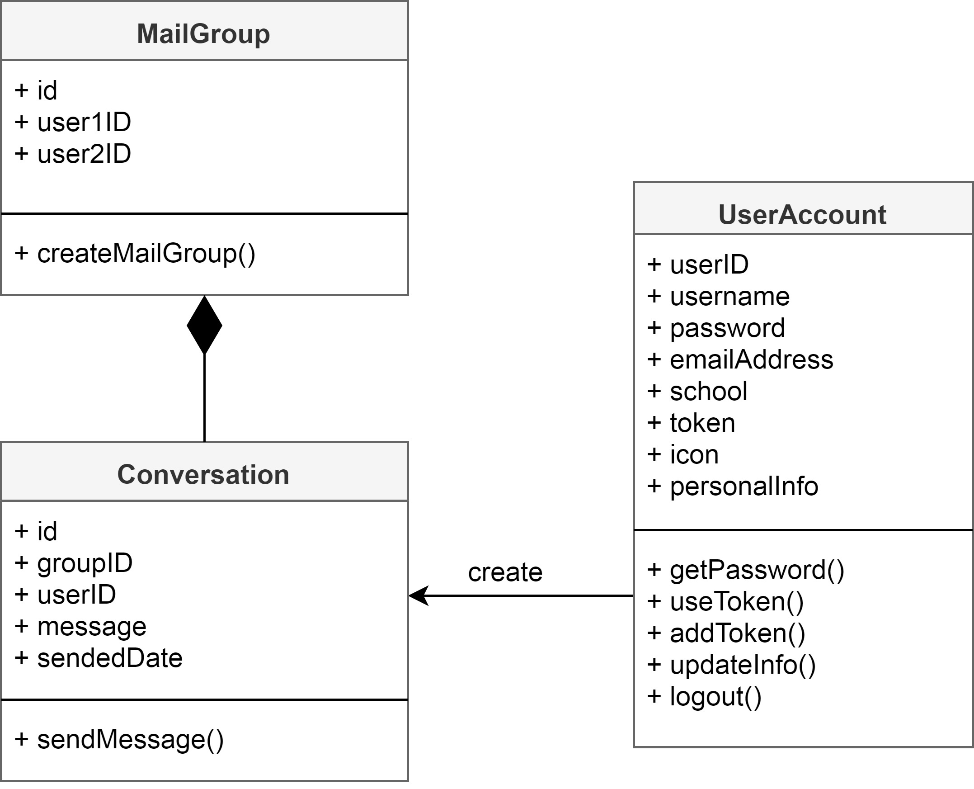

### 3.4.2. UMLs

#### 3.4.2.1. Use Case Diagram

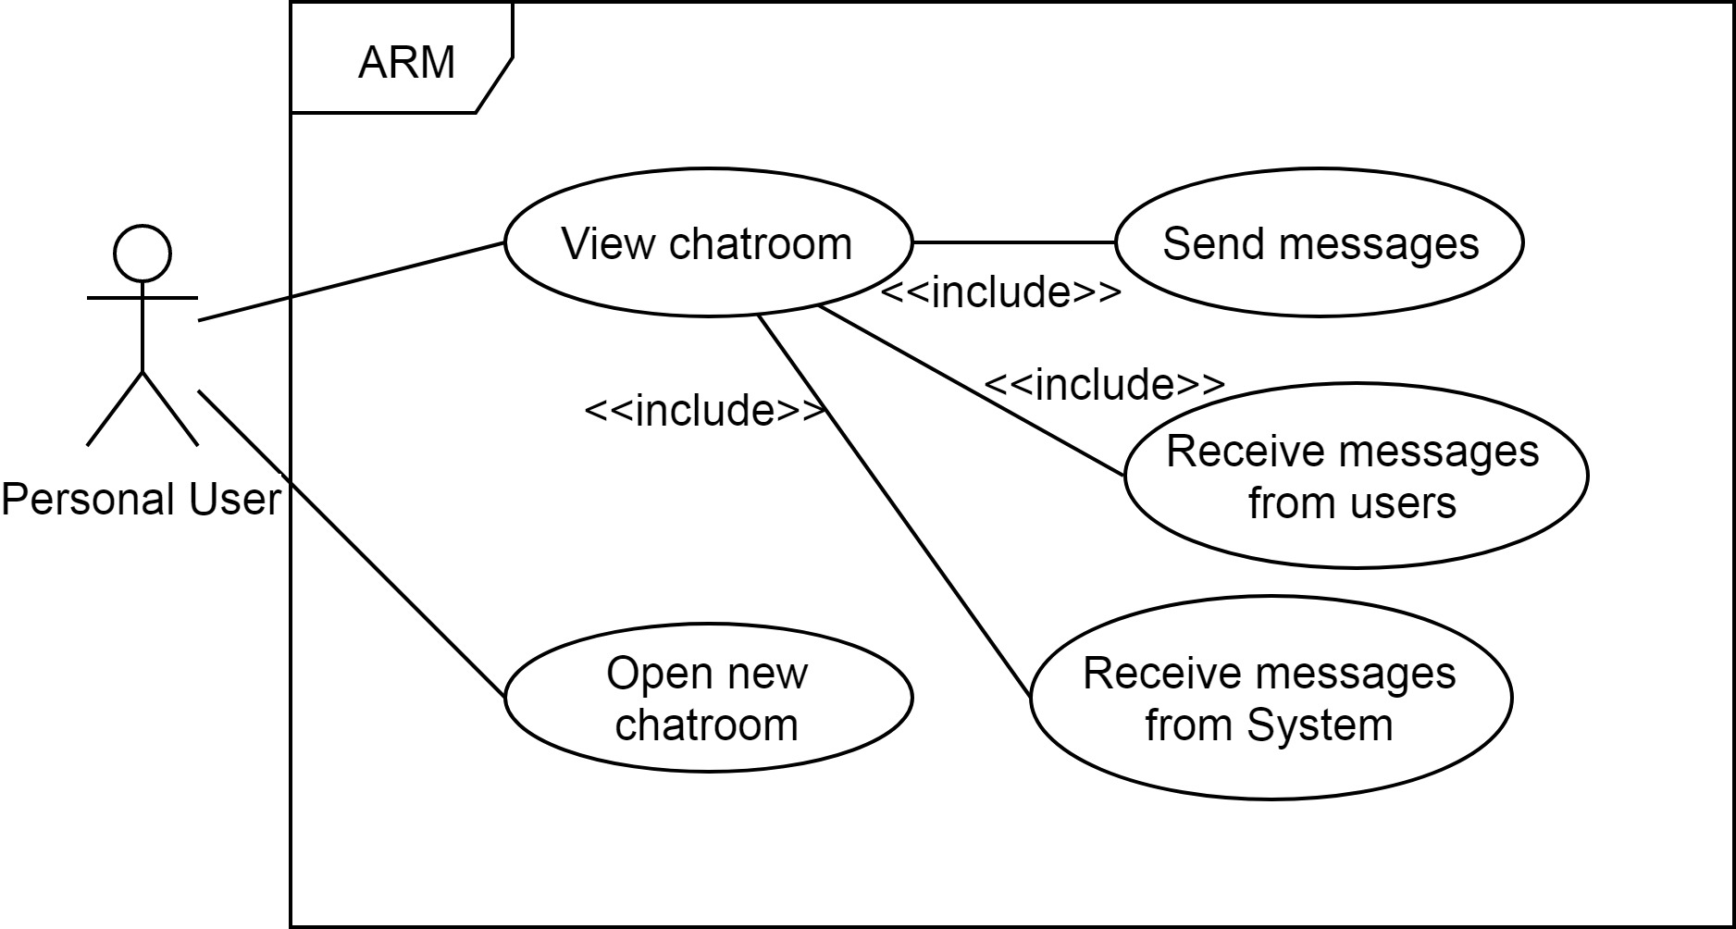

Mailbox is only for users. Users can view their chatroom, which allows them to send messages, receive messages from users, or receive system messages. And they are allowed to open a new chatroom by entering a user’s username.

#### 3.4.2.2. Sequence Diagram for Sending message

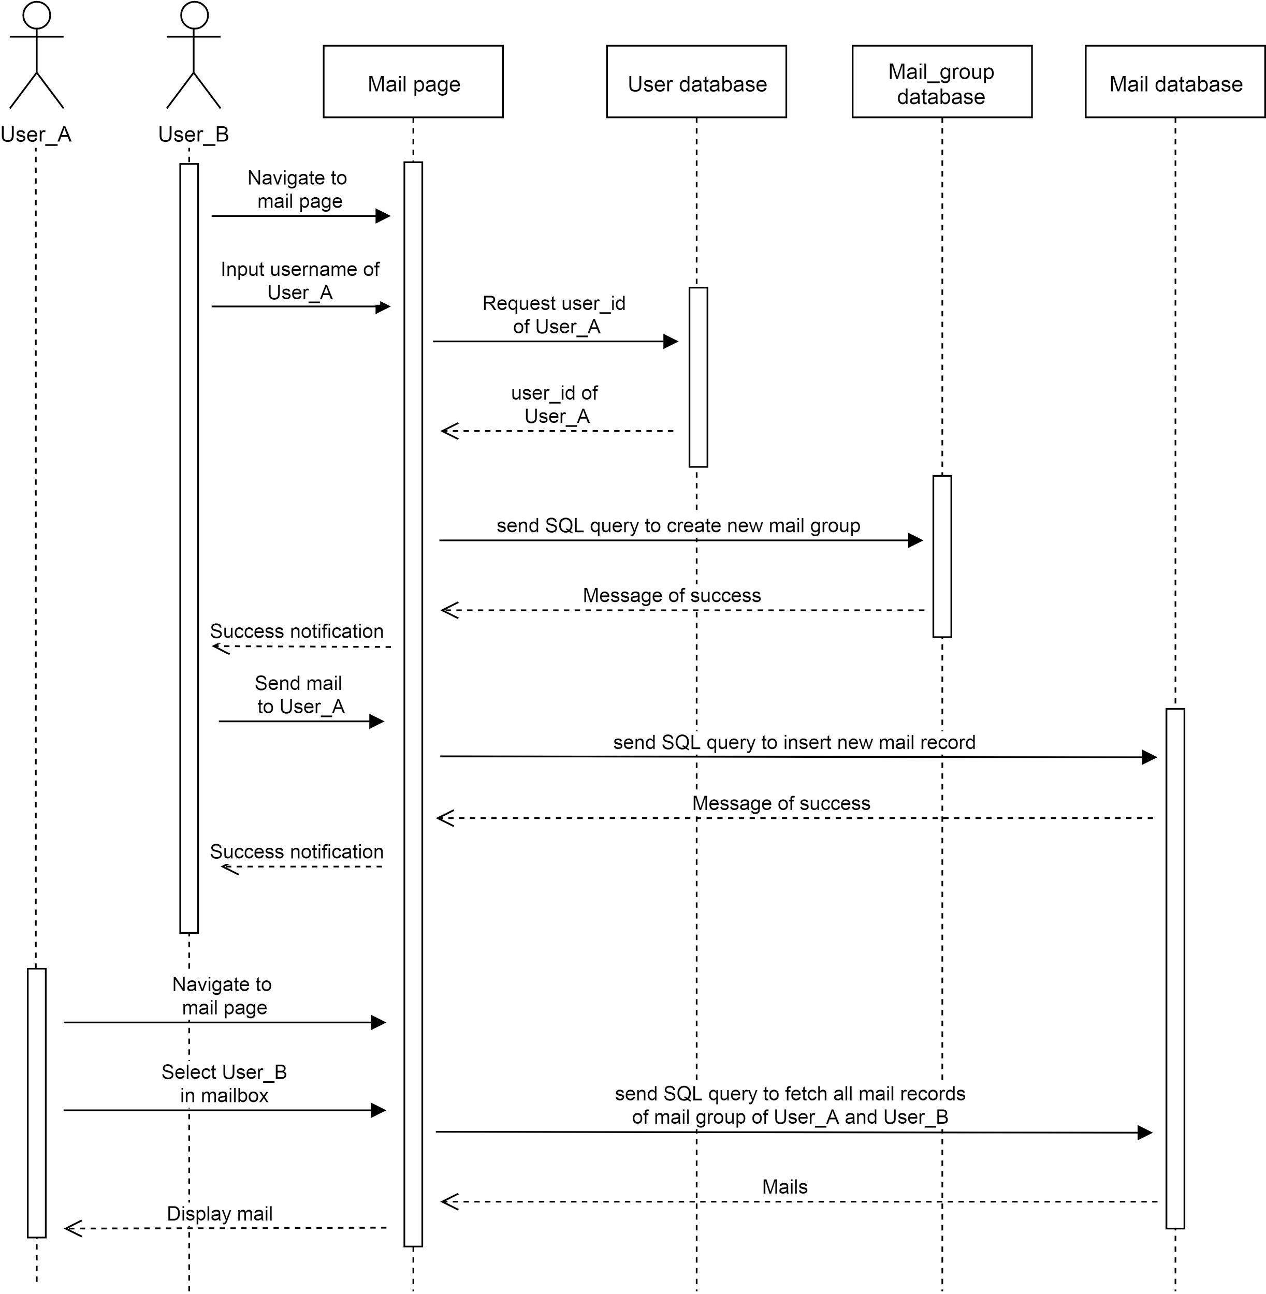

#### 3.4.2.3. Sequence Diagram for System message

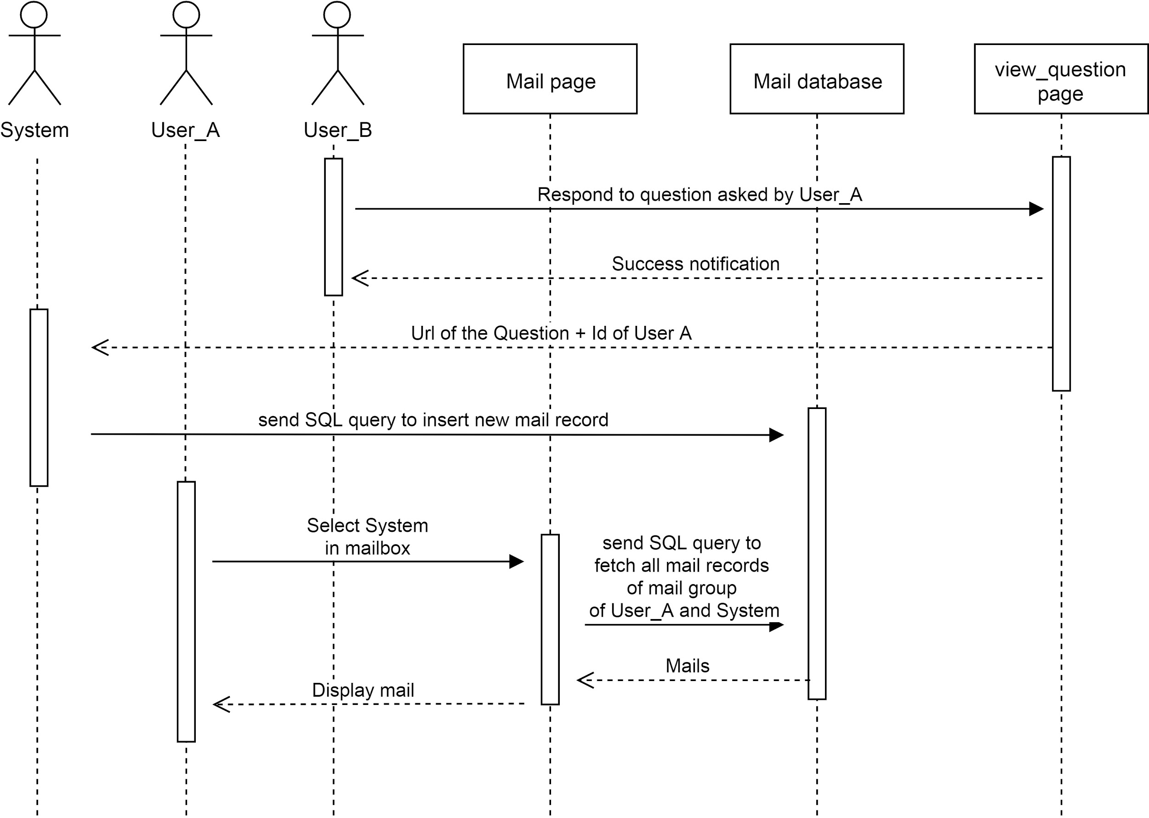

### 3.4.3. Functionality

The mailbox allows a user to send a private message to other users. Also, users can retrieve system messages through the mailbox. When someone answers a question, the question creator will retrieve a system message, which is “Someone has replied your question. Click here to check.” with a link of the question. A user is allowed to check all messages in the same place conveniently.

### 3.4.4. Procedures and Functions

Users can check their mailbox in the mailbox page. If they want to send a private message to another user, they need to add the user into their mailbox first. The system will check whether the user existed after a user is added into a mailbox. If a user sends a private message to another user, the data will be sent to the database and recorded.

In the mailbox page, users are allowed to select the name, to check the messages came from other user or system.

In conclusion, this system contains the following functions:

* **Send Mail**, which reads user ID(s) and message content as user input and records the message content into the mail database refer to the user ID.
* **Retrieve Mail**, which reads a user ID, access into the mail database and returns the content inside refer to the user ID.

## 3.5. Overall Class Diagram

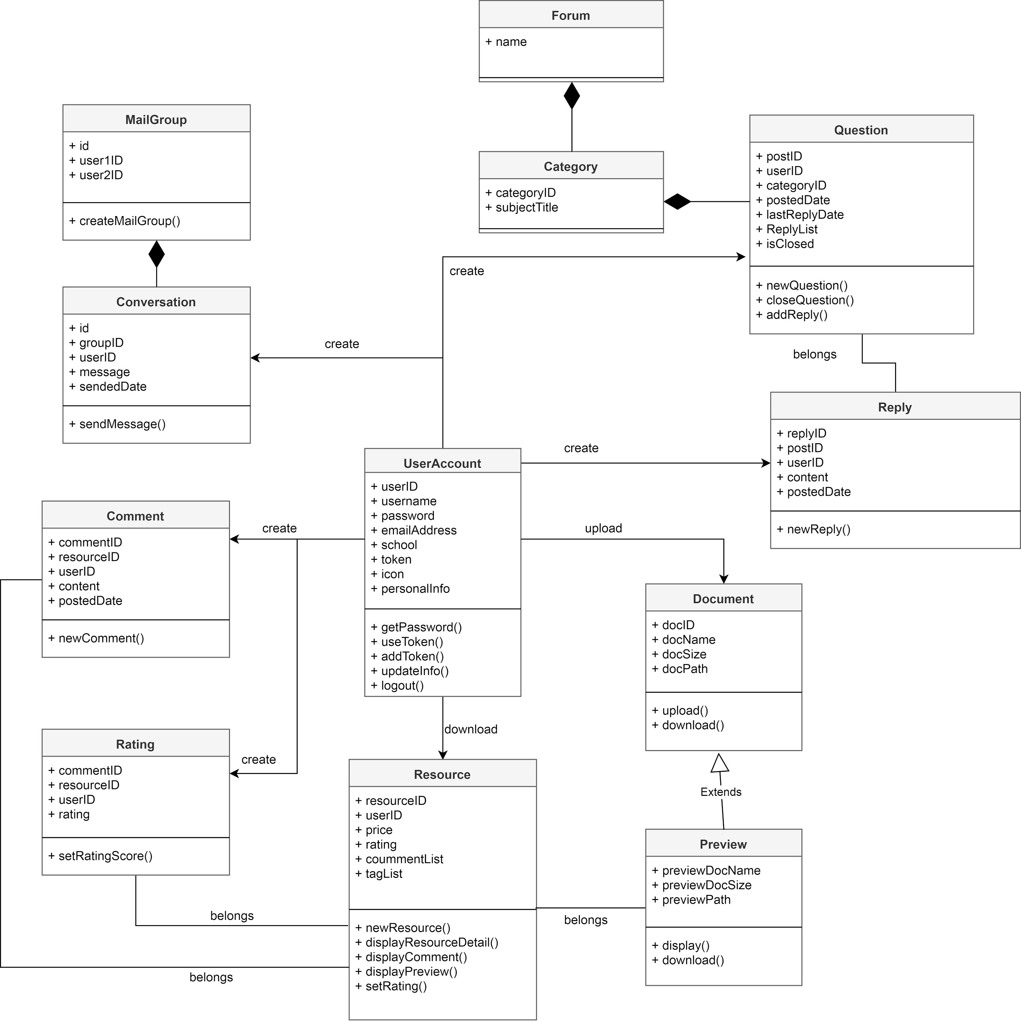

# 

# 4. User Interface Design

## 4.1. Description of the User Interface

### 4.1.1. Interaction style

The User Interface of ARM should be easily controlled by the user. Therefore, we implement the interaction style of ARM by using form-filling and menu selection. Menu selection style can satisfy the novice and intermittent users, we mainly use the iconic menus to provide the selection with users instead of text menus since users can quickly know the meaning or metaphor of the element of selection lists. Form-filling style can accurately and efficiently receive the input from the user. For example, we implement it in the account registration and uploading file parts.

### 4.1.2. Golden rules of UI Design

First, designing UI should strive for consistency that the color, layout, and style should be consistent. In our design, we adopt dark cyan as the main color of all the page. we import the bootstrap library in our page design to make a good alignment style in our website pages.

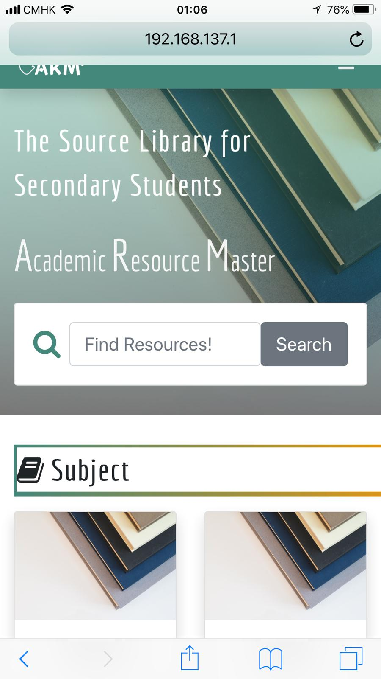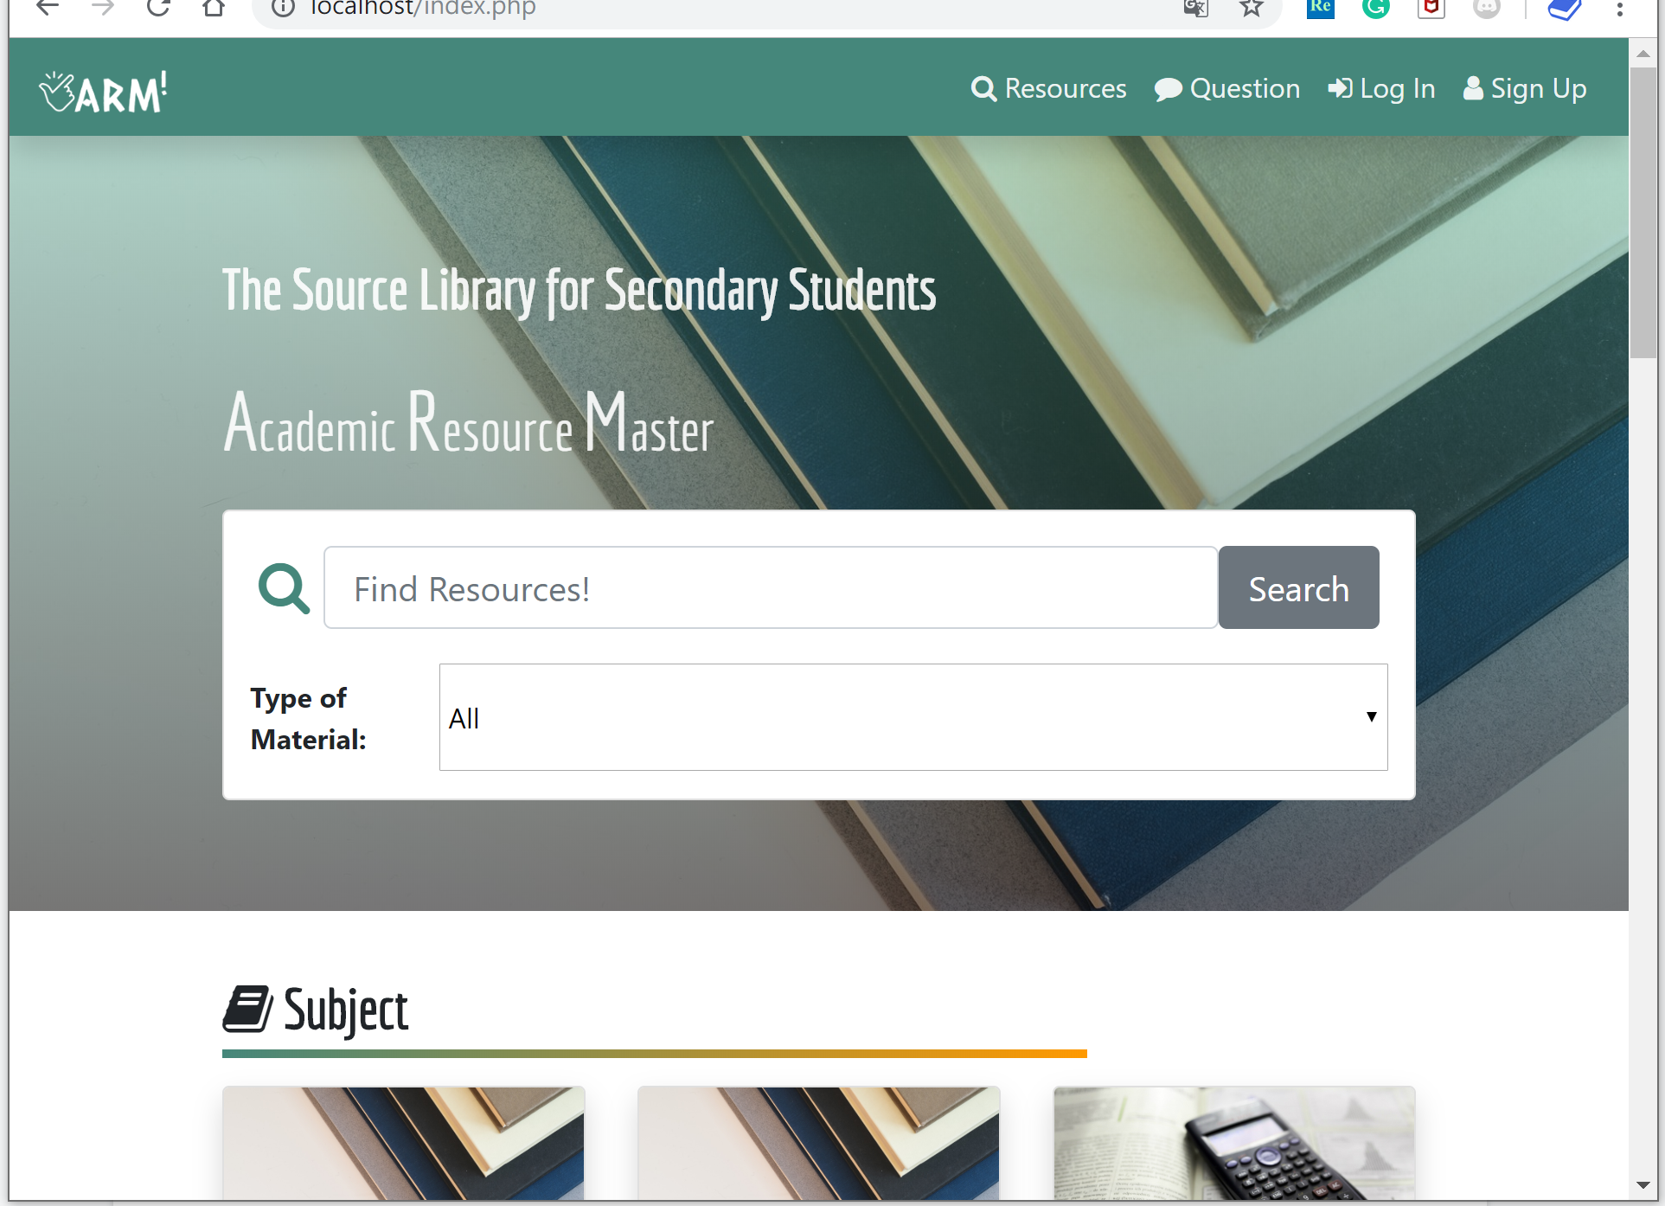

Second, designing UI should contain universal usability. We notice that the user may use ARM in different devices such as computer and smartphone. We import the Bootstrap library that can align the layout of the website in different devices. By transforming the UI format, we make sure that every user can use our website in different places.

Third, the Application should give information feedback to users. For every action of users, the UI should provide feedback. For example, it will pop-up an alert window to show users have already signed out if they click the logout button.

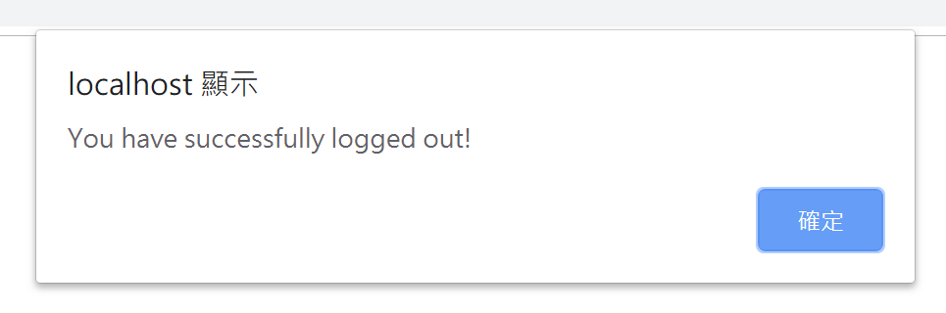

When user register for creating a new account and enter the password of the account, it gives the information feedback that instructs the rule of the password.

Fourth, the Application should prevent an error that users may make. The main mistake that users make is typing mistakes. For example, when creating an account, the user may type the password wrong. They will fail in login because of the mistake of the password. To prevent that, we add an input bar of confirming password.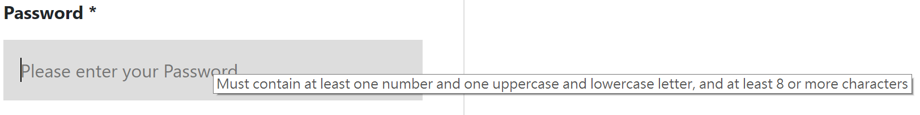

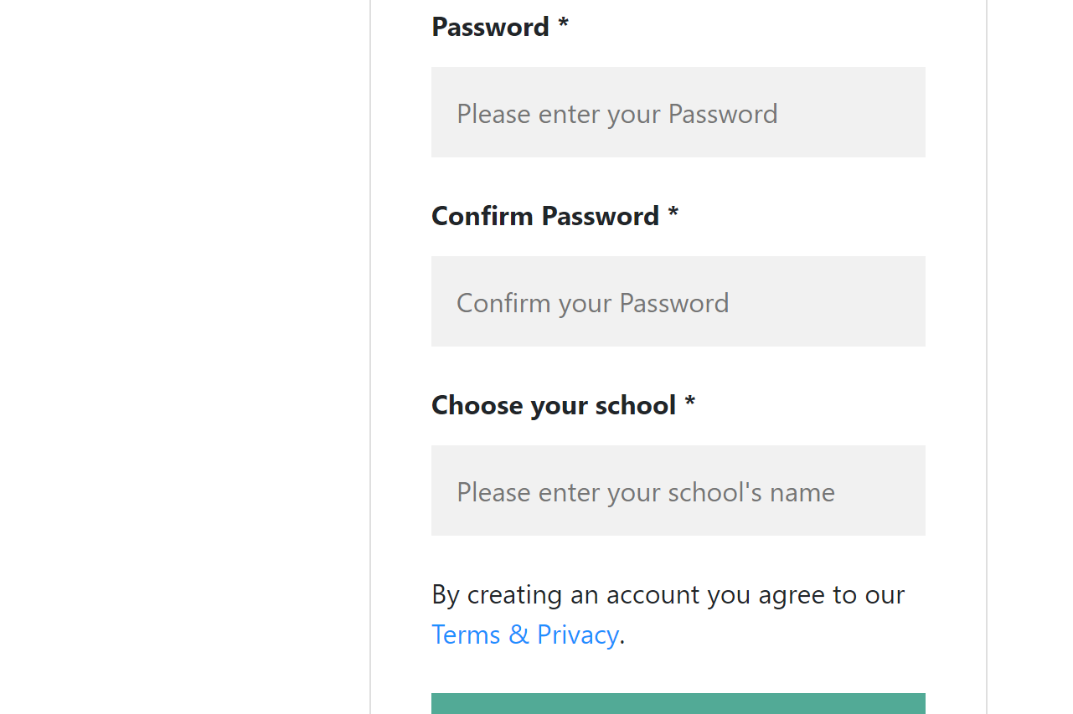

## 4.2 Screen Images

### 4.2.1. Homepage

The top of the homepage:

## 

The bottom of the homepage:

## 

### 4.2.2. Menu Bar (Without Login)

# 

### 4.2.3. Menu Bar (Login)

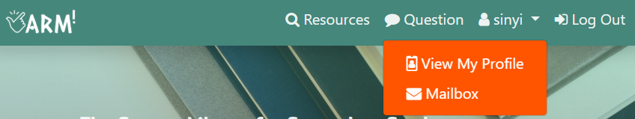

### 4.2.4. About Us

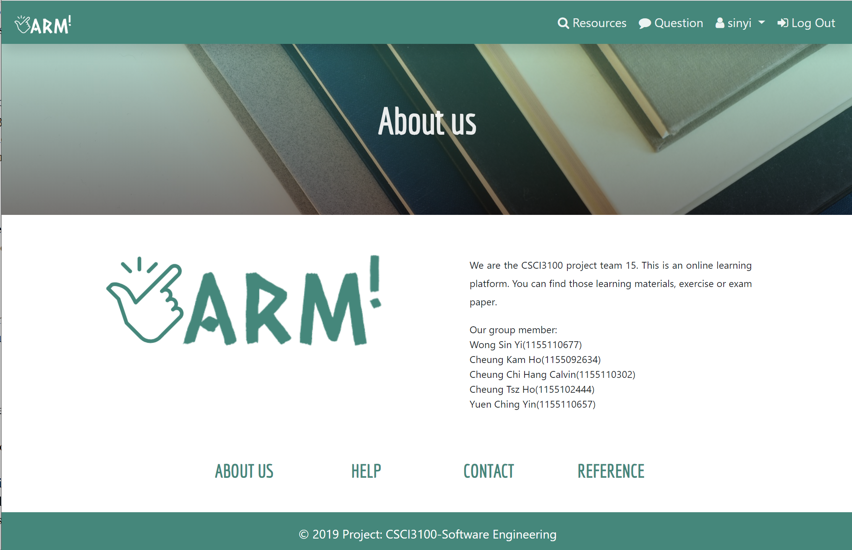

**4.2.5. Help**



**4.2.6. Reference**

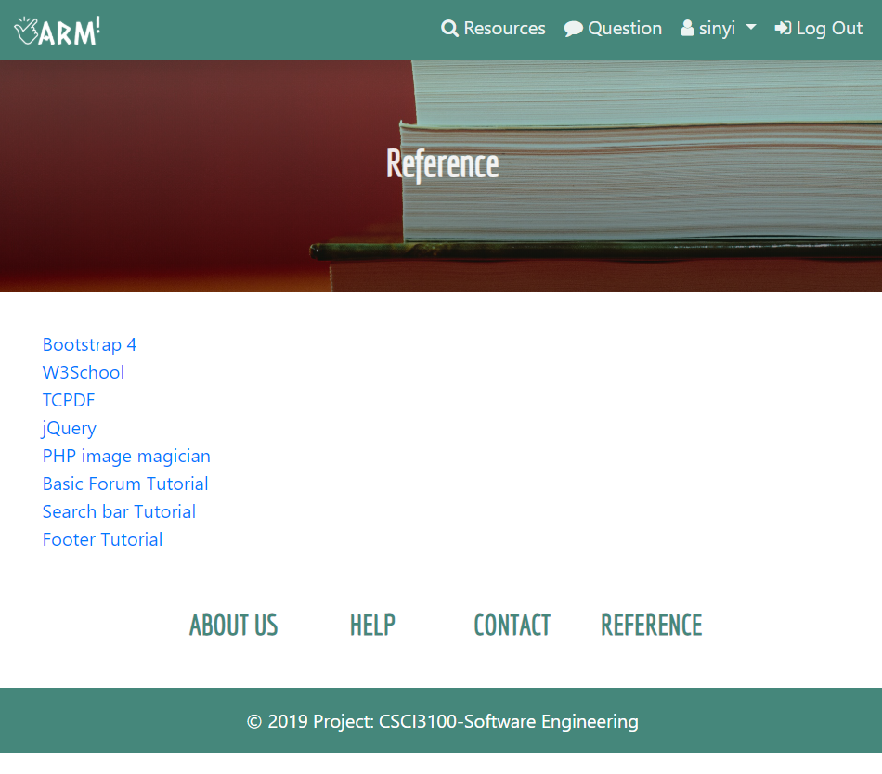

## 4.3. Object and Action

### 4.3.1. Homepage of ARM

The homepage shows the main functions of ARM: Searching the materials(Resources), Forum(Question). For finding resources, ARM allows the user to search them by typing keywords or selecting the categories.

In the Bottom of the homepage shows the topic of the forum. Users can click the “question” button to ask a question and view other questions.

## 

# 

### 4.3.2. Registration

To create an account, users only select the identity, then fill the email address, username, password, and school.

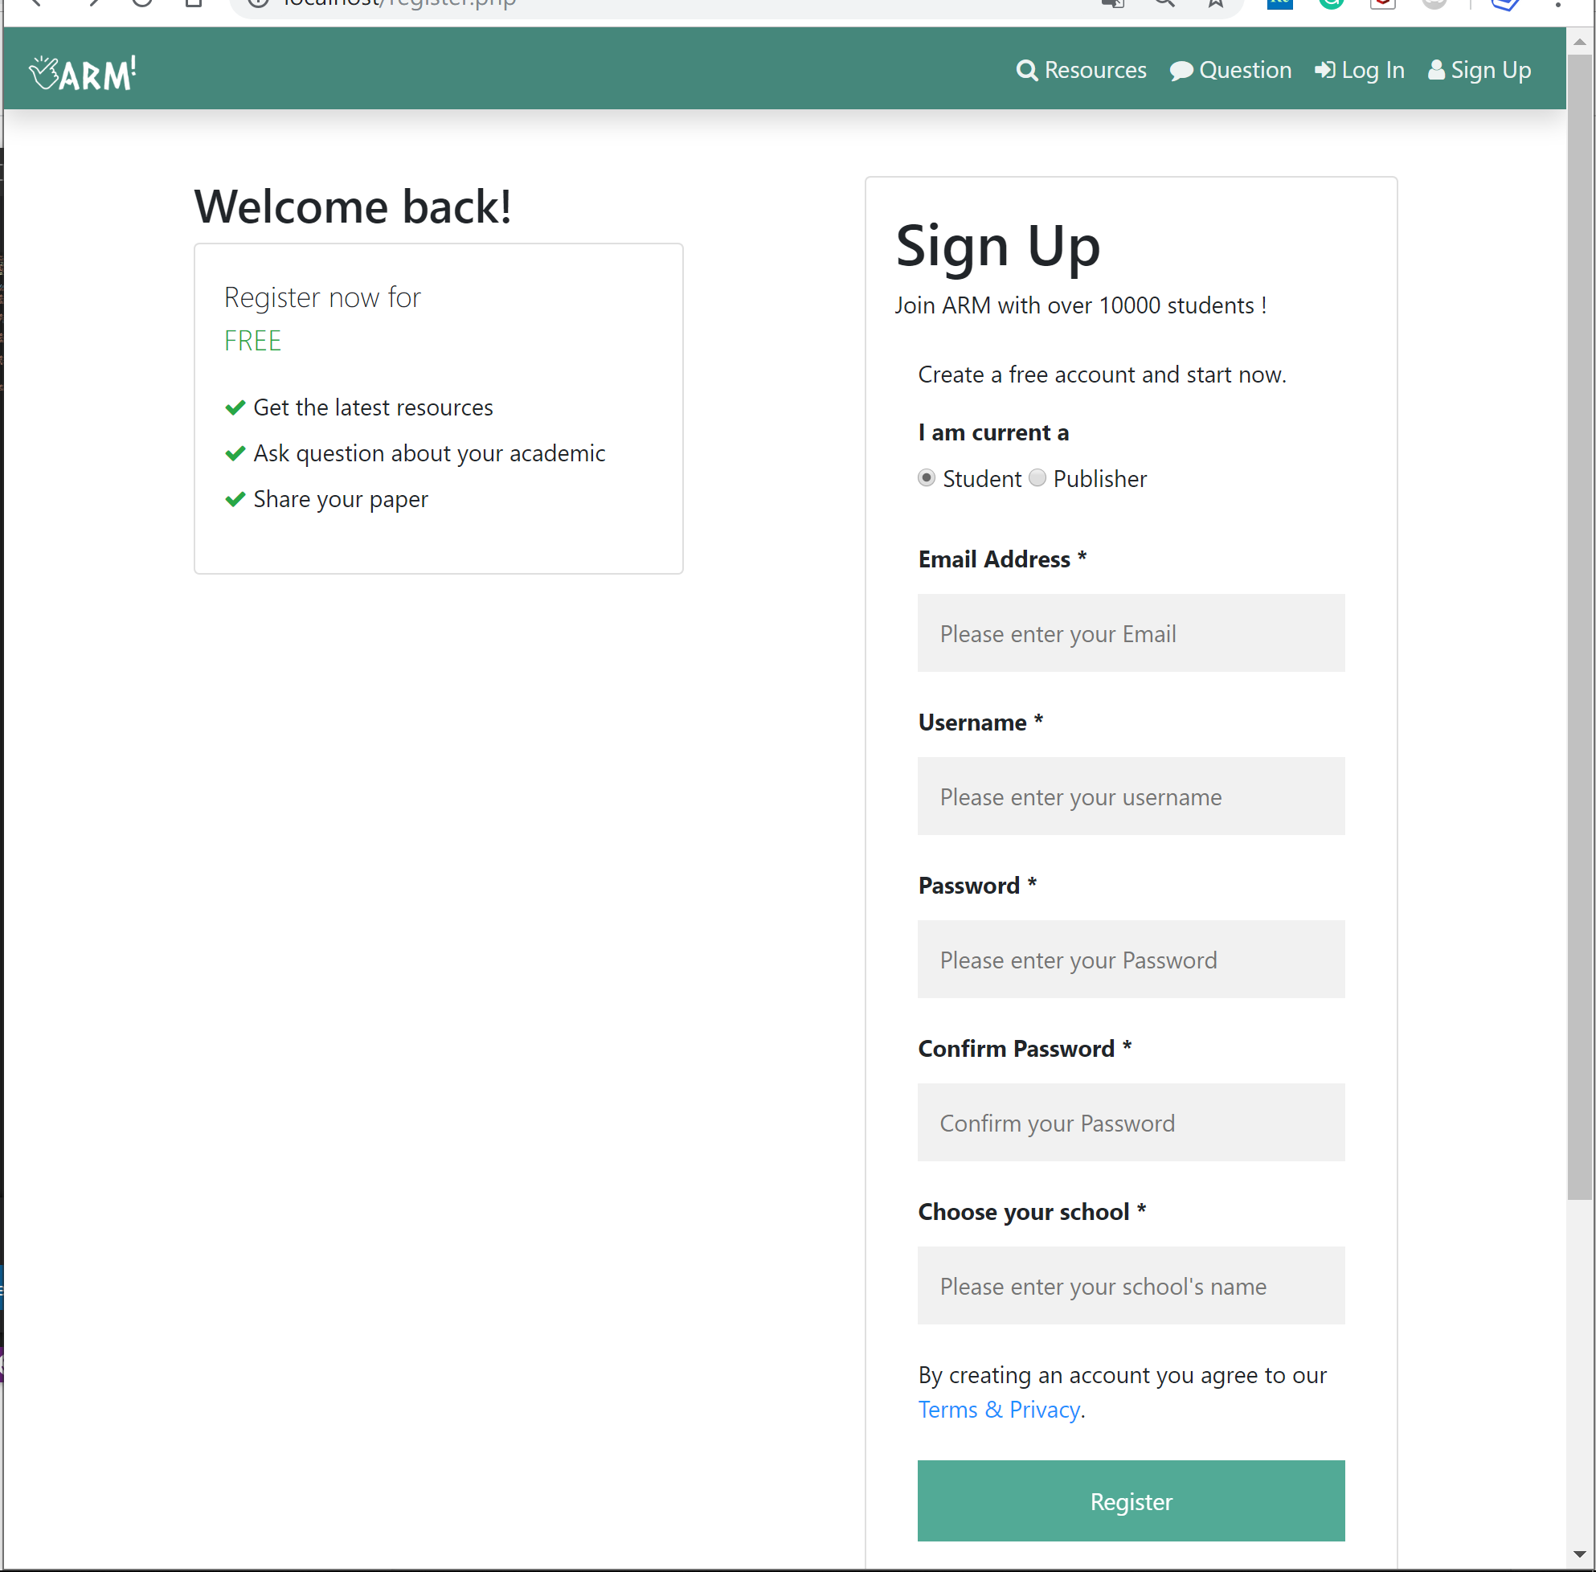

### 4.3.3. Login

Fill in the username and password.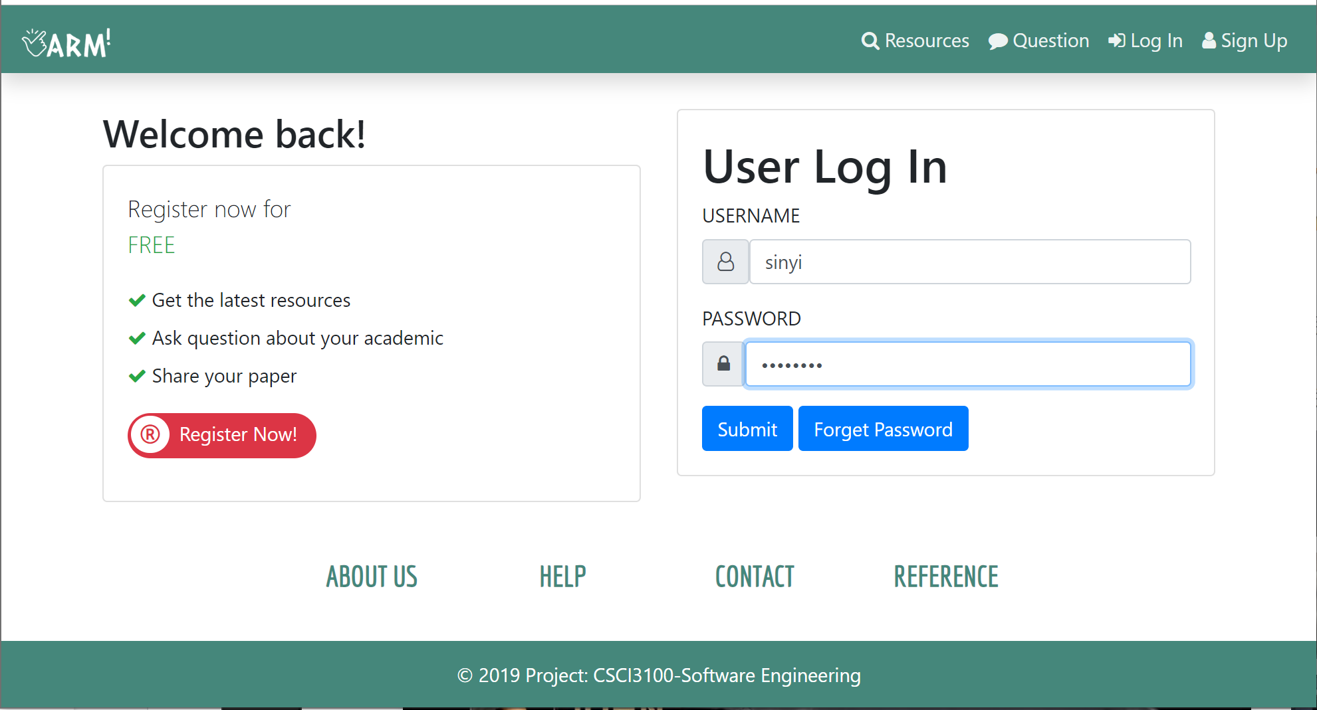

### 4.3.4. Profile

It is the personal information of the user account. It shows the token the user has and the history of question thread that the user created. Also, User can change their profile such as icon, email address. Tokens can be refilled as well.

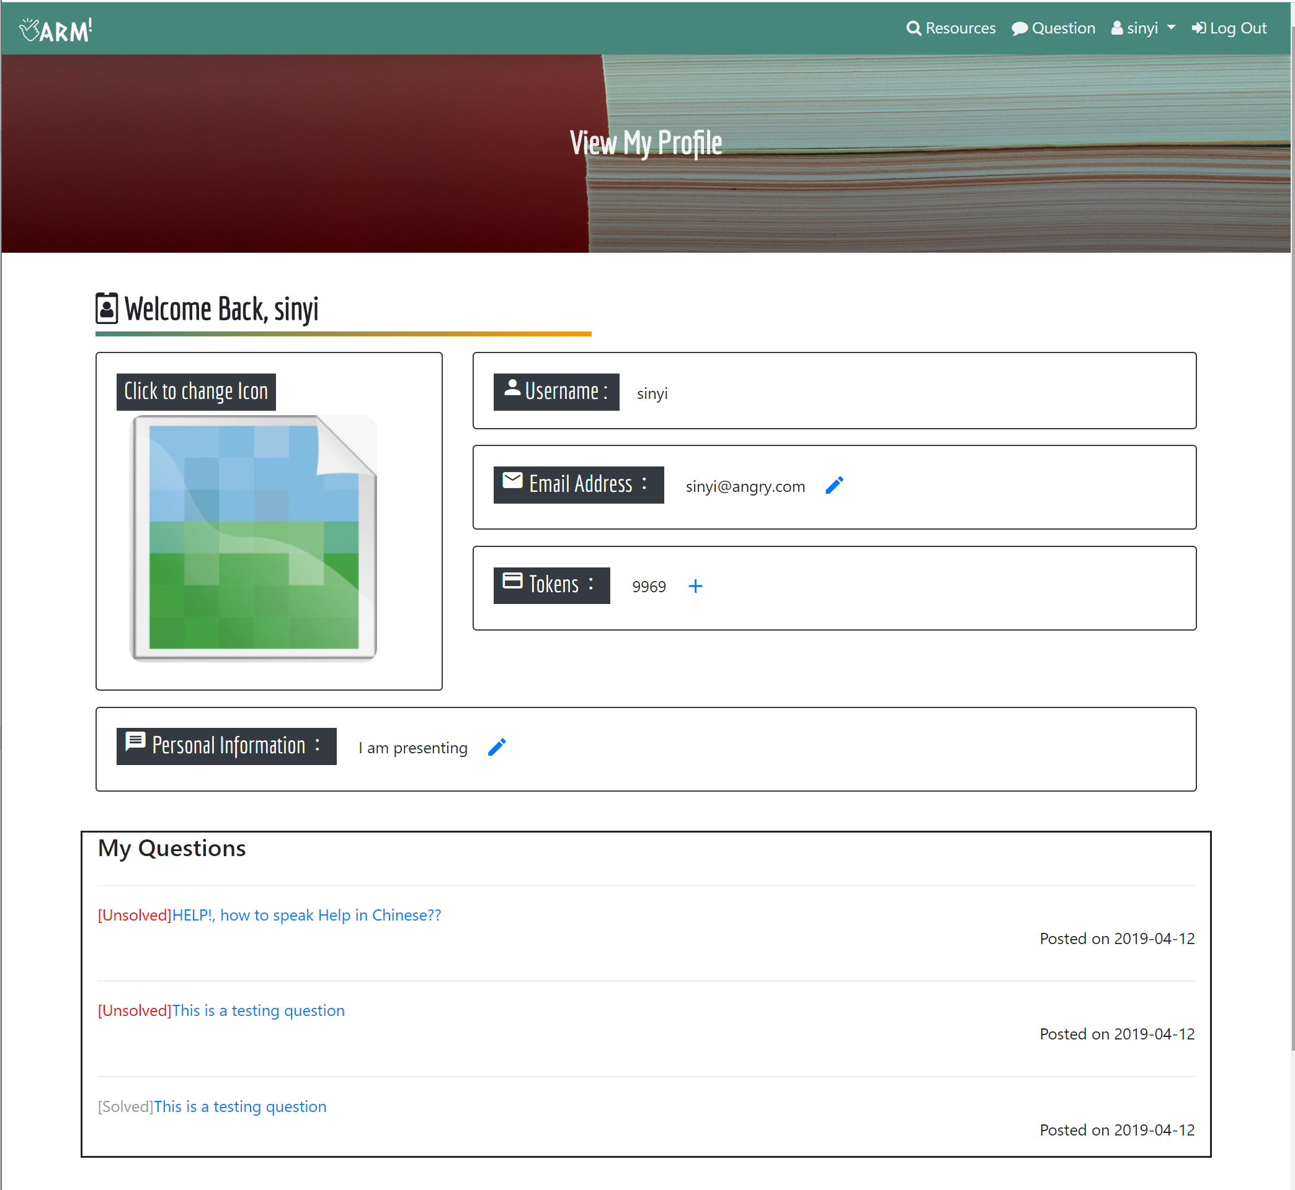

### 

### 4.3.5. Forum

User clicks the “Question” button at the top of the homepage. Then it lists the thread of the forum that grouped by subject. Users can select the subject(Chinese, English, Mathematics) that they want.

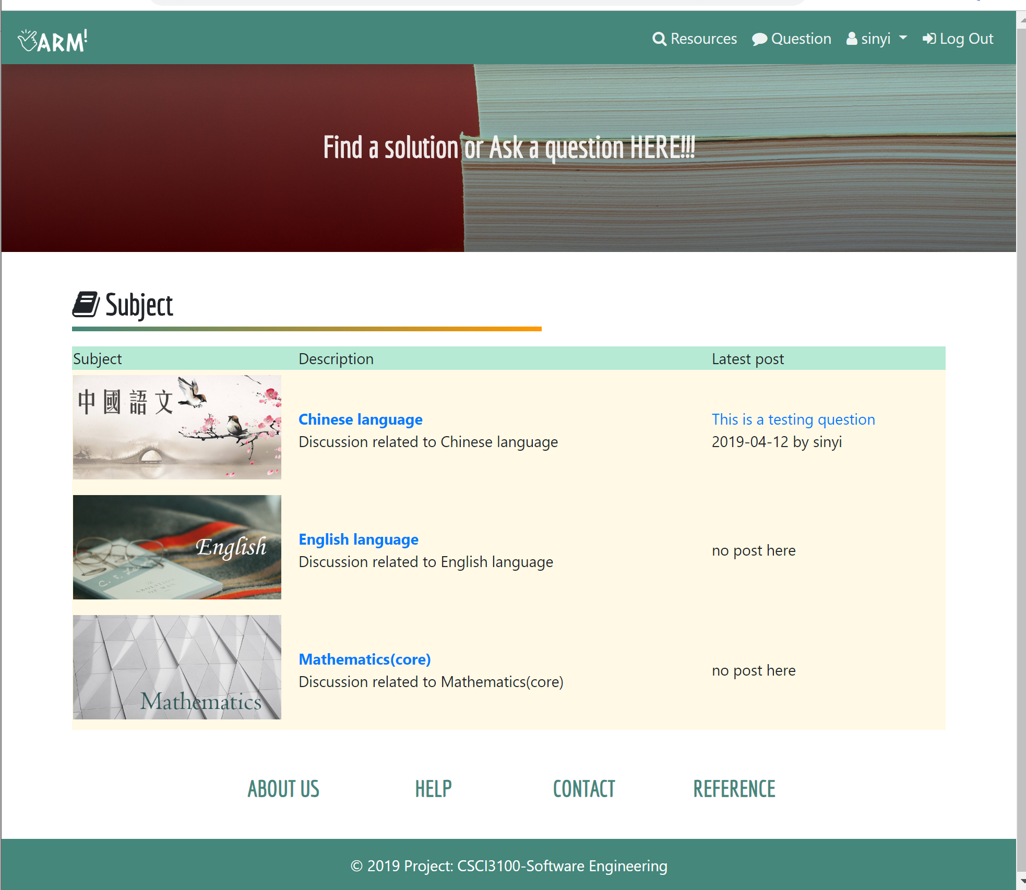

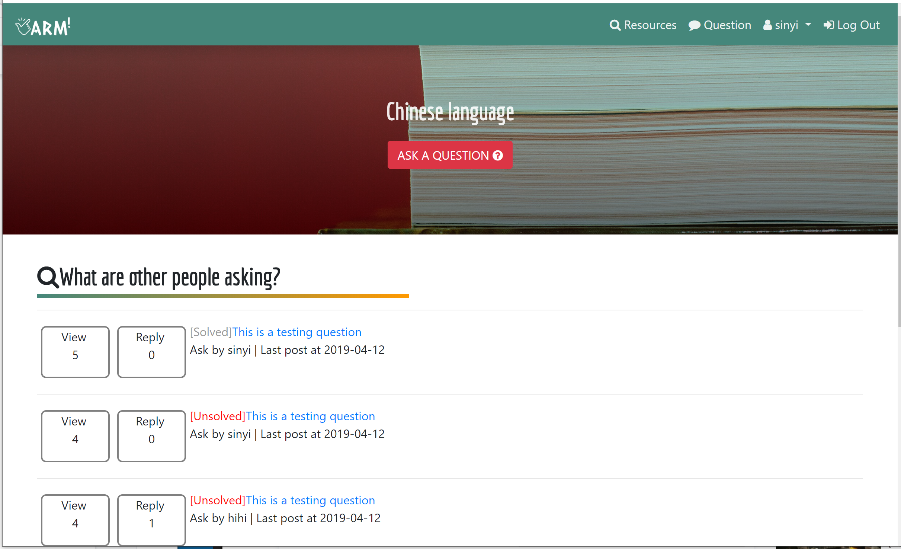

In the question page, users can see others’ comment. They can also reply to the question.

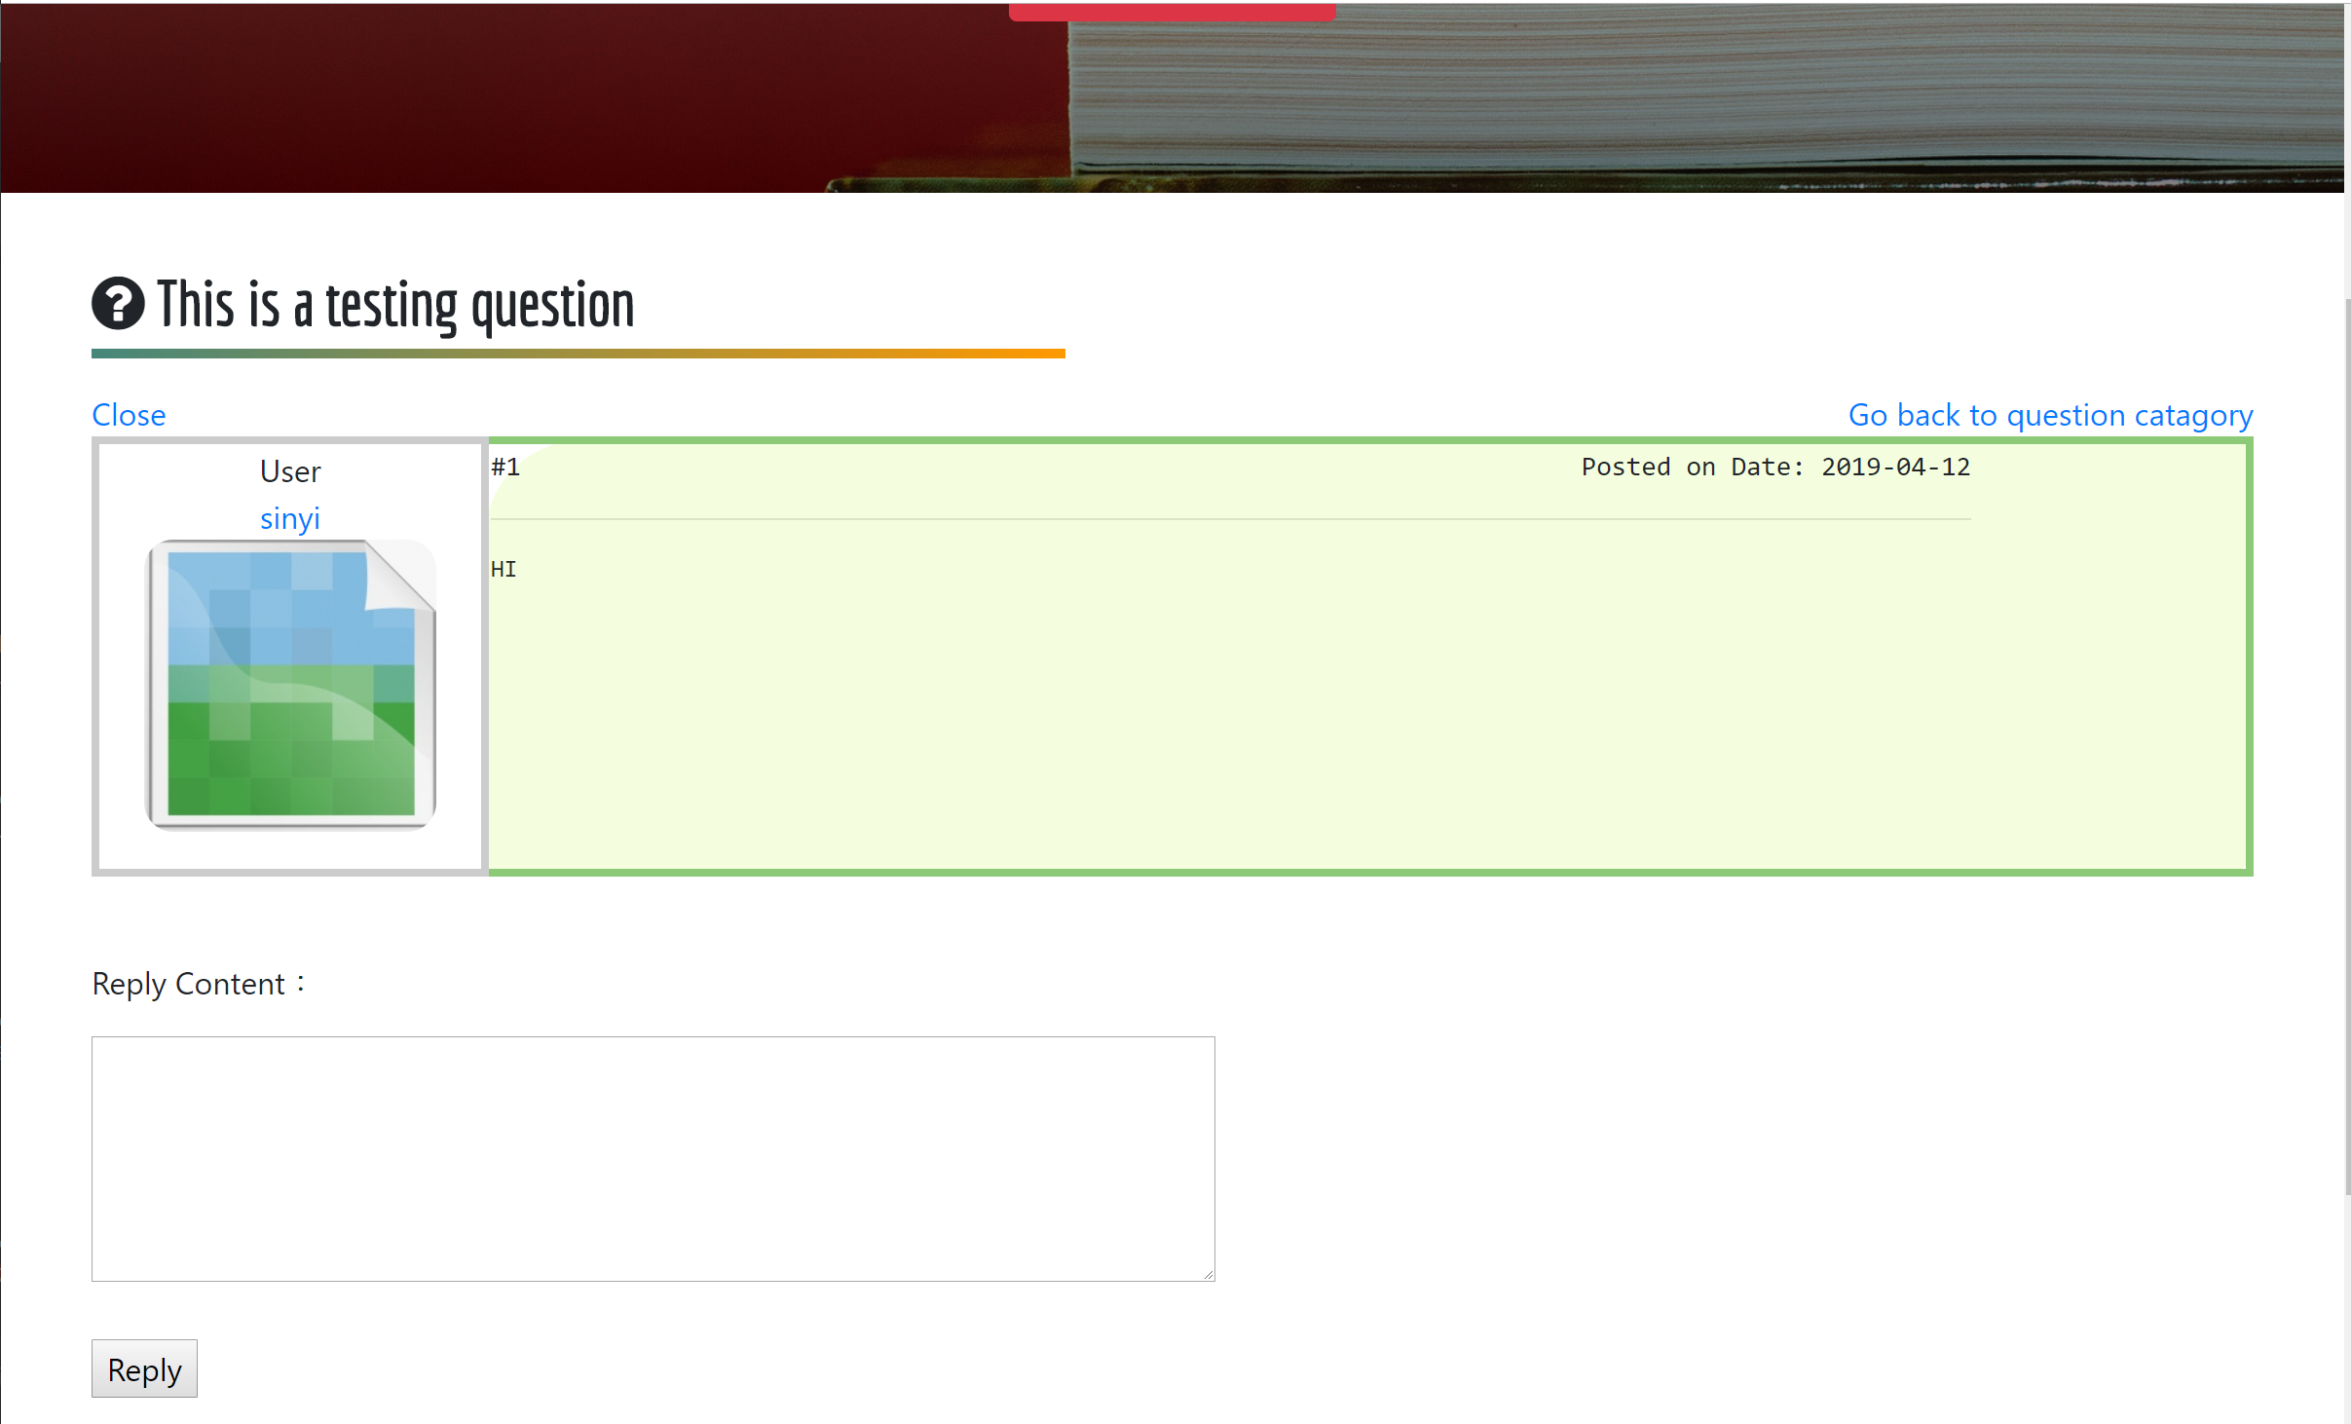

### 4.3.6. Mail Box

User can privately chat with other users.

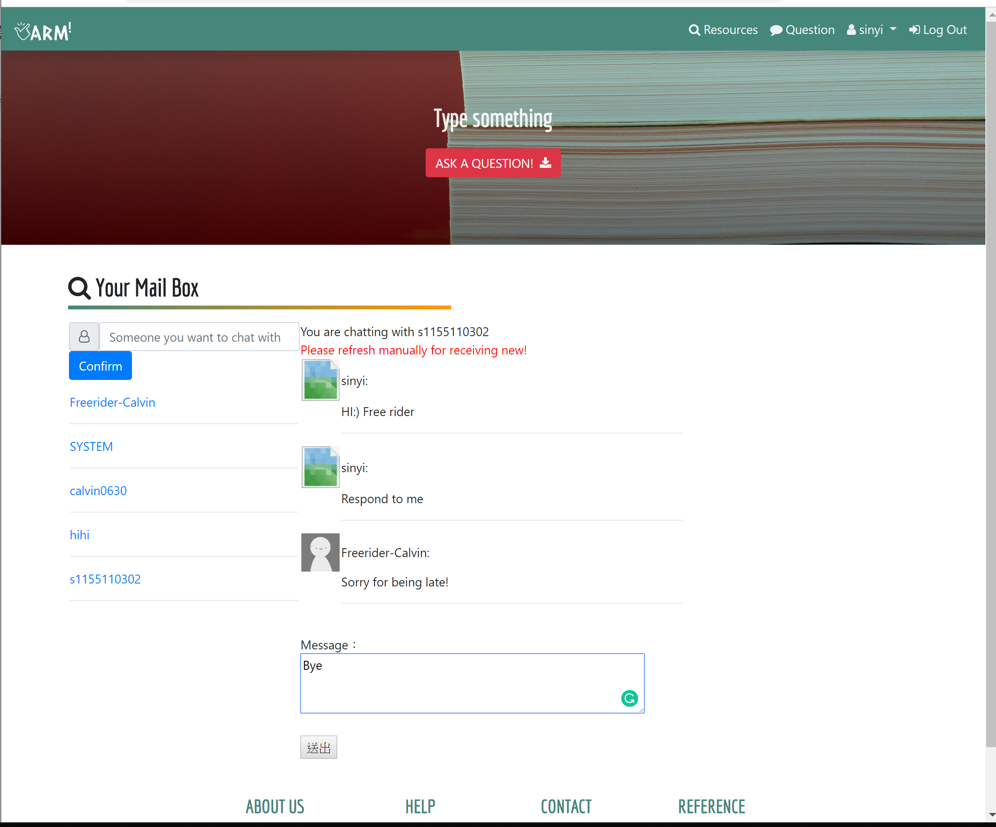

### 4.3.7. Materials Searching

Users can type the keywords for searching. Also, they can select the type of material. Also, users can choose the subject to all related materials.

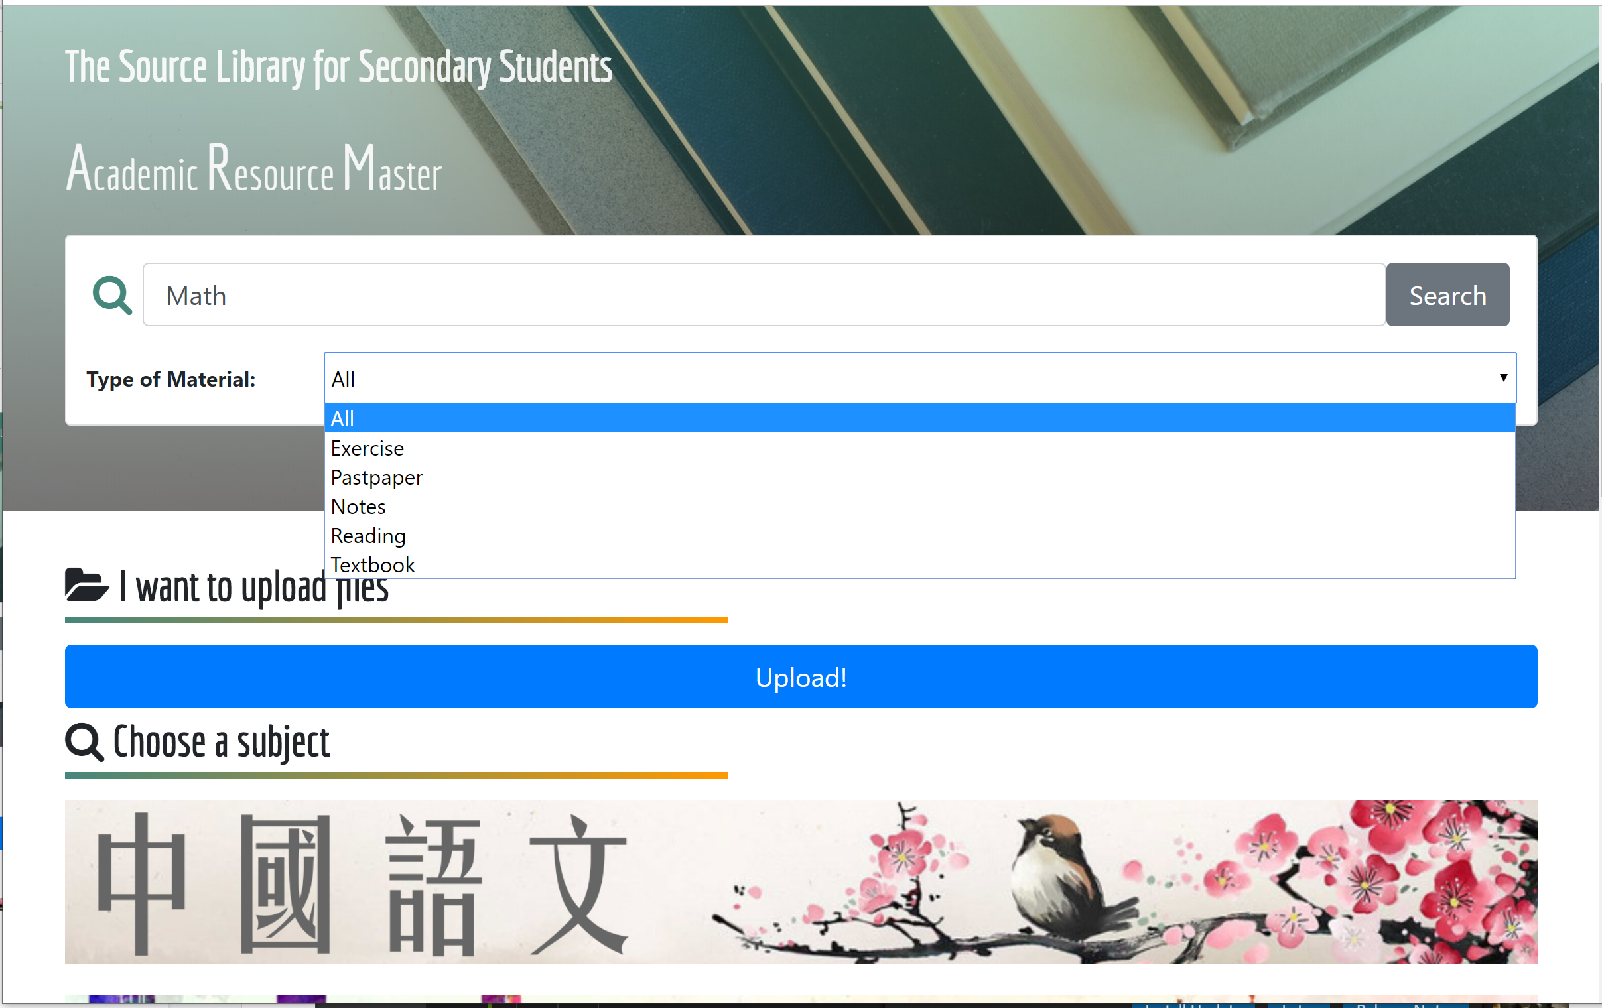

### 

### 4.3.8. View and Download the materials

When users select the file that they want, they can preview the document that only shows the first six pages of the whole document and the watermark is added in each preview pages. For full version download, if it is priced material, users need to pay the tokens.

Also, Users can rate the material and leave a comment on the materials.

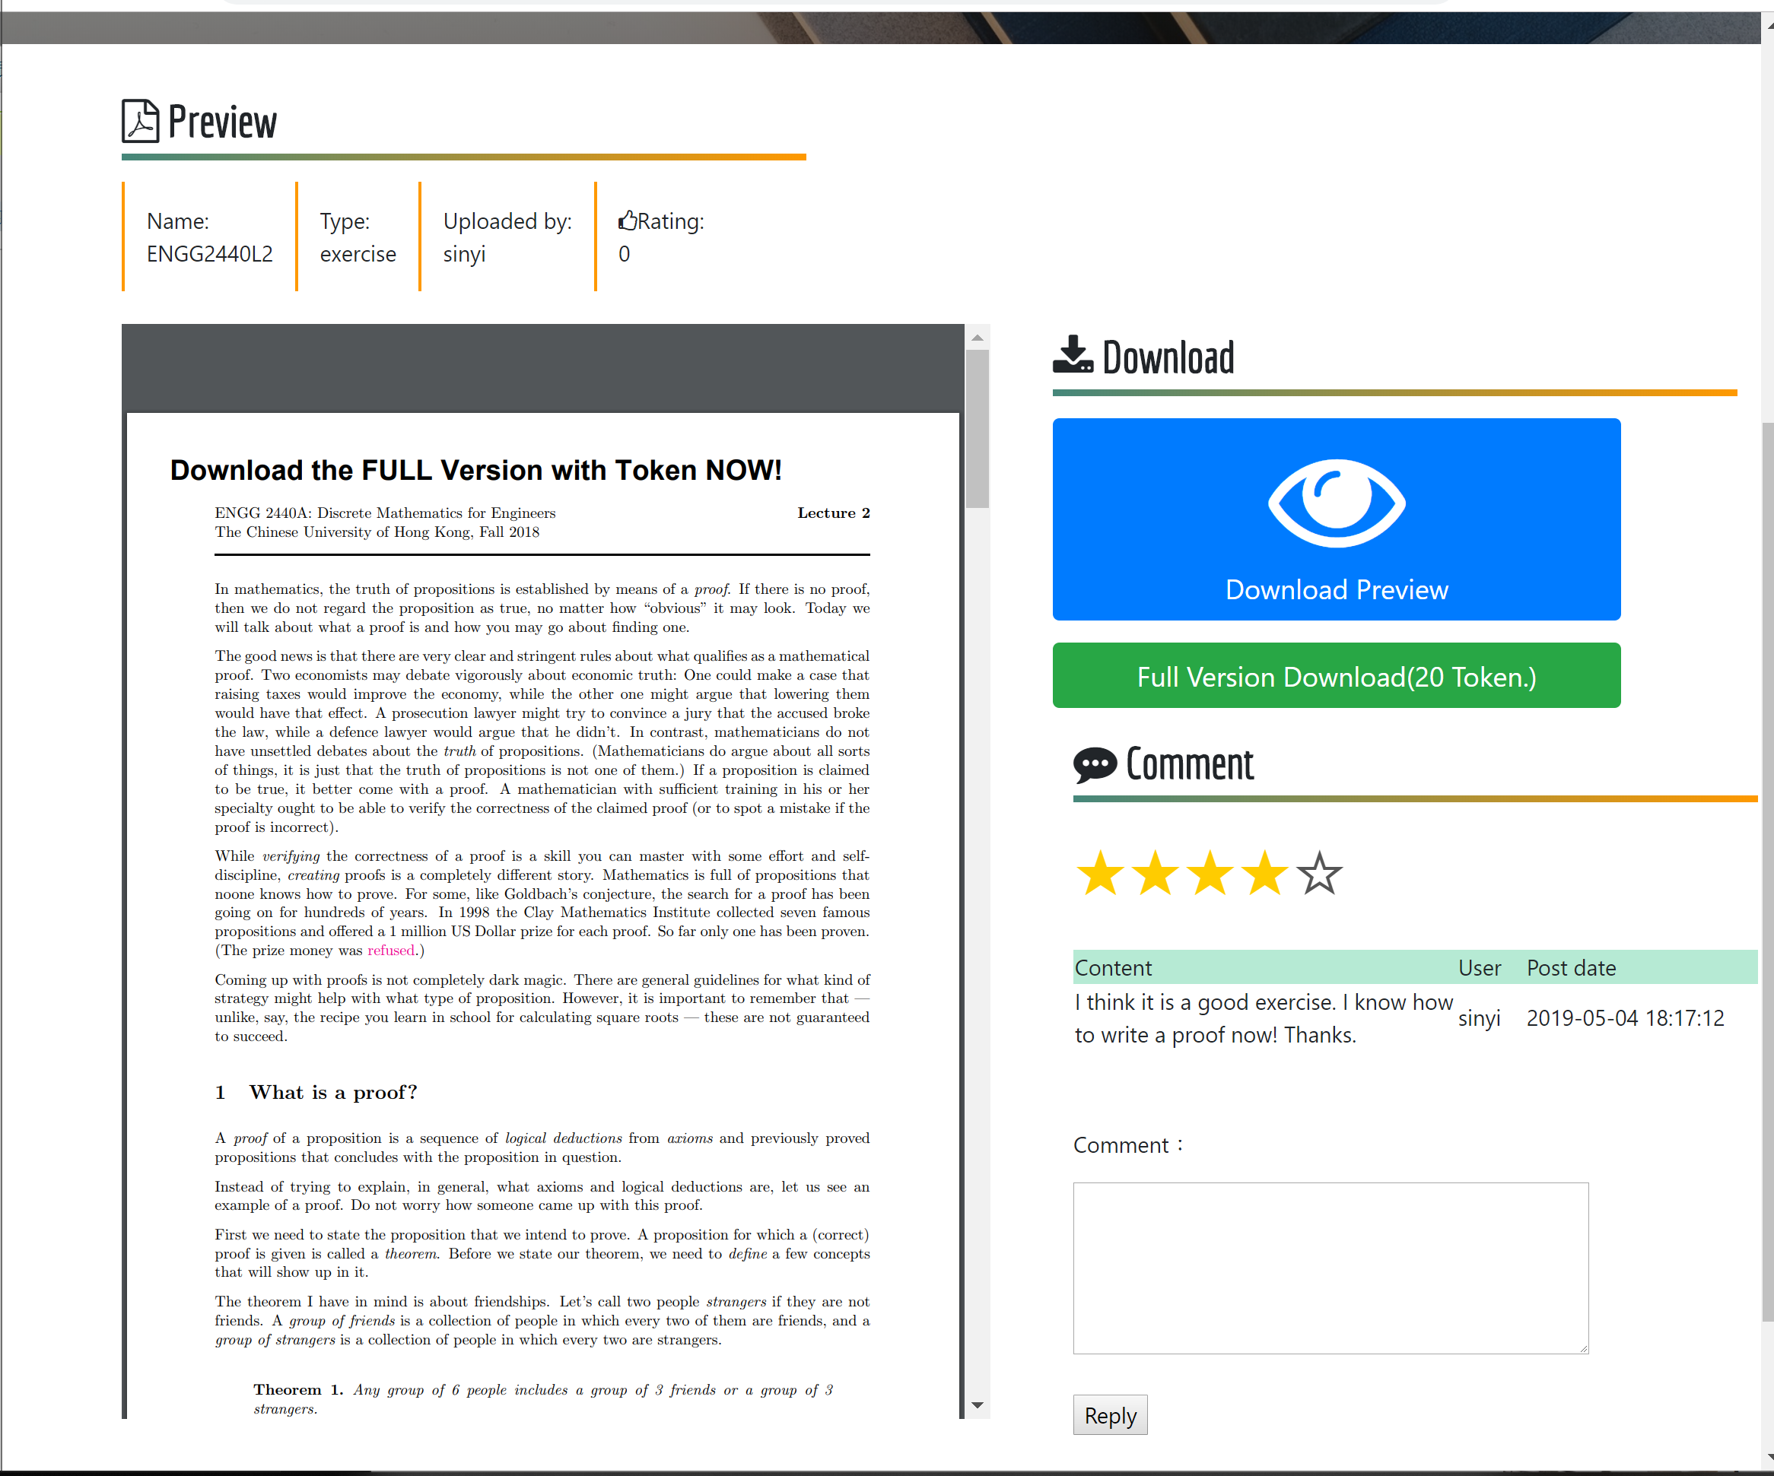

When Download the Full version of priced materials, it shows the message of payment success!

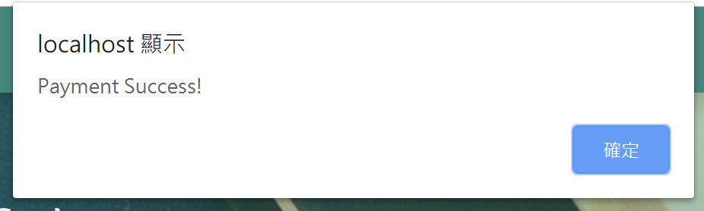

### 

### 4.3.9. Upload the file.

User can upload files and enter the information of the file.

### 

# 5. Test

## 5.1. Overview and plan

The system can be separated into four major components: Register/login + personalInfo, Material List and search, Forum and Mailbox. All components are test independently with set of test cases. This ensure all user activity would be tested, under condition that four major component are not in cohesion.

## 5.2. Register/login + personalInfo

### 5.2.1. purpose

This part of test case is to test the correctness of user authentication and registration components. We will test user authentication and registration separately since two are mutually exclusive to each other. We will test each component by three goals, pass, fail and also boundary cases.

### 

### 5.2.2. Inputs

### 5.2.2.1. Login Page:

Case 1: sinyi, !Abc1234 (correct pair)

Case 2: (empty), !Abc1234 (Not filled in)

Case 3: sinyi, (empty) (Not filled in)

Case 4: sinyi, 12345678 (wrong password format)

Case 5: 123, (empty) (wrong username format)

### 5.2.2.2. Registration Page:

Case 1 : 1234@gmail, cal, 12345678 , 12345678, school) (wrong) (Register suggestion) (one by one)

Case 2 : wrong email “1234”, “1234@gmail.” correct: “1234@g.com”

Case 3 : wrong username “cal”, correct: “calvin”

Case 4 : wrong password “12345678”, “abcdefgh”, “ABCDEFGH”,“1234” correct: “!Abc1234”

Case 5 : wrong school “school” , “test” correct “Chinese University HongKong”

Case 6: [1234@g.com](mailto:1234@g.com), calvin, !Abc1234, Chinese University Hong Kong

### 5.2.3. Expected Outputs & Pass/Fail Criteria

### 5.2.3.1 Login page:

These cases are supposed to observe the login system work in correct way. A user only can log in with a correct pair of username and passowrd. And the system will give a warning that the user haven’t filled in all or the format is incorrect.

The test results are following.

Case 1 (pass)

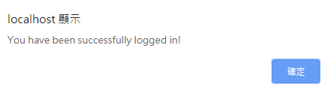

A user has been successfully logged in with a correct pair of username and password.

Case 2 (pass)

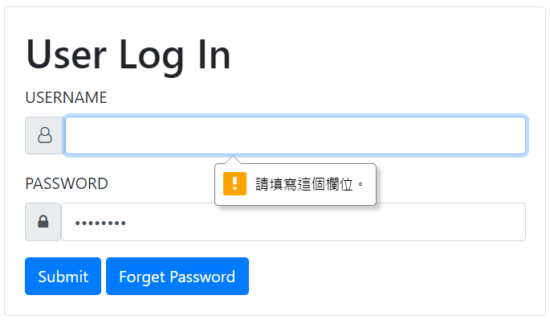

A warning has been shown when the user has not filled in the username field.

Case 3 (pass)

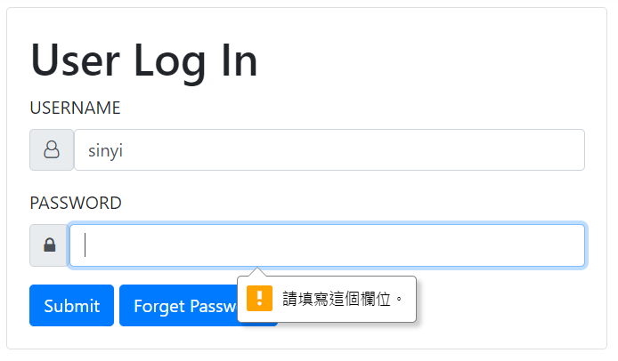

A warning has been shown when the user has not filled in the password field.

Case 4 (pass)

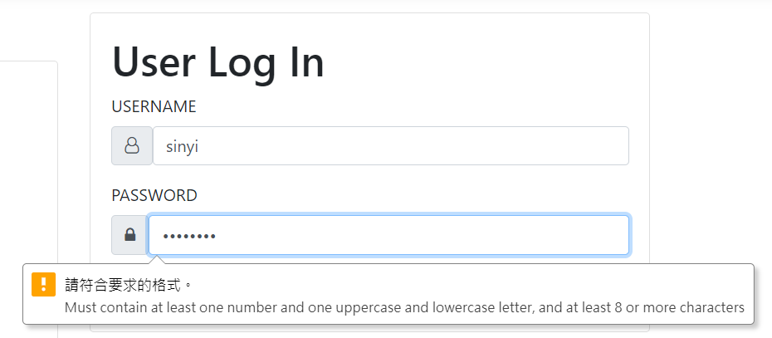

A warning has been shown when the user has filled in a password with wrong format.

Case 5 (pass)

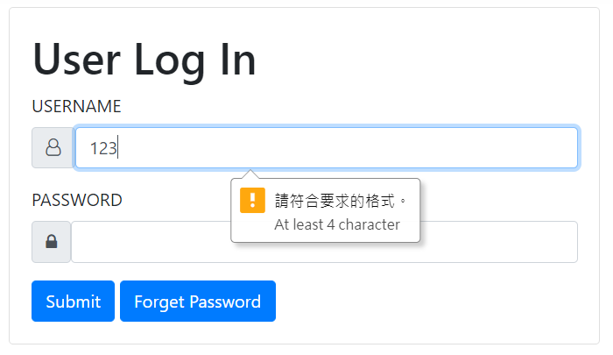

A warning has been shown when the user has filled in a username with wrong format.

### 5.2.3.2 Restratation page:

These cases are supposed to observe the register system work in correct way. User should fill in valid information otherwize system will give a warning that user filled in all or the format is incorrect.

Case 1 (pass):

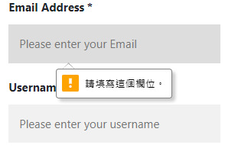

Case 2 (pass):

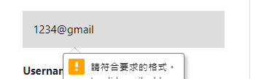

Case 3 (pass):

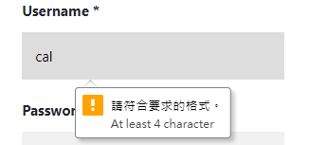

Case 4 (pass):

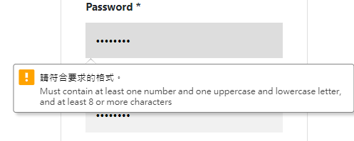

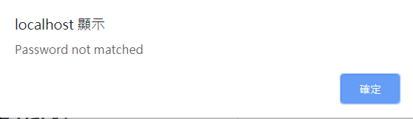

Case 5 (pass):

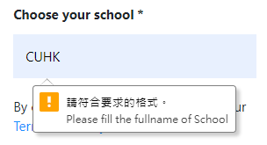

Case 6 (pass)

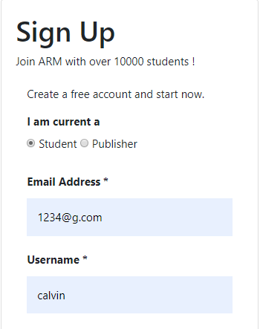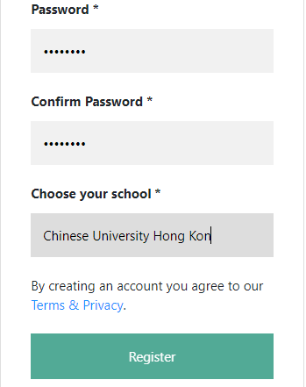

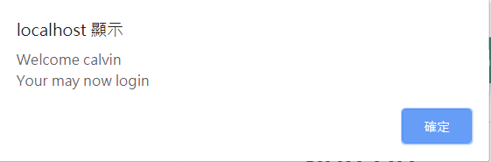

## 5.3. Material List and search

### 5.3.1. purpose

Material part contains three main feature, which is upload, search and purchase. Testing in this part is to ensure each feature could work well and supporting each other. The best scenario are material could be well uploaded, then could be searched refer to the tag and be purchased related to its set price. Test cases is individually designed for three part.

As upload material could gain 5 tokens for each upload. Therefore, this test observe the change of token number of users.

### 

### 5.3.2. Upload Material

#### 5.3.2.1. Inputs

In upload material, three test cases simulated two users uploading total three files with different categories. Input of test cases are the following.

Case 1 : Chinese, Exam Paper, 0 price ,user: s1155110302) 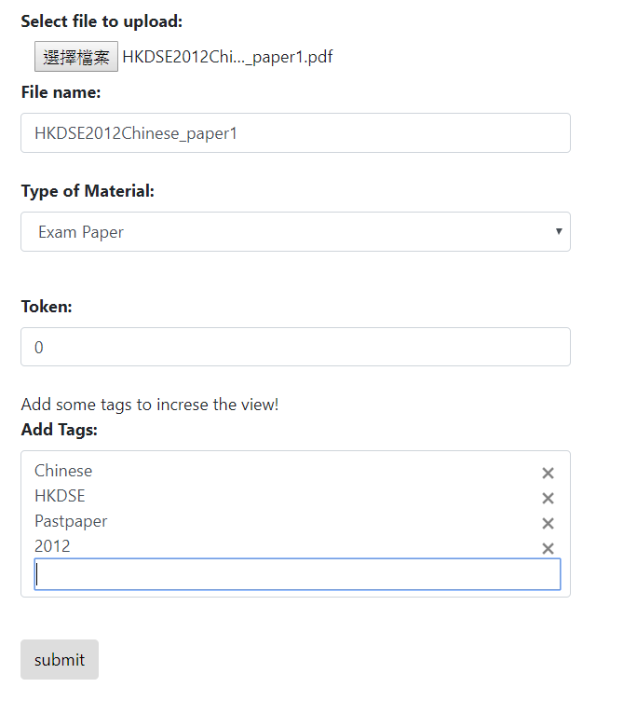

(Case 2 : English, Reading, 10 price, user: s1155110302)

### 

(Case 3 : Math, Notes, 20 price, user: sinyi)

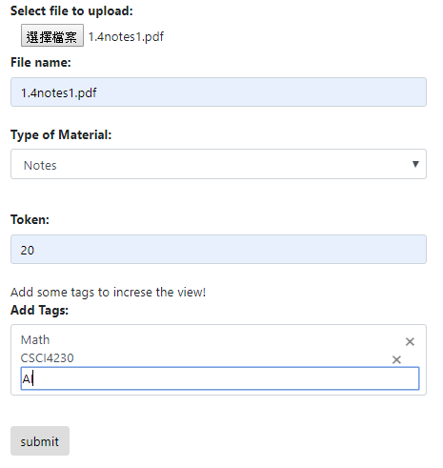

#### 5.3.2.2. Expected Outputs & Pass/Fail Criteria

Three cases are supposed to observe “Uploaded successful” message after submitted and redirected to the material preview page. the expected content in the preview page should have correct file name, type of material, uploader and price. The watermark of “Download the FULL Version with Token NOW!” should also locate on the PDF version to show a preview PDF is generated.

The test results are following.

Case 1 (Pass)

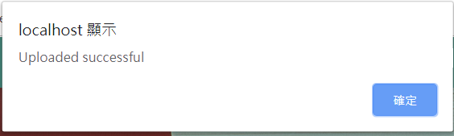

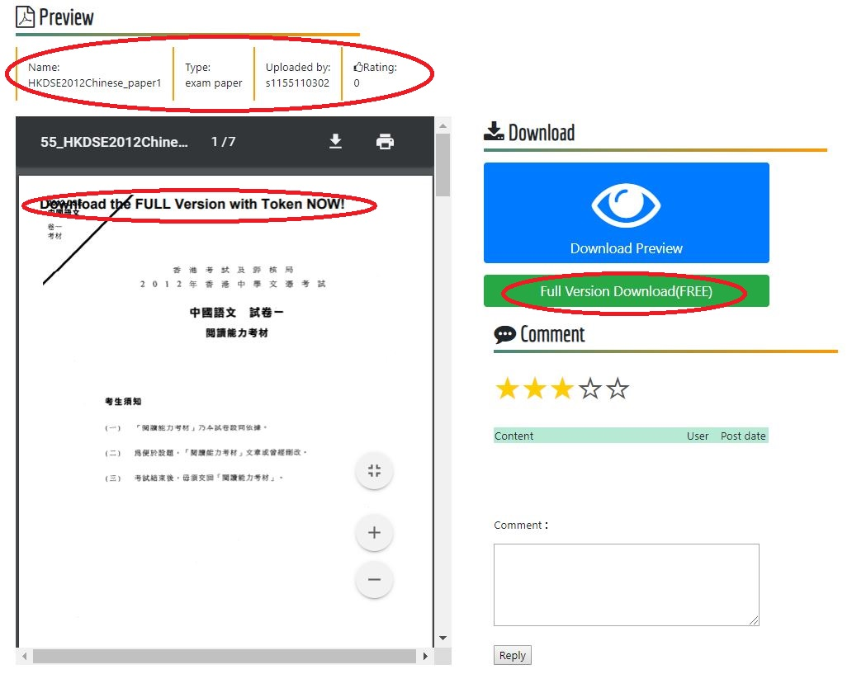

File name : Correct

File type : Correct

Uploader: Correct

Price : Correct

Preview watermark : Yes

Case 2 (Pass)



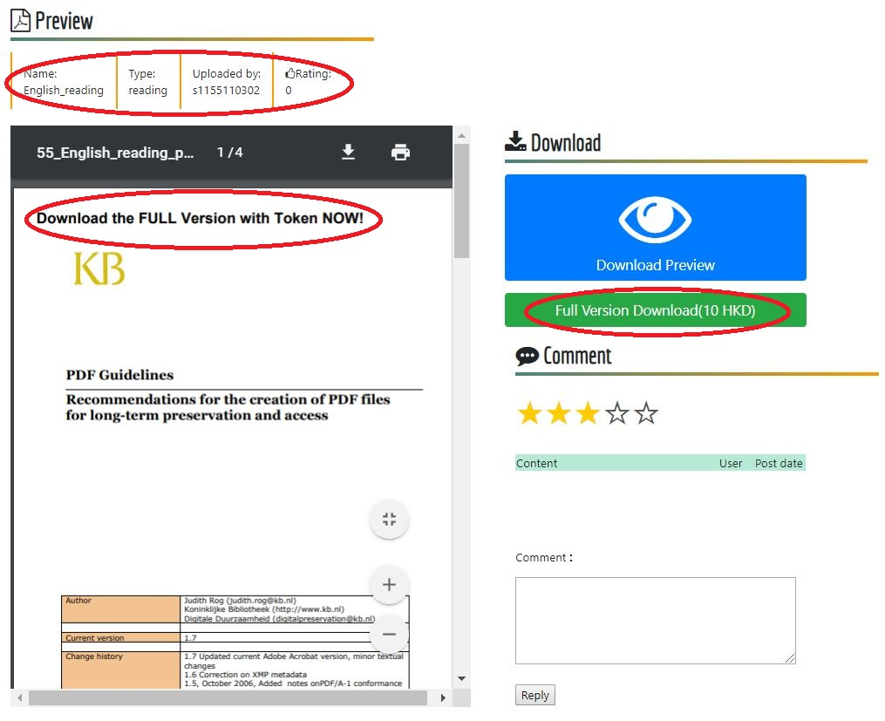

File name : Correct

File type : Correct

Uploader: Correct

Price : Correct

Preview watermark : Yes

Case 3 (Pass)



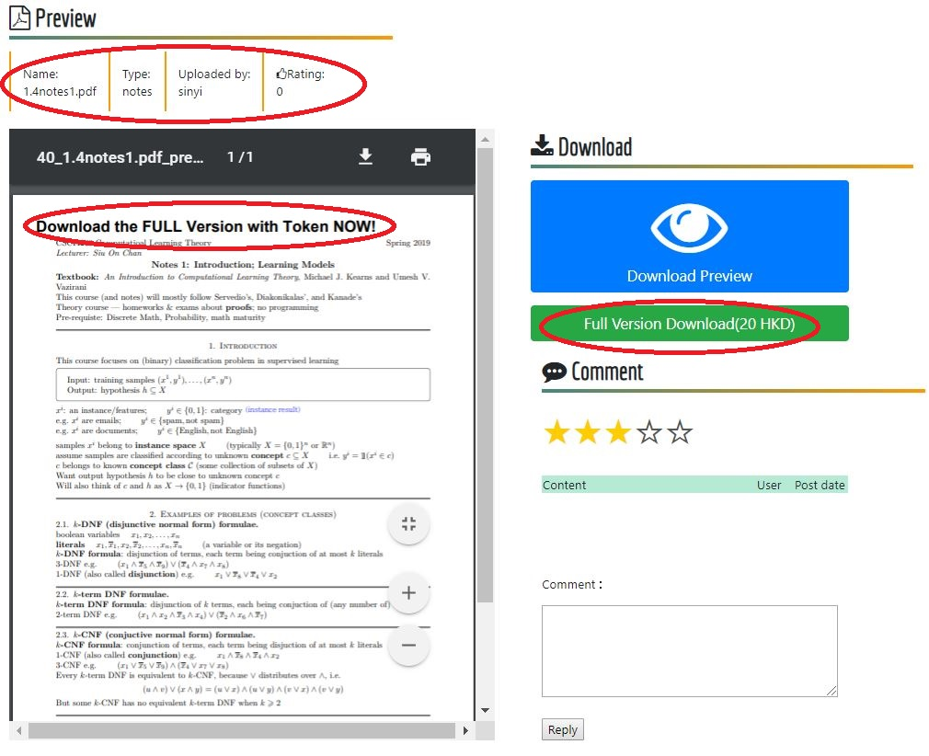

File name : Correct

File type : Correct

Uploader: Correct

Price : Correct

Preview watermark : Yes

Token number of user s1155110302 before and after test :

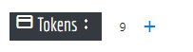 → 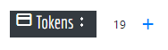

Token number of user sinyi before and after test:

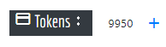 → 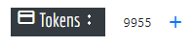

As expectation, file with different categories and price can be well record to the database. The preview PDF is generated properly. Resource page read each material in database correctly.

10 tokens increase for user s1155110302(2 files upload) and 5 tokens increase for user sinyi (1 file upload) is well observed.

### 5.3.3. Purchase material

#### 5.3.3.1. Inputs

Tests in this part tends figure out purchase function work under all conditions which are free resources and priced resources. Test cases is designed in user facing zero cost, enough tokens and not enough tokens conditions. The testing environment runs under user account s1155110302, which is default with 19 tokens.

The purchase material are the files uploaded in 5.2.

Case 1

Material name : HKDSE2012Chinese_paper1

Price : 0/Free

Case 2

Material name : 1.4notes1

Price : 20

Case 3

Material name : English_reading

Price : 10

#### 5.3.3.2 Expected Outputs & Pass/Fail Criteria

Case 1 : Download success without token reduce

Result :

### Case 1 (Pass)

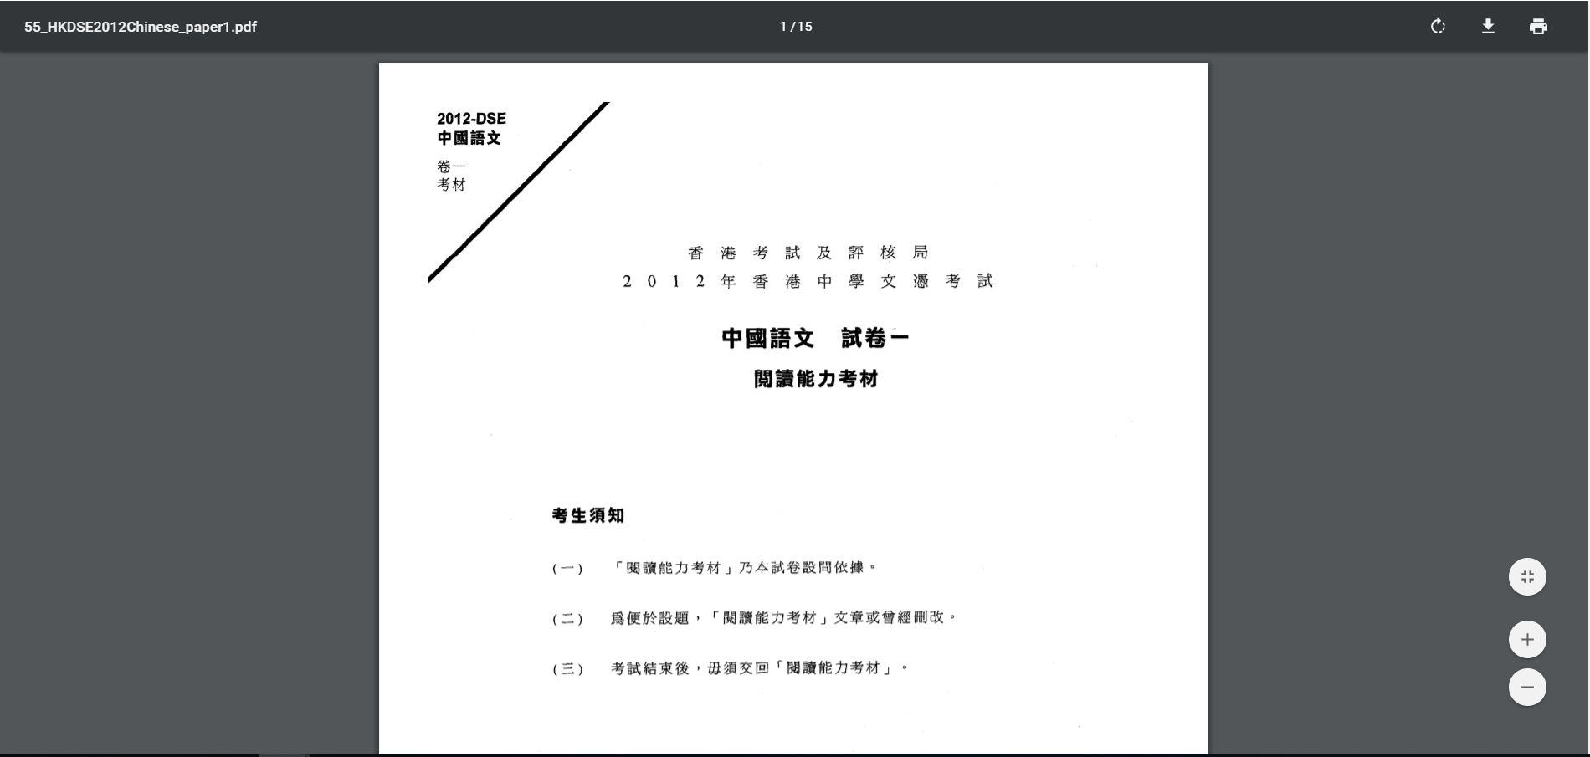

Full version directly access and download

 → 

Token number unchange

Case 2 (Pass)

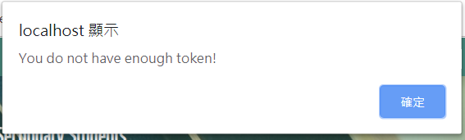

Designed purchase unsuccessful message

Case 3 (Pass)

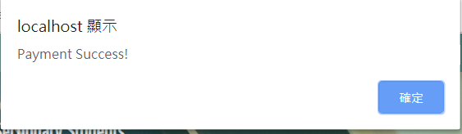

Payment success message

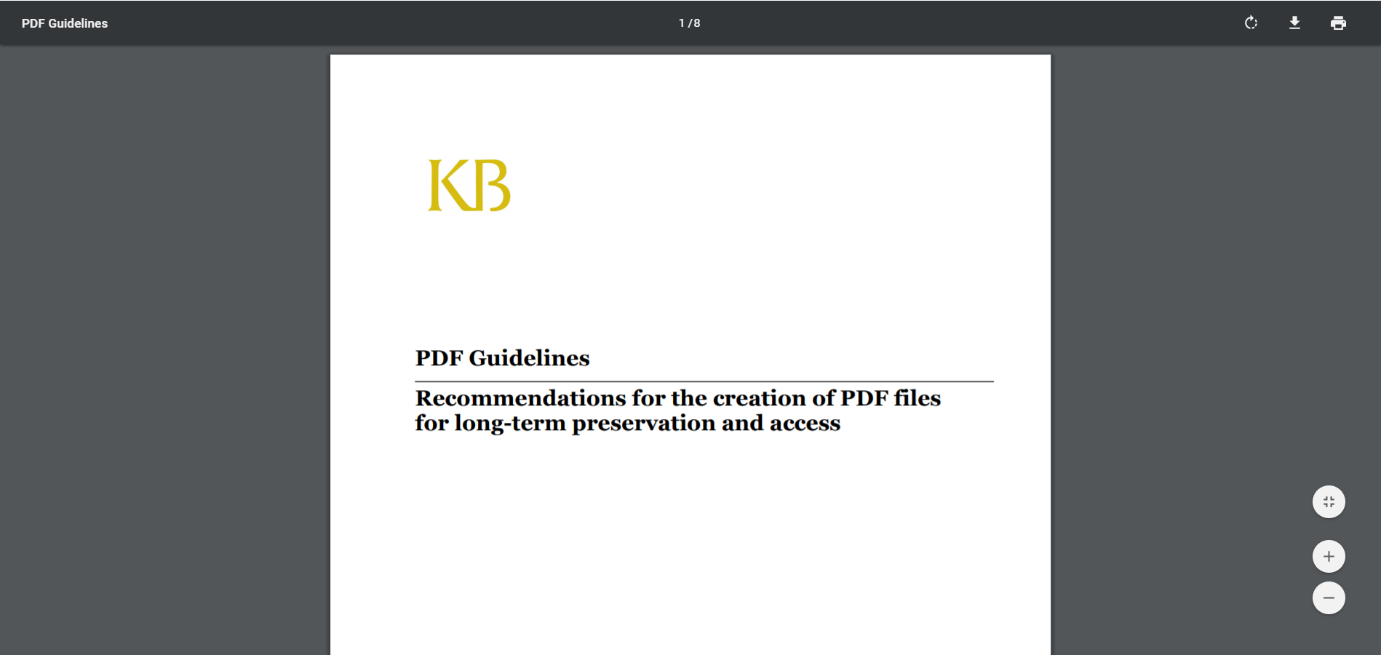

Full version directly access and download

 → 

Token number reduced by 10 (price in case 3)

### 5.3.4. Search Material

#### 5.3.4.1. Inputs

Search function should face many probabilities. Test cases try to simulate all the combination could appear and make sure the result and result counter works.

Case 1 : All the material in resource database

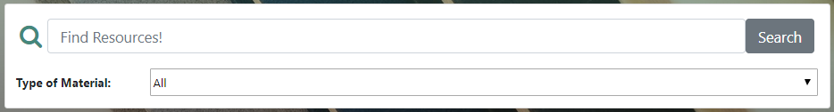

Case 2 : All the “Notes” in resource database

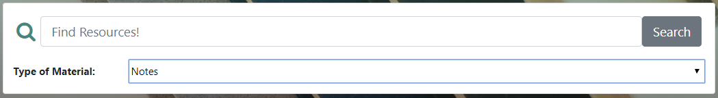

Case3 : Single keyword

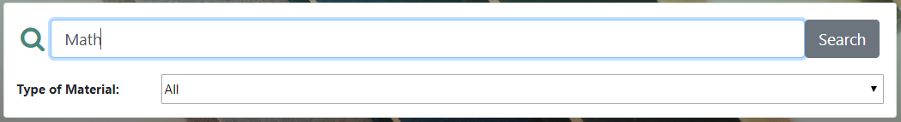

Case 4 : Single keyword (different keyword)

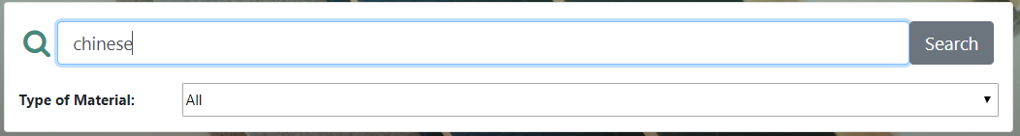

Case 5 : More than one keyword

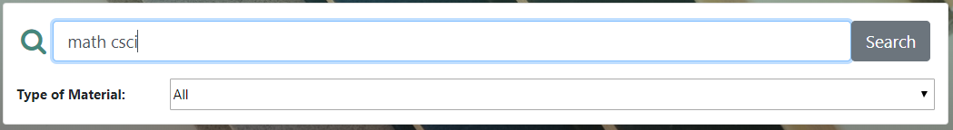

Case 6 : Double keyword and chosen resource type

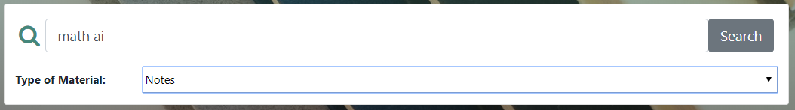

Case 7 : No match resource result

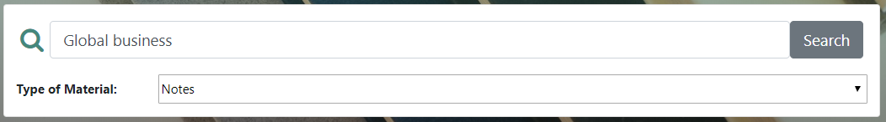

#### 

#### 5.3.4.2. Expected Outputs & Pass/Fail Criteria

A success search should display all the matched result and count the total number. Each result box should have the type of the resource, file name and its rating. all the boxes must capable to redirect its material page.

Case 1 (Pass)

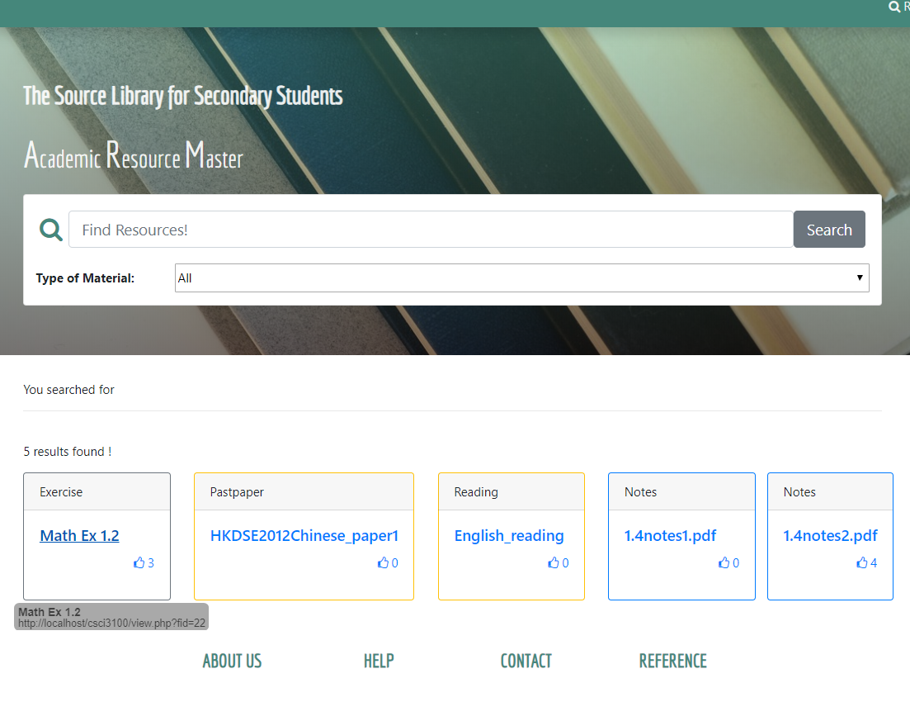

5 results is found with all correct type and file details. Hyperlink works well.

Case 2 (Pass)

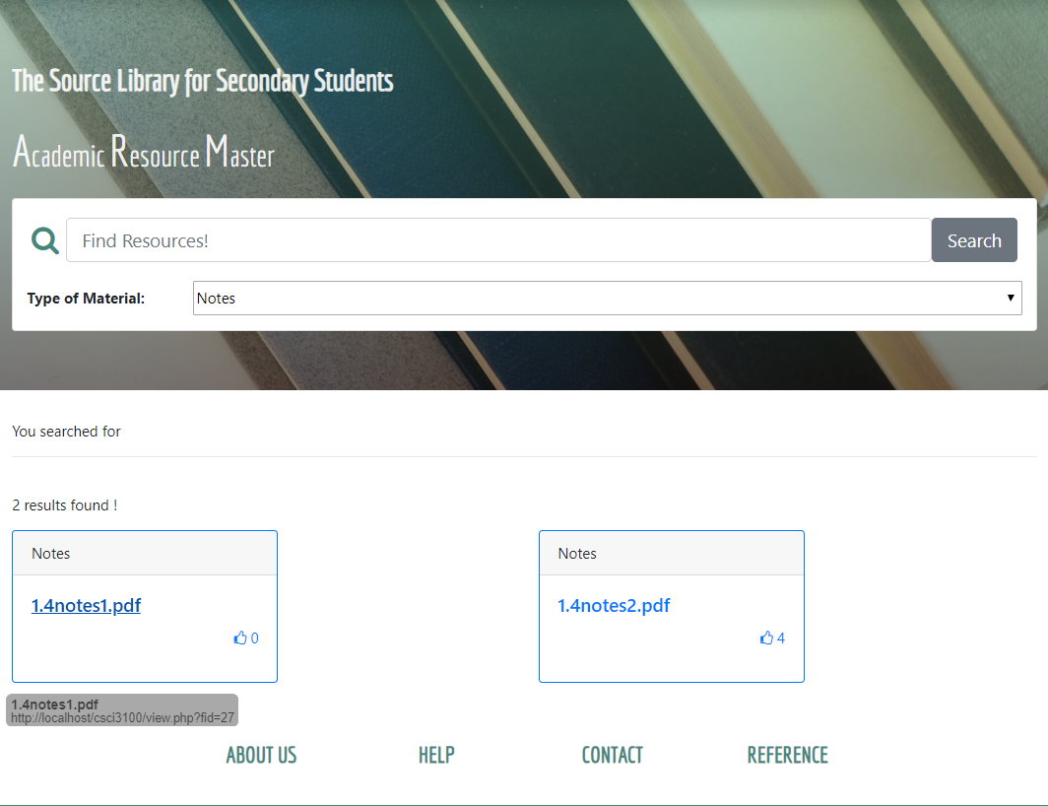

All “Notes” type result is displayed

## 

Case 3,4 (Pass)

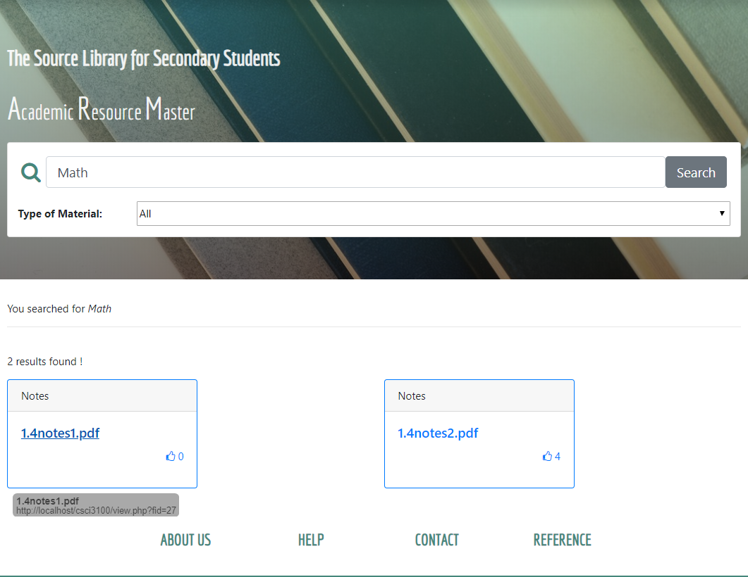

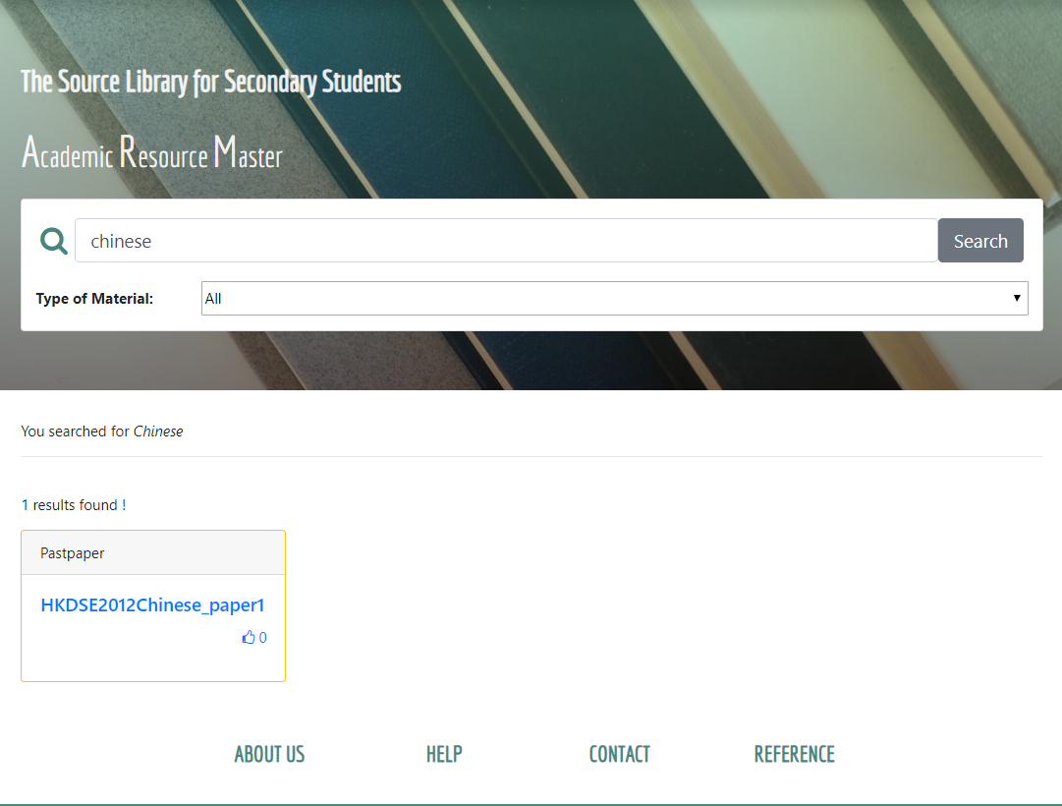

Single keyword search success

Case 5 (Pass)

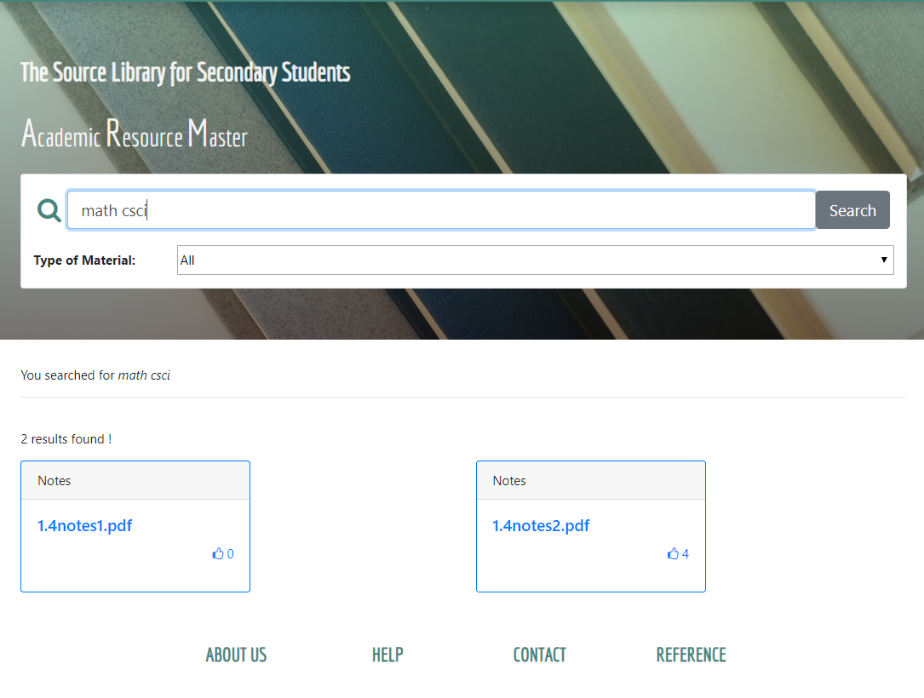

Multiple keywords search success

Case 6 (Pass)

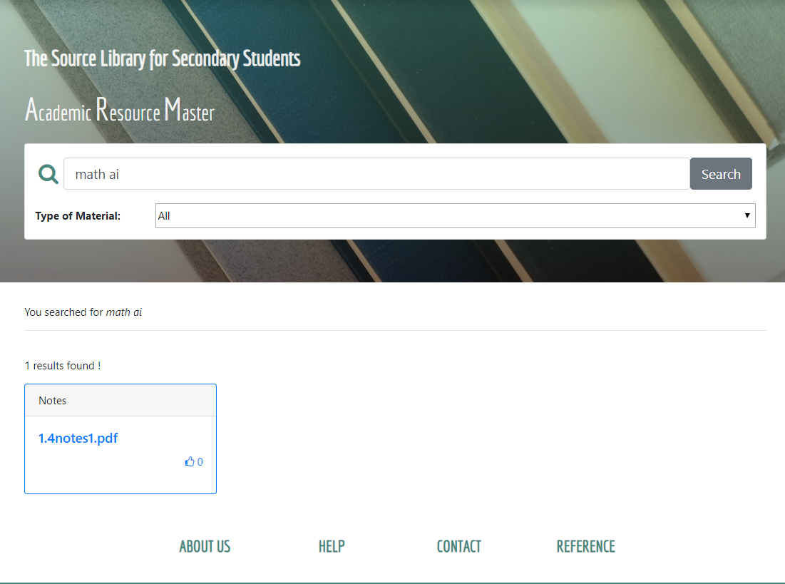

Multiple keywords in selected type search success

Case 7 (Pass)

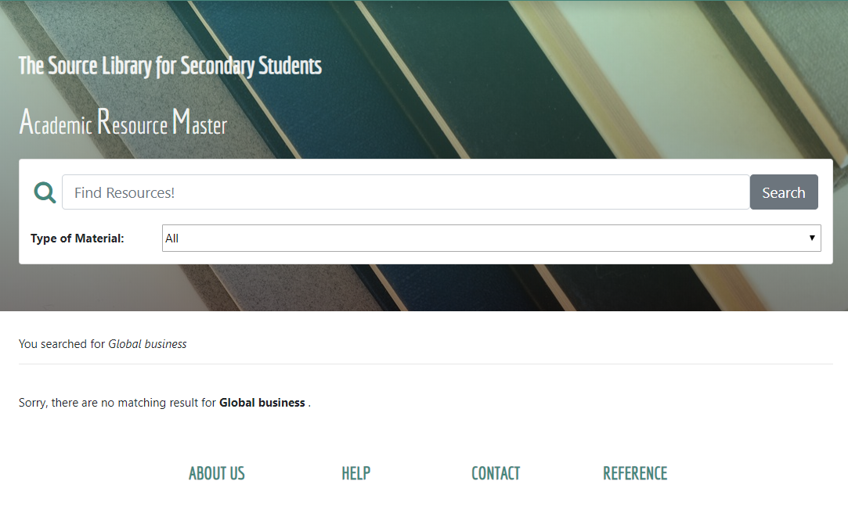

Correct no matching result

## 5.4. Question Discussion Forum

### 5.4.1. purpose

Forum is an open system but function and display is various user identity. The purpose of testing in question forum is to evaluate the forum pages variation due to a different user and to validate the performance of the function in the forum system. Pass or fail of the test is judged by comparing all the resopon of different identities.

### 5.4.2. Question Category

#### 5.4.2.1. Inputs

This part of testing only focus on the display, the update of the category page refer to identity will be evaluated in other testing parts.

Case 1 : Guest user

Case 2 : Locked in user

#### 5.4.2.2. Expected Outputs & Pass/Fail Criteria

Both case 1 and case 2 should have given same display result.

Case 1 :

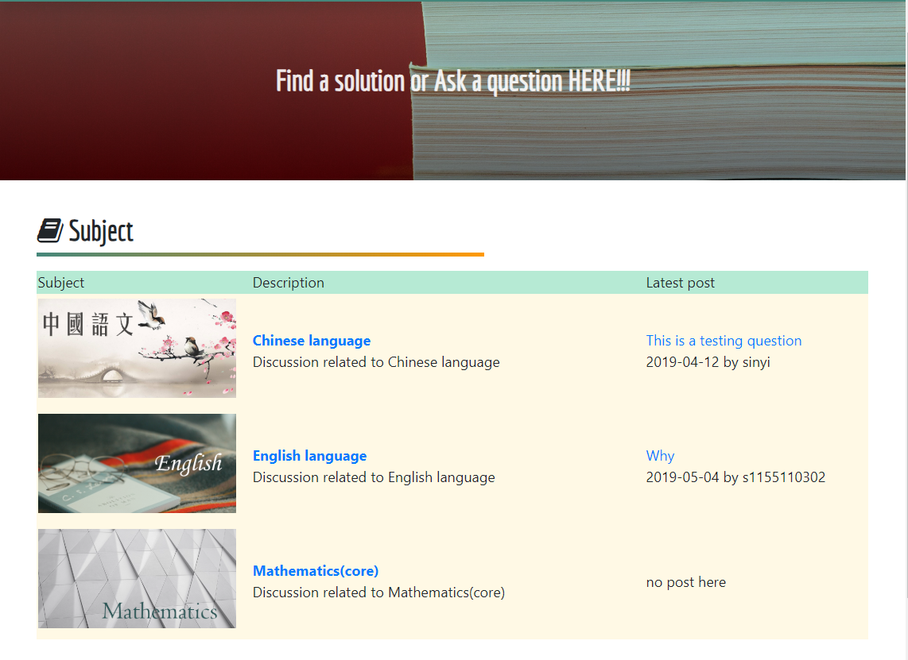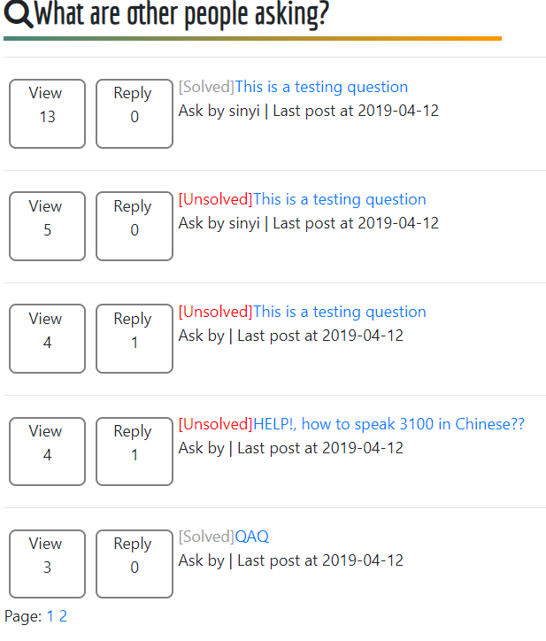

Case 2:





Case 1 and case 2 show all the details well without error, question categories page pass the test.

### 

### 5.4.3 View Question

#### 5.4.3.1. Inputs

Case 1 : Guest user

Case 2 : My question

Case 3 : Others question

#### 5.4.4.2. Expected Outputs & Pass/Fail Criteria

Case 1 :

Guest user access is expected for all the post related to the question. There should be a message “You can reply after you logged in.” on the top of all post and no answer box afterward. The access should also be seen as visit and update the view in category page. 

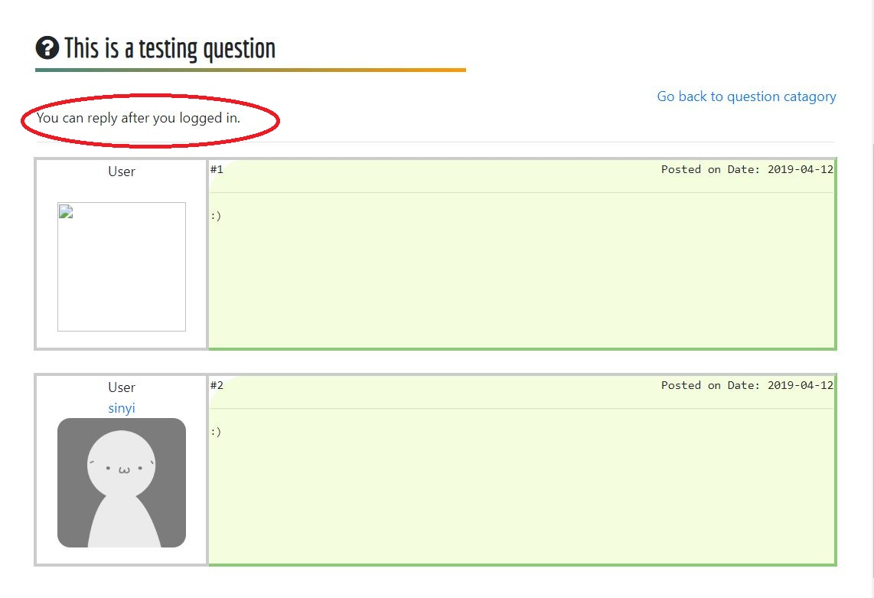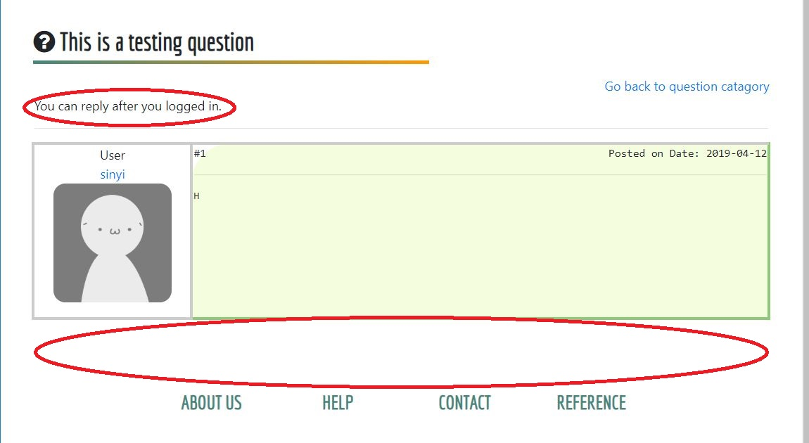

### 

Case 2 :

Enter my question is expected for close button when a unsolved question and answer box. Question asker can close the question and end all conversation for everybody. Close function should also update the category page and mark the question as solved”.



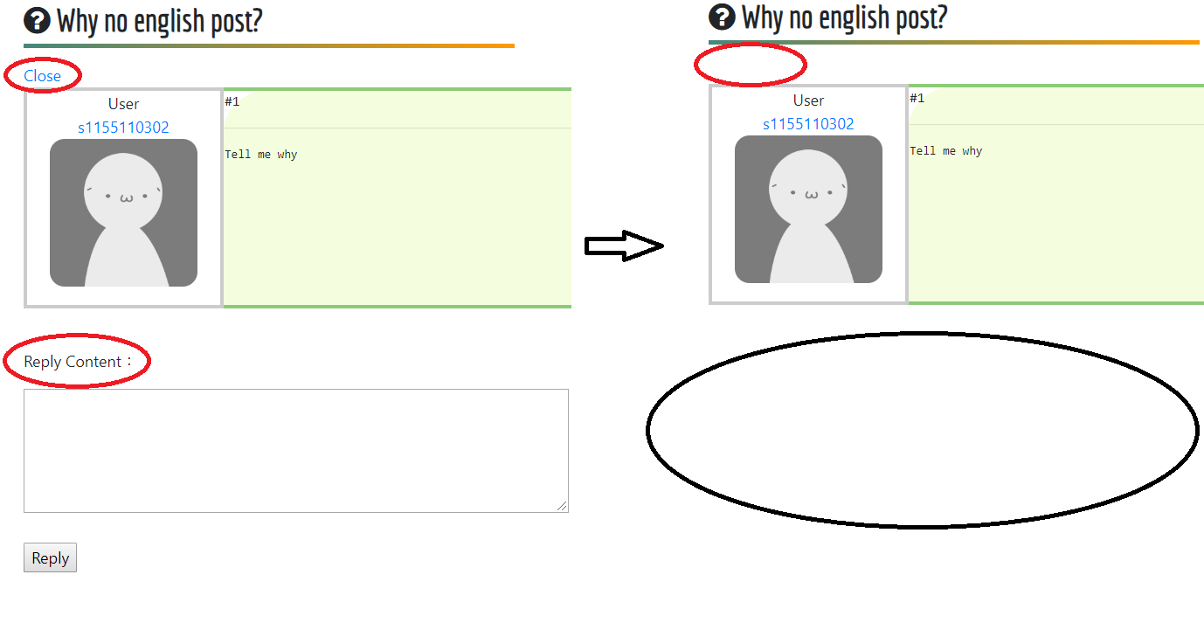



Case 3:

The display of enter others question is similar to my question, without the close function button.

Whatever your access identity, the entry should be count as visit and update the category page. Reply function should work well to obtain user’s reply content, date and display the in page with correct replier id.



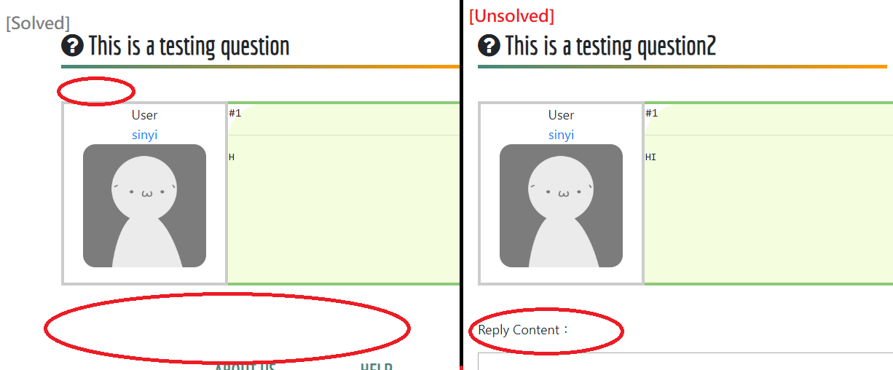

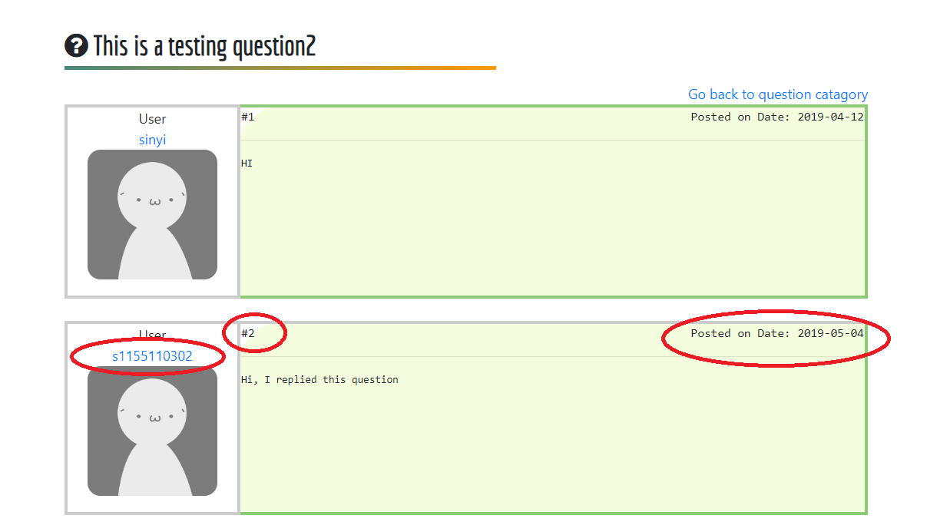

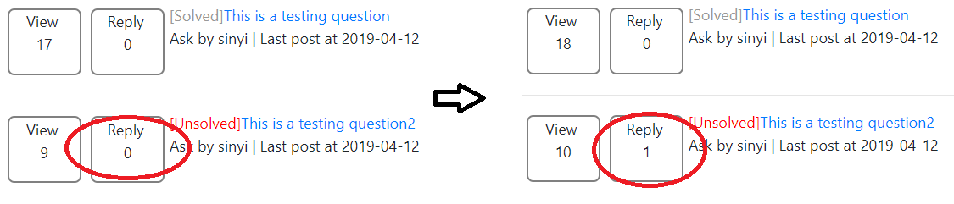

Compare three cases, answer page work accurate with each access identity and correctly update the category pages. The view question page pass the test.

### 5.4.4 Ask Question

#### 5.4.4.1. Inputs

Case 1: Guest user

Case 2 : Locked in user (ask a question in mathematics )

#### 5.4.4.2. Expected Outputs & Pass/Fail Criteria

Case 1 :

Guest user with no right to ask question and error message should alert.



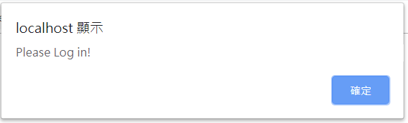

Case 2:

Ask question function is expected a result of saving the question form into server according to the question topic, content and date. Message to announce the declair successful or failure after kicking submission button.

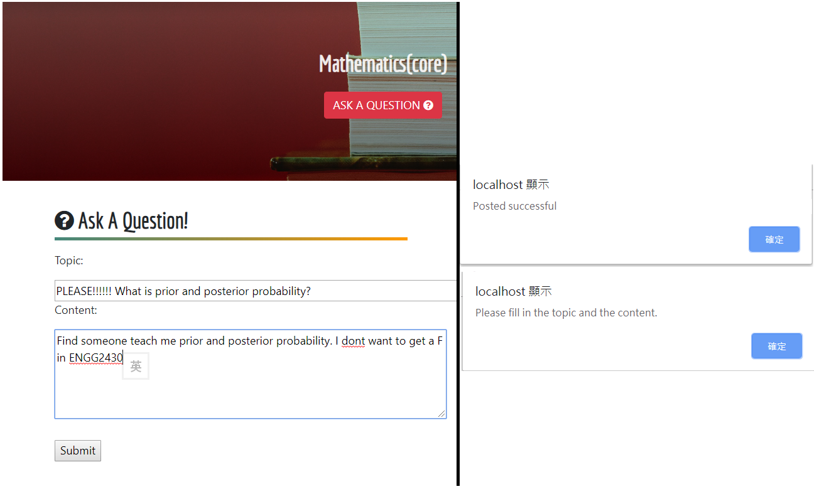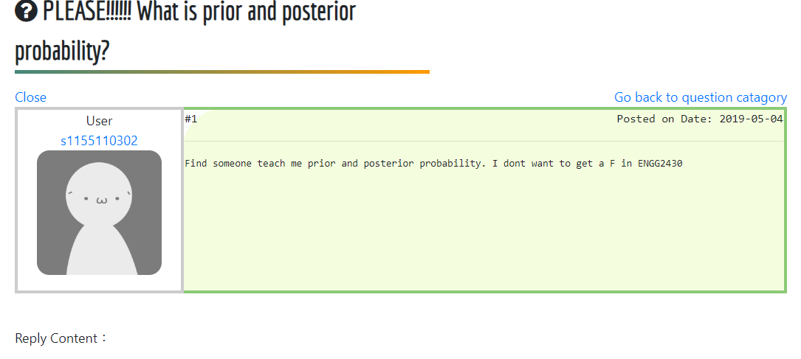

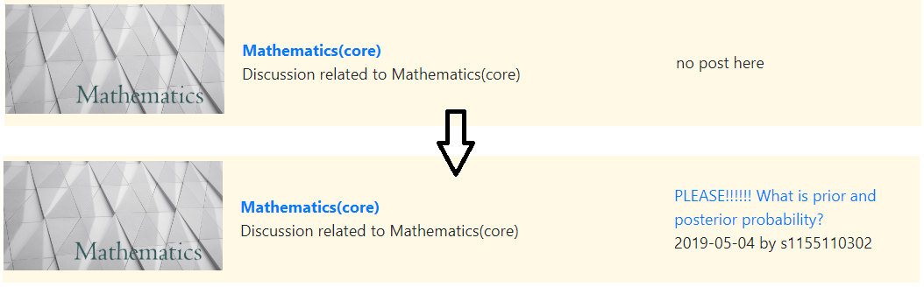

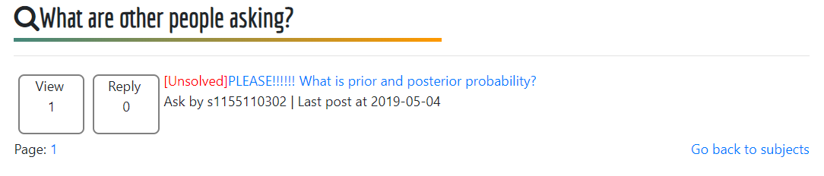

The above capture figure all the record and update function work along with its specification. Therefore, the answer function is judged as pass.

## 5.5 Mailbox

### 5.5.1. purpose

The purpose of testing mail function is evaluating the correctness of user private communication perform and function are working designate.

### 5.5.2. Inputs

There are two set of simulation, test 1 as a new account get start of using mail and search set up contact and test 2 is two users mail each other. The testing environment is user accounts “s1155110302”, which is completely new in mail database in windows, and "sinyi", which is already recorded inside the mail system in IOS.

Test 1 : Check linkage form between valid user

Step1 : "s1155110302" search for user “emmil” which is not inside the user database.

Step2 : "s1155110302" search "sinyi” and automatically add into contact.

Step3 : Check whether “s1155110302” is in “sinyi”’s contact.

Test 2 : Message by two-side

Step1 : “s1155110302” send message ”Hi,sinyi Calvin again” to “sinyi”.

Step2 : “sinyi” reply with message “What!??? this is your third account”.

### 5.5.3. Expected Outputs & Pass/Fail Criteria

Test 1 : Error and successful message alert properly

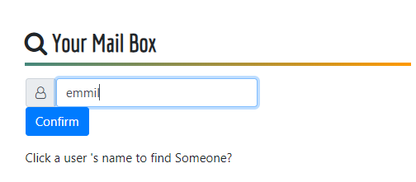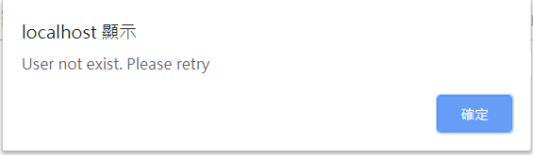

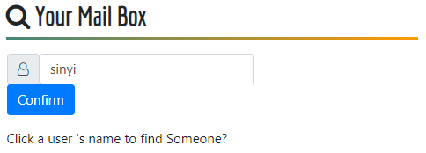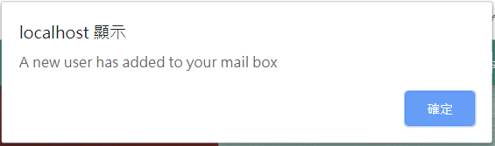

Test 2 Mail sent and show on both users run well

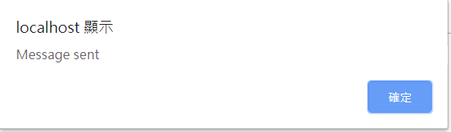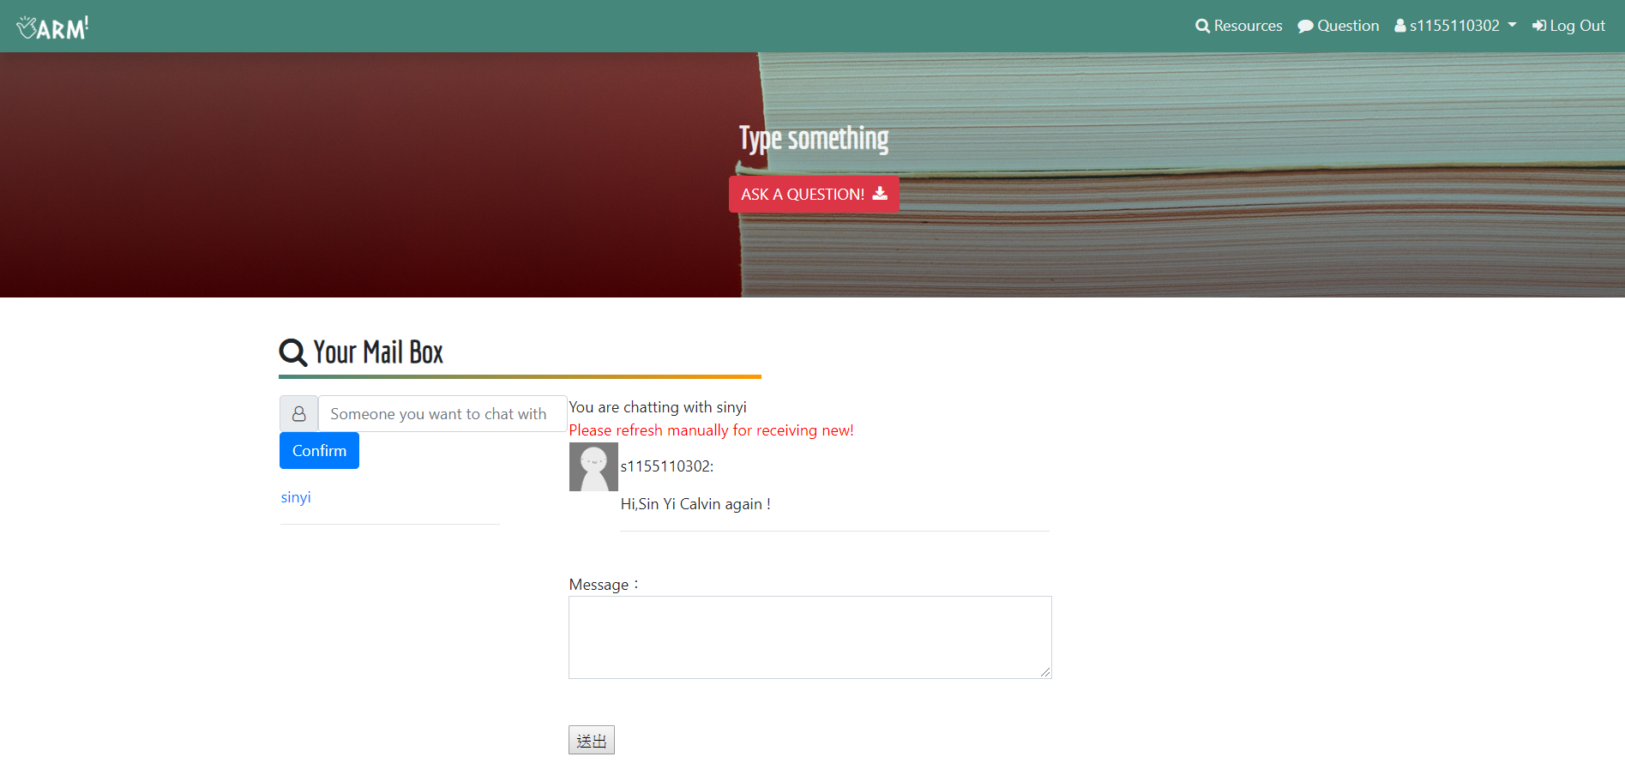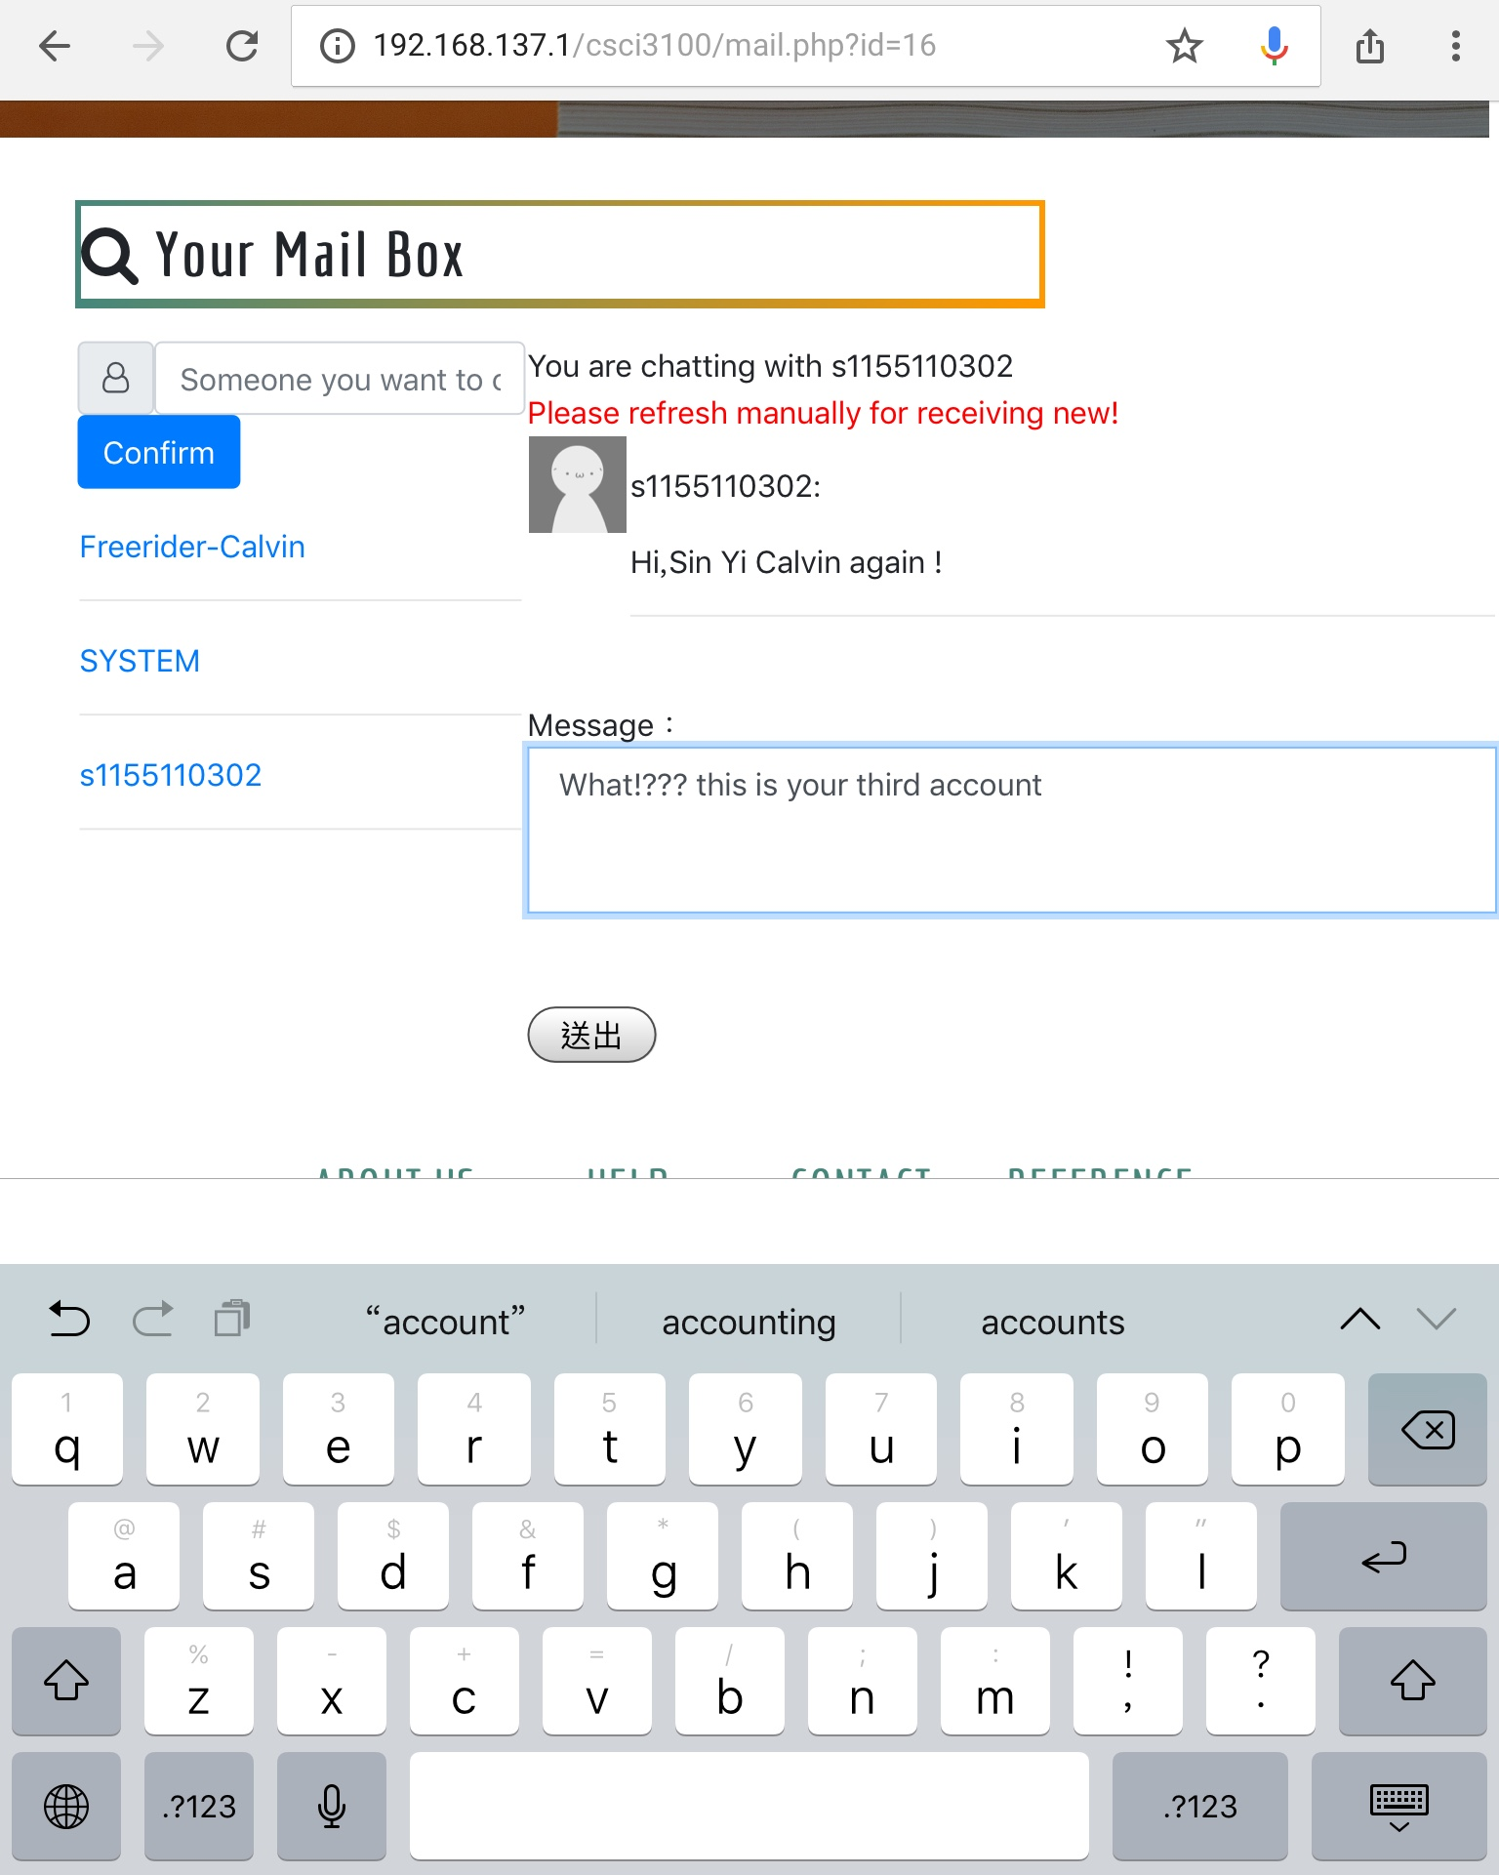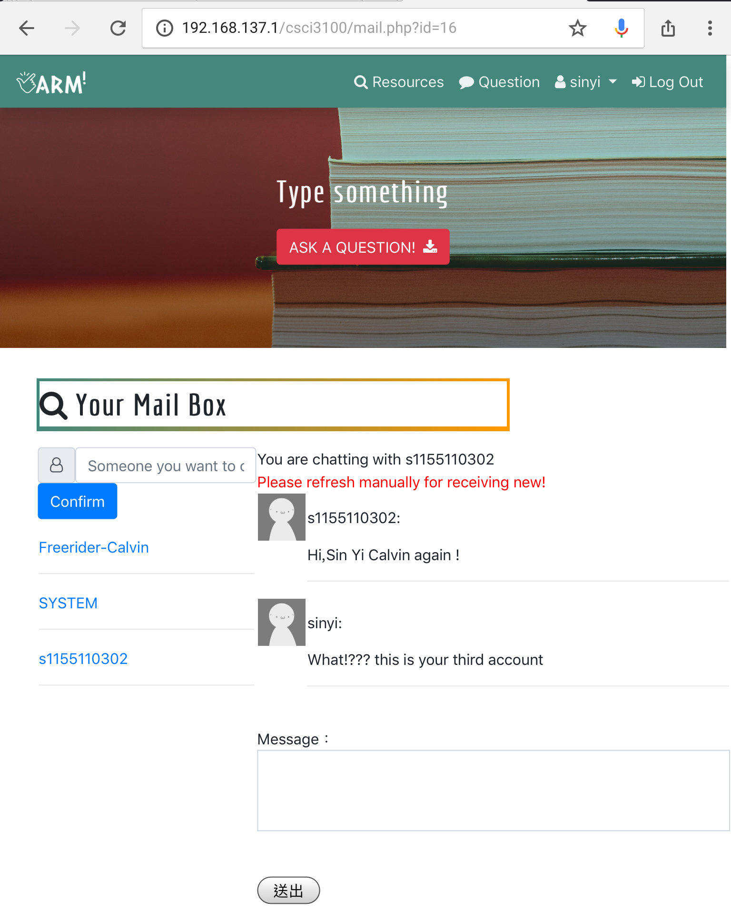

# 

# 6. Lesson Learned

Throughout the whole project, we have gone through almost the whole development cycle. We try to apply the waterfall model in this project. In the beginning, we decide to develop an online learning system for the students to find and share the learning materials. And we submit the initial design outline which includes the requirement and design steps. Then we break the system down into modules and produce the actual code based on the initial design. We tested the modules individually and it is an implementation step of the waterfall model. After module testing, we integrated the modules and tested the whole system. Finally, we write this report as a verification part.

If we have can re-do this project again, we would like to focus on increasing the reusability of code, like using more functional programming or even OOP. There are numbers of code are repeated, but, as we using inline coding at that part, codes cannot be reused easily. OOP would definitely provide much higher reusability, and more flexible for further upgrade.

The system is currently on version1.1, which stated that there are rooms for improvement. If we have the chance to continue developing this system, our goal would be improving the GUI design with animation and using more OOP.

# 7. Conclusion

The aim of the ARM is providing an online platform for the students to get learning materials with a lower cost. The ARM supports distinctive functions which allow students to learn more through the question and answer forum and to communicate with other users via the mailbox. The implementation of ARM is performed with respect to the system architecture, UML and user interface design. The ARM has been tested successfully with various cases. Overall, our ARM is user-friendly, reliable, and functional.